

CAPSTONE PROJECT REPORT
Report 4 – Software Design Document

– Ho Chi Minh City, October 2026 –

Table of Contents
I. Record of Changes 3
II. Software Design Document 4
1. System Design 4
1.1 System Architecture 4
1.2 Package Diagram 4
2. Database Design 4
3. Detailed Design 5
3.1 <Feature/Function Name1> 5
3.2 <Feature/Function Name2> 6

I. Record of Changes
Date | A, M, D * | In charge | Change Description
16/10/2026 | A | Tran Ngoc Khiet | Version 1.0  Add:  - 3. Detailed Design
17/10/2026 | A | Tran Ngoc Khiet | Version 1.1  Add:  - 1.1 System Architecture
21/10/2026 | M | Vo Minh Son | Version 1.2  Modify:  - 1.1 System Architecture
27/10/2026 | A | Tran Ngoc Khiet | Version 1.3  Add:  - 1.2 Package Diagram  - 3. Detailed Design: Class, Sequence and State Machine diagram placeholders  - 3.13–3.18 Detailed Design: six new functional groups and 21 Sequence Diagram placeholders (Scope V10)  - 4. Activity Diagrams: five main business flows (F1–F5)  - 5. Technology Stack and External Services  - 6. Source Control, CI/CD and Release Management  - 7. AI Tools and Model Usage  - Add all state machine diagram images  - Add all class diagram images
27/10/2026 | A | Doan Duc Hai | Version 1.4  Add:  - All Sequence Diagrams  Modify:  - Updated Section 6.3, include the Staging environment for the Backend, Frontend, and Mobile applications.
27/10/2026 | A | Tran Ngoc Khiet | Version 1.5  Add:  - All activity diagrams
28/10/2026 | A | Vo Minh Son | Version 1.6  Add:  - 3. Detailed Design: common transaction, idempotency, concurrency and exception conventions (Table 3.0) and a new final sub-section in each group 3.1 – 3.18 (e.g. 3.1.4, 3.5.8, 3.13.7, 3.18.5) designing the transaction boundary, idempotency, concurrency control and exception handling of every function
28/10/2026 | A, M | Truong Le Huy Hoang | Version 1.8:  Add: Database Design  Modify: Table Description content according to latest Database Design
28/10/2026 | A, M | Vo Minh Son | Version 1.9  Add:  - 1.2.4 Out-of-Scope and Optional Packages  - 2.1 Mapping to the SRS Entity List  - 2.2 Key Data Definitions Used by the Detailed Design  - Table 3.0B – State Dictionary and display-label mapping  Modify:  - 3. Detailed Design: daily allocation run and cutoff at 00:00 ICT (Table 3.0 TX-5, 3.5.8, 3.6.8, 3.13.7, 3.15.5)  - 3. Detailed Design: idempotency rule – one key per payload with a stable DraftId (Table 3.0 ID-2, 3.5.8)  - 3. Detailed Design: stock lock with LockedReserved, reservation and write-off rules (Table 3.0 CC-2, 3.7.7, 3.15.5)  - 3.4, 3.14: shelf-life discount Percentage or FixedPerUnit; near-expiry offer with MLOR override marked as future scope  - 3.8 – 3.18: PO issued at quotation acceptance with picking lists and shipments, prepaid payment gate at dispatch, shortage handling at receipt, credit due date = actual final receipt date + term, financial adjustment, manual refund and reward redemption lifecycles  - 3. Detailed Design: transaction tables use the new Database Design tables (PICKING_SCAN, PICKING_EXCEPTION, DELIVERY_ATTEMPT, SHIPMENT_ASSIGNMENT, MANUAL_REFUND_EVIDENCE, JOB_RUN, PROCESSED_MESSAGE, attachments)  - 1.2 Package Diagram, 5.1 and 5.2: removed internal transfers, payOS and GraphQL from the MVP baseline; added Chart.js, scheduled worker and Azure Monitor  - 2. Database Design: table descriptions for INVENTORY_BALANCE, RESERVATION, ALLOCATION_PLAN_PRICE, ALLOCATION_RUN_LINE, SALES_ORDER_LINE, REWARD_REDEMPTION, NEAR_EXPIRY_OFFER and BATCH_PROMOTION  - State machine diagrams: 3.5.7, 3.6.4, 3.6.5, 3.6.6, 3.6.7, 3.7.5, 3.7.6, 3.8.5, 3.8.6, 3.8.7, 3.9.5, 3.9.6  - Sequence diagrams: 3.5.2, 3.5.3, 3.5.4, 3.5.5, 3.6.3, 3.7.4, 3.8.3, 3.9.2, 3.9.4, 3.12.2, 3.13.3, 3.13.4, 3.13.5, 3.15.4, 3.16.2, 3.16.3, 3.16.4, 3.17.2, 3.17.3, 3.18.3, 3.18.4  - Renamed 3.4.3, 3.6.3 and 3.16.2; corrected figure captions 3.2.3 and 3.2.4
*A - Added M - Modified D - Deleted

II. Software Design Document

1. System Design

1.1 System Architecture
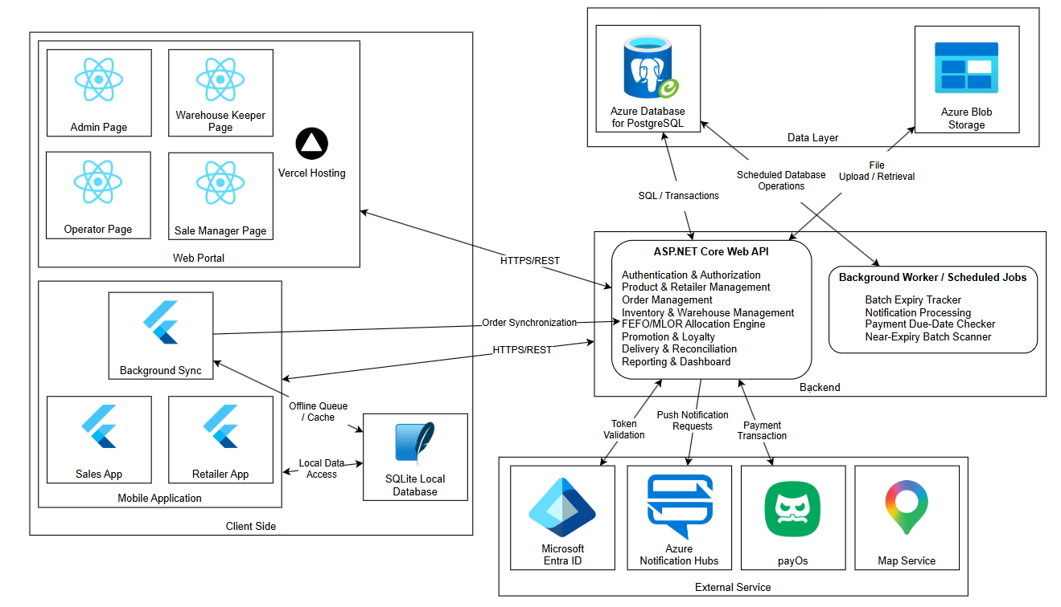
Figure 1.1 FSCM High-Level System Architecture diagram

1.2 Package Diagram

1.2.1 Backend Package Diagram
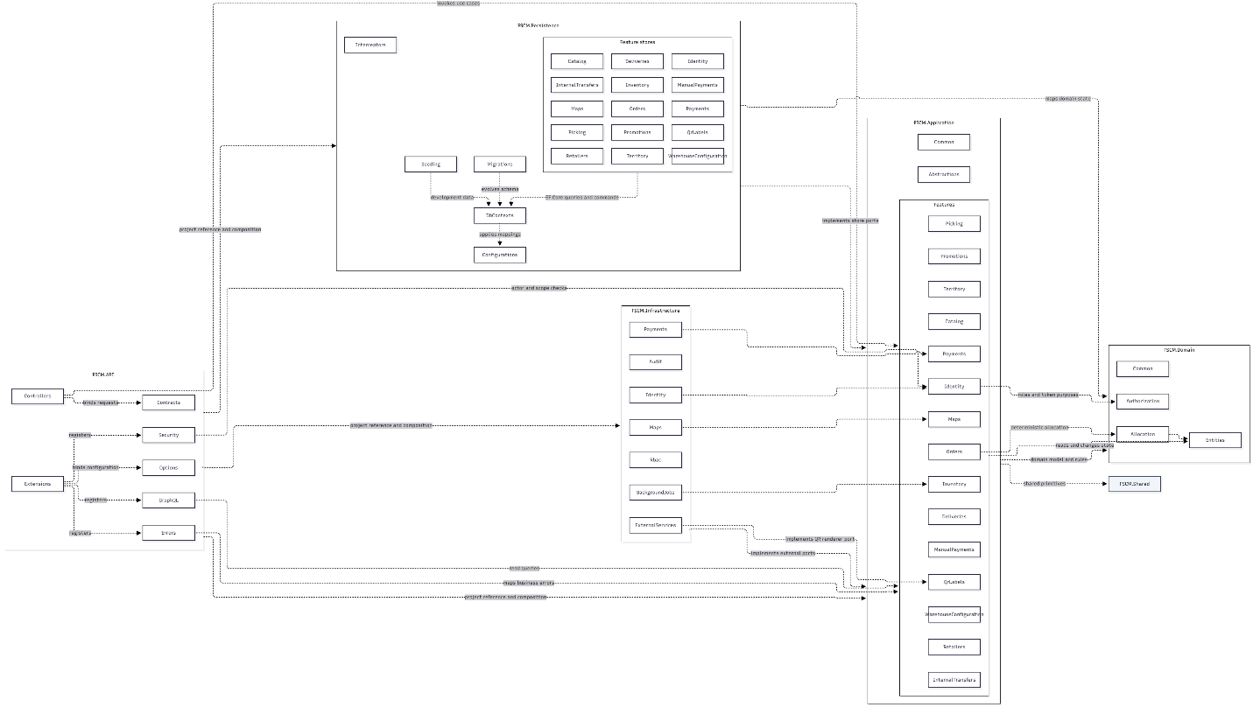
Figure 1.2.1 FSCM Backend Package diagram
Package Descriptions
No | Package | Description
1 | FSCM.API | ASP.NET Core transport and composition boundary; exposes the REST API, authentication, middleware and dependency registration without owning business rules
2 | FSCM.API.Controllers | Thin REST controllers that authorize, bind requests, invoke one application use case, and map the response
3 | FSCM.API.Contracts | HTTP request models grouped by business feature
4 | FSCM.API.Security | Request-user accessors and authorization helpers used to enforce actor and assignment scope at the API boundary
5 | FSCM.API.Errors | Maps feature exceptions and stable error codes to RFC Problem Details responses
6 | FSCM.API.Extensions | Composes services, exception handling, authentication, middleware, and the HTTP pipeline
7 | FSCM.API.Options | Strongly typed settings for authentication and external integrations
8 | FSCM.Application | Use-case layer; owns orchestration, application contracts, policies, and ports implemented by outer adapters
9 | FSCM.Application.Features | Parent package for feature-oriented services, result/command contracts, operation exceptions, and store/gateway interfaces
10 | FSCM.Application.Features.Catalog | Category, product lifecycle, SKU replacement, publication, and effective-price use cases
11 | FSCM.Application.Features.Deliveries | Dispatch, delivery assignment, and retailer receipt-confirmation workflows
12 | FSCM.Application.Features.Identity | Sign-in, token lifecycle, user administration, identity-provider linking, and user scope operations
13 | FSCM.Application.Features.Inventory | Goods receipt, inventory balance, batch lifecycle, expiry sweep, and inventory outbox workflows
14 | FSCM.Application.Features.ManualPayment | Full cash or bank-transfer payment recording and validation
15 | FSCM.Application.Features.Maps | Geocoding, route-distance cache, and map-location orchestration through an application-owned provider port
16 | FSCM.Application.Features.Orders | Assisted ordering, pricing snapshots, allocation, approval, cancellation, and scoped order queries
17 | FSCM.Application.Features.Payments | Receivable planning, manual prepaid-transfer verification, deferred-payment settlement and overdue-state rules (no payment gateway in the MVP)
18 | FSCM.Application.Features.Picking | Picking-list planning, QR scans, completion, and dispatch preparation
19 | FSCM.Application.Features.Promotions | Ordinary campaigns, remaining-shelf-life discount tiers and deterministic price snapshots
20 | FSCM.Application.Features.QrLabels | QR-label lookup, rendering, splitting, lineage, and inspection operations
21 | FSCM.Application.Features.Retailers | Retailer declaration, review, activation, profile, and scoped retailer management
22 | FSCM.Application.Features.Territory | Regions, sales groups, assignment history, and Sales-to-retailer eligibility
23 | FSCM.Application.Features.WarehouseConfiguration | Warehouse master data, transit-time rules, MLOR, and versioned business configuration
24 | FSCM.Application.Abstractions | Reserved home for cross-cutting application ports such as clocks, actor context, transactions, and gateways
25 | FSCM.Application.Common | Reusable application concerns such as audit, concurrency, and unit-of-measure conventions
26 | FSCM.Domain | Dependency-free business model and deterministic rules; it has no transport, database, or provider dependency
27 | FSCM.Domain.Entities | Persisted domain state, aggregate records, enums, value-like records, and domain constants
28 | FSCM.Domain.Allocation | Deterministic candidate filtering, scoring, and greedy stock-allocation algorithm
29 | FSCM.Domain.Authorization | Business roles, scope claim names, and account-token purposes
30 | FSCM.Domain.Common | Reserved location for domain primitives shared across aggregates
31 | FSCM.Persistence | EF Core/PostgreSQL adapter implementing application store ports and transaction behavior
32 | FSCM.Persistence.DbContexts | EF Core database context and model-configuration entry point
33 | FSCM.Persistence.Configurations | Entity mappings, constraints, indexes, relationships, and physical-schema configuration
34 | FSCM.Persistence.<Feature> | Feature-aligned store implementations for Catalog, Deliveries, Identity, Inventory, ManualPayments, Maps, Orders, Payments, Picking, Promotions, QrLabels, Retailers, Territory and WarehouseConfiguration
35 | FSCM.Persistence.Migrations | Immutable EF Core migration history for the PostgreSQL schema
36 | FSCM.Persistence.Seeding | Deterministic development-only identity and business datasets
37 | FSCM.Persistence.Interceptors | Extension point for EF Core cross-cutting behavior
38 | FSCM.Infrastructure | Adapter layer for technical or third-party services that are not database persistence
39 | FSCM.Infrastructure.Identity | JWT creation/validation and password hashing implementations for application identity ports
40 | FSCM.Infrastructure.Maps | Google Maps provider adapter for geocoding and road-distance operations
41 | FSCM.Infrastructure.BackgroundJobs | Hosted workers and scheduling for expiry sweeps and durable inventory-outbox dispatch
42 | FSCM.Infrastructure.ExternalServices | Template/extension package for additional third-party adapters
43 | FSCM.Infrastructure.Audit | Reserved package for infrastructure-level audit adapters
44 | FSCM.Infrastructure.Rbac | Reserved package for infrastructure-level role-based access-control adapters
45 | FSCM.Shared | Intended for small, stable, domain-neutral primitives shared across layers; currently contains no production C# types

1.2.2 Frontend Package Diagram
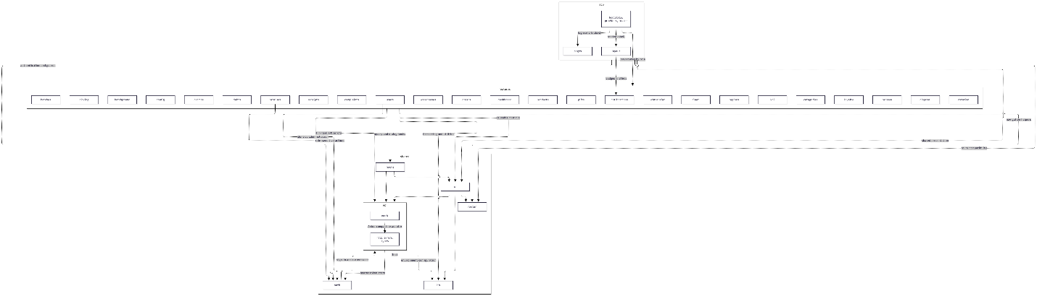
Figure 1.2.2 FSCM Frontend Package diagram
No | Package | Description
1 | app | React application composition root containing startup, global providers, route definitions, and top-level layout
2 | app.layout | Authenticated portal shell with sidebar, top bar, role navigation, and notification entry points
3 | app.pages | Application-level pages that are not owned by a business feature, currently login and not-found pages
4 | features | Parent package for independently lazy-loaded, business-oriented portal modules
5 | features.dashboard | Administrative overview and revenue visualization
6 | features.orders | Order list/detail, approval actions, and allocation-trace inspection
7 | features.debts | Receivable and outstanding-debt monitoring
8 | features.picking | Picking-list list/detail views and picking workflow visibility
9 | features.receipts | Goods-receipt listing, creation, and receipt details
10 | features.fleet | Delivery vehicle and driver/person management
11 | features.batches | Inventory-batch list and detailed batch state
12 | features.batchpromo | Shelf-life discount management and batch scan workflow
13 | features.disposal | Expired-stock write-off listing, creation, and details
14 | features.promos | Promotion campaign listing, creation, editing, and details
15 | features.retailers | Retailer list/detail, registration review, and retailer profile actions
16 | features.loyalty | Loyalty account and point-ledger administration
17 | features.gifts | Loyalty gift catalog administration
18 | features.redeem | Gift-redemption request list, details, and processing actions
19 | features.regions | Region, Sales-group, and assignment management
20 | features.categories | Product-category hierarchy management
21 | features.products | SKU lifecycle, pricing, product actions, and product details
22 | features.warehouses | Warehouse master-data list, editing, and details
23 | features.users | User account, role, status, identity-provider, and assignment administration
24 | features.kpi | Sales KPI, ranking, and detailed performance views
25 | features.complaints | Complaint list/detail and resolution workflow
26 | features.config | Business configuration editors, including allocation weights and transit rules
27 | features.notifications | Notification retrieval, unread badges, and notification-bell UI
28 | shared | Cross-feature client capabilities that do not belong to one business module
29 | shared.api | Central Axios client, Problem Details mapping, HTTP helpers, and common API types
30 | shared.api.mock | In-browser API adapter, fixtures, handlers, and calculation engines used in mock mode
31 | shared.auth | FSCM session context, bearer-token storage, role definitions, guards, and external identity exchange
32 | shared.hooks | Reusable React hooks for API mutations and common UI state
33 | shared.lib | Environment access, identifiers, date/status helpers, and display formatting
34 | shared.router | React Router compatibility helpers used by application and feature packages
35 | shared.ui | Reusable controls, tables, dialogs, form fields, status views, and feedback components

1.2.3 Mobile Package Diagram
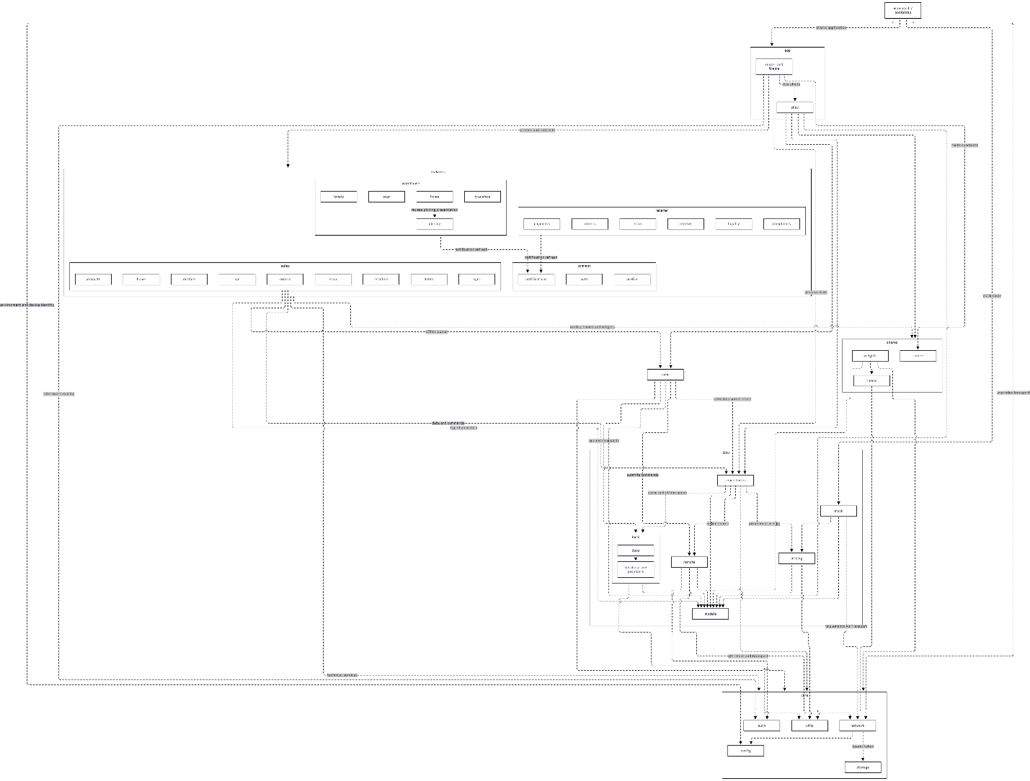
Figure 1.2.3 FSCM Mobile Package diagram
No | Package | Description
1 | main.dart | Flutter bootstrap that loads preferences, device/environment configuration, and replaces the real transport with `MockApi` when mock mode is enabled
2 | app | Application-level Material configuration, routing, theme selection, and role-based navigation composition
3 | app.shell | Separate bottom-navigation shells for Sales, Warehouse Keeper, and Retailer roles
4 | features.common | Parent package for presentation flows shared by more than one role
5 | features.common.auth | Splash/session restoration and login screens
6 | features.common.notifications | Notification list and reusable notification-bell behavior
7 | features.common.profile | Shared account/profile screen and role-specific action links
8 | features.sales | Parent presentation package for the Sales role
9 | features.sales.home | Sales dashboard and shortcuts to current work
10 | features.sales.orders | Assisted-order listing, creation, confirmation, and details
11 | features.sales.products | Product, stock, and promotion browsing for Sales
12 | features.sales.retailers | Assigned-retailer browsing and order-entry navigation
13 | features.sales.debts | Customer receivable lookup and collection context
14 | features.sales.declare | New-retailer declaration and declaration-status screens
15 | features.sales.kpi | Personal Sales KPI and ranking presentation
16 | features.sales.scan | Sales QR-scanning flow
17 | features.sales.sync | Offline command queue status, retry, and synchronization UI
18 | features.warehouse | Parent presentation package for the Warehouse Keeper role
19 | features.warehouse.home | Warehouse task overview and shortcuts
20 | features.warehouse.picking | Picking lists, line-level scans, progress, and completion screens
21 | features.warehouse.labels | QR-label detail and lineage presentation
22 | features.warehouse.scan | Warehouse QR scanner for picking or label lookup
23 | features.retailer | Parent presentation package for the Retailer role
24 | features.retailer.orders | Retailer order history and order details
25 | features.retailer.receive | Delivery receipt confirmation by expected QR labels
26 | features.retailer.payments | Payment, checkout, and receivable presentation
27 | features.retailer.loyalty | Loyalty balance, ledger, gifts, and redemption entry points
28 | features.retailer.complaints | Complaint list and complaint-submission flow
29 | features.retailer.scan | Retailer QR scanner used for receipt-related navigation
30 | data | Data-access layer that hides online, local, calculated, and mock sources from presentation packages
31 | data.models | Typed DTOs, enums, and JSON mapping shared by repositories and screens
32 | data.repositories | Riverpod-backed facades that coordinate remote calls, local cache/queue, session state, and invalidation
33 | data.remote | Resource-oriented REST adapters that map typed requests and responses through the central API client
34 | data.local | SQLite database, local providers, cached snapshots, and the offline-order queue
35 | data.local.daos | Focused SQLite access for products, retailers, promotions, inventory snapshots, offline orders, and sync state
36 | data.pricing | Provisional offline order-limit and promotion calculations; the server remains authoritative
37 | data.mock | In-process implementation of the REST transport contract with seeded prototype data and resource handlers
38 | core | Parent package for role-independent technical services and pure utilities
39 | core.auth | Session state and user-role definitions
40 | core.config | Build-time environment values and stable device identity
41 | core.network | Transport abstraction, Dio implementation, endpoints, connectivity monitoring, and API exception mapping
42 | core.storage | Secure persistence for access and refresh tokens
43 | core.utils | Pure clock, date, ID, money, and status-display utilities
44 | sync | Offline queue ordering/retry logic and service that submits queued commands then refreshes authoritative state
45 | shared | Cross-feature presentation assets and navigation constants
46 | shared.routes | Single source of route names, paths, and parameter patterns
47 | shared.theme | Shared application color tokens
48 | shared.widgets | Reusable cards, states, dialogs, scanners, filters, order widgets, status chips, and timeline components

1.2.4 Out-of-Scope and Optional Packages
The packages below still exist in the repositories but are not part of the MVP baseline committed by Registration v1.8 and Report 1 v1.6. They are listed only for traceability; no design in Sections 3 – 4 depends on them and no test in Report 5 treats them as a success path. The package diagrams in Figures 1.2.1 – 1.2.3 still draw them and are to be redrawn without them.
Package | Layer | Status and reason
FSCM.Application.Features.InternalTransfers (with its FSCM.Persistence store) | Backend | Out of scope – internal warehouse transfers are excluded (Registration v1.8 §4, Report 1 LI-01). Legacy code kept for migration compatibility only.
features.whtransfer | Web Portal | Out of scope – warehouse-transfer screens (same reason).
features.rotation | Web Portal | Out of scope – near-expiry rotation/redistribution between warehouses is excluded (Report 1 §2, LI-01).
features.warehouse.transfers | Mobile | Out of scope – transfer list and detail screens (same reason).
FSCM.Infrastructure.Payments (payOS adapter) | Backend | Optional / not used – gateway checkout, webhooks and settlement are excluded (Report 1 LI-08). Prepaid transfers are verified manually by authorized staff.
FSCM.API.GraphQL | Backend | Optional / not used – Registration v1.8 specifies an ASP.NET Core REST API. All reads and writes in Sections 3 – 4 use REST; a read-only GraphQL surface may only be enabled after it is approved.
Table 1.2.4 – Out-of-scope and optional packages

2. Database Design
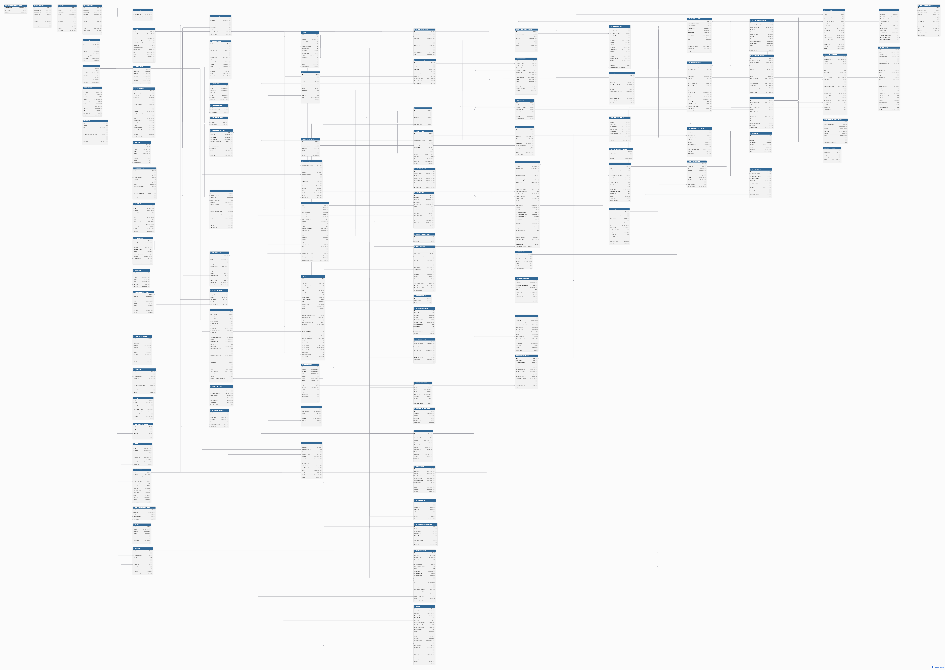

Table Descriptions

No | Table | Description
01 | ACCOUNT_TOKEN | Stores hashed activation, OTP and password-reset tokens with purpose, expiry and one-time consumption details for a user account.  Primary key: Id  Foreign keys: UserAccountId -> USER_ACCOUNT.Id
02 | ALLOCATION_LINE_  TRACE | Stores the allocation outcome and explanation for a run line and proposal revision, including demand, shortage, eligibility limits and scoring weights.  Primary key: Id  Foreign keys: AllocationPlanVersionId -> ALLOCATION_PLAN_VERSION.Id; AllocationRunLineId -> ALLOCATION_RUN_LINE.Id
03 | ALLOCATION_PLAN_  PRICE | Preserves the price of each allocated batch line: list price, ordinary promotion and base price, shelf-life tier and table version, DiscountType (Percentage | FixedPerUnit), DiscountValue, DiscountAmount, final unit price, quantity, rounded line amount and explanation.  Primary key: Id  Foreign keys: AllocationPlanVersionId -> ALLOCATION_PLAN_VERSION.Id; AllocationRunLineId -> ALLOCATION_RUN_LINE.Id; BatchId -> BATCH.Id; WarehouseId -> WAREHOUSE.Id; ShelfLifeDiscountTierId -> SHELF_LIFE_DISCOUNT_TIER.Id
04 | ALLOCATION_PLAN_  VERSION | Stores a proposal revision for an allocation run, including pricing totals, fulfillment results, approval details and recalculation requests.  Primary key: Id  Foreign keys: AllocationRunId -> ALLOCATION_RUN.Id; ApprovedByUserId -> USER_ACCOUNT.Id; RecalculationRequestedByUserId -> USER_ACCOUNT.Id
05 | ALLOCATION_RUN | Records the allocation run for a business date, with immutable input settings, execution stages, failure details, outcome counters and closure information.  Primary key: Id  Foreign keys: ClosedByUserId -> USER_ACCOUNT.Id
06 | ALLOCATION_RUN_  ALLOCATION | Records a batch and warehouse quantity allocated to a run line in a proposal revision, with selection score, sequence, ETA and remaining shelf life.  Primary key: Id  Foreign keys: AllocationPlanVersionId -> ALLOCATION_PLAN_VERSION.Id; AllocationRunId -> ALLOCATION_RUN.Id; AllocationRunLineId -> ALLOCATION_RUN_LINE.Id; BatchId -> BATCH.Id; WarehouseId -> WAREHOUSE.Id
07 | ALLOCATION_RUN_  LINE | Snapshots an admitted order line, including SKU, demand, price and effective MLOR with its source for allocation and recalculation. The near-expiry offer reference is future scope and remains null in the MVP.  Primary key: Id  Foreign keys: AllocationRunOrderId -> ALLOCATION_RUN_ORDER.Id; SalesOrderLineId -> SALES_ORDER_LINE.Id; (NearExpiryOfferId, OfferVersion) -> NEAR_EXPIRY_OFFER.(Id, VersionNumber); ProductId -> PRODUCT.Id
08 | ALLOCATION_RUN_  ORDER | Snapshots an order admitted to a run, including retailer, acceptance priority, delivery deadline, allocation result and shortage reason.  Primary key: Id  Foreign keys: AllocationRunId -> ALLOCATION_RUN.Id; SalesOrderId -> SALES_ORDER.Id; RetailerId -> RETAILER.Id
09 | ALLOCATION_RUN_  STOCK | Snapshots batch availability, warehouse, product, expiry and inventory version used by an allocation run without committing or deducting physical stock.  Primary key: Id  Foreign keys: AllocationRunId -> ALLOCATION_RUN.Id; BatchId -> BATCH.Id; ProductId -> PRODUCT.Id; WarehouseId -> WAREHOUSE.Id
10 | ALLOCATION_TRACE_  CANDIDATE | Records each batch and warehouse candidate evaluated for a run line, including ETA, shelf-life eligibility, evaluation stage and exclusion reason.  Primary key: Id  Foreign keys: AllocationLineTraceId -> ALLOCATION_LINE_TRACE.Id; BatchId -> BATCH.Id; WarehouseId -> WAREHOUSE.Id
11 | ALLOCATION_TRACE_  SCORE | Stores candidate component scores, ranking, iteration, remaining demand and selected quantity to explain the allocation algorithm decisions.  Primary key: Id  Foreign keys: AllocationLineTraceId -> ALLOCATION_LINE_TRACE.Id; BatchId -> BATCH.Id; WarehouseId -> WAREHOUSE.Id
12 | AUDIT_LOG | Records actor, time, action, entity reference, reason and before-and-after values for administrative and operational changes.  Primary key: Id  Foreign keys: UserAccountId -> USER_ACCOUNT.Id
13 | BATCH | Stores warehouse stock grouped by SKU and expiration date, with production details, quantity and stock states. Receiving origin and parent/root references retain lineage.  Primary key: Id  Foreign keys: GoodsReceiptLineId -> GOODS_RECEIPT_LINE.Id; ParentBatchId -> BATCH.Id; ProductId -> PRODUCT.Id; RootBatchId -> BATCH.Id; WarehouseId -> WAREHOUSE.Id
14 | BATCH_PROMOTION | Future scope – batch link of NEAR_EXPIRY_OFFER. Retained for schema compatibility only; empty in the MVP.  Primary key: Id  Foreign keys: AssignedByUserId -> USER_ACCOUNT.Id; BatchId -> BATCH.Id; NearExpiryOfferId -> NEAR_EXPIRY_OFFER.Id
15 | BATCH_QR_LABEL | Identifies a batch quantity through a unique QR code and retains warehouse, status, generation, invalidation and parent/root label lineage.  Primary key: Id  Foreign keys: BatchId -> BATCH.Id; CurrentWarehouseId -> WAREHOUSE.Id; GoodsReceiptId -> GOODS_RECEIPT.Id; ParentLabelId -> BATCH_QR_LABEL.Id; RootLabelId -> BATCH_QR_LABEL.Id
16 | BUSINESS_  DOCUMENT_SEQUENCE | Maintains the last issued number for each document type and business date to support serialized generation of unique business document codes.  Primary key: DocumentType, BusinessDate  Foreign keys: None.
17 | DELIVERY_ATTEMPT | Records each shipment delivery attempt, its assignment, timing, outcome and failure reason, together with the Administrator decision on retry or exception settlement.  Primary key: Id  Foreign keys: ShipmentId -> SHIPMENT.Id; ShipmentAssignmentId -> SHIPMENT_ASSIGNMENT.Id; RecordedByUserId -> USER_ACCOUNT.Id; DecidedByUserId -> USER_ACCOUNT.Id
18 | DRIVER | Stores warehouse delivery-person master data, including identifying code, contact information, license details and active status.  Primary key: Id  Foreign keys: WarehouseId -> WAREHOUSE.Id
19 | EXPIRY_SWEEP_RUN | Records daily expiry maintenance, execution timing, status, errors and counts of scanned batches and updated expiry states.  Primary key: Id  Foreign keys: None.
20 | FINANCIAL_  ADJUSTMENT | Records an approved complaint-item adjustment at the allocated net price, retaining affected quantity, amount, rounding rule, evidence and approval for refund and loyalty reconciliation.  Primary key: Id  Foreign keys: PaymentId -> PAYMENT.Id; ReceiptDiscrepancyItemId -> RECEIPT_DISCREPANCY_ITEM.Id; ShipmentId -> SHIPMENT.Id; AllocationPlanPriceId -> ALLOCATION_PLAN_PRICE.Id; ApprovedByUserId -> USER_ACCOUNT.Id
21 | GOODS_RECEIPT | Stores a warehouse receiving document, its code, status, receipt time, creator, approval and request identifiers used to prevent duplicate submissions.  Primary key: Id  Foreign keys: ApprovedByUserId -> USER_ACCOUNT.Id; CreatedByUserId -> USER_ACCOUNT.Id; WarehouseId -> WAREHOUSE.Id
22 | GOODS_RECEIPT_  LINE | Records the product, source lot, production date, expiration date and actually received quantity for one goods-receipt line.  Primary key: Id  Foreign keys: GoodsReceiptId -> GOODS_RECEIPT.Id; ProductId -> PRODUCT.Id
23 | IDEMPOTENCY_KEY | Stores a scoped request key and hash, processing status, expiry and saved response so repeated commands can return their earlier result without repeating business effects.  Primary key: Id  Foreign keys: SalesOrderId -> SALES_ORDER.Id; UserAccountId -> USER_ACCOUNT.Id
24 | INVENTORY_BALANCE | Stores one batch balance with OnHand, Reserved, Locked and LockedReserved quantities (LockedReserved = the part of Locked that overlaps reserved stock). Available = OnHand − Reserved − (Locked − LockedReserved), so a lock on reserved stock is not subtracted twice (CC-2).  Primary key: Id  Foreign keys: BatchId -> BATCH.Id
25 | INVENTORY_LOCK | Records unusable batch quantity, reason, warehouse, status and locking/releasing actors. A lock restricts availability without reducing physical quantity.  Primary key: Id  Foreign keys: BatchId -> BATCH.Id; LockedByUserId -> USER_ACCOUNT.Id; ProductId -> PRODUCT.Id; WarehouseId -> WAREHOUSE.Id; ReleasedByUserId -> USER_ACCOUNT.Id
26 | INVENTORY_LOCK_  ATTACHMENT | Stores evidence-file references, metadata, hashes and upload details supporting a batch inventory lock.  Primary key: Id  Foreign keys: InventoryLockId -> INVENTORY_LOCK.Id; UploadedByUserId -> USER_ACCOUNT.Id
27 | INVENTORY_  TRANSACTION | Records physical, reserved and locked quantity changes and resulting balances. Document, reservation, shipment and operation references support reconciliation and duplicate protection.  Primary key: Id  Foreign keys: BatchId -> BATCH.Id; CreatedByUserId -> USER_ACCOUNT.Id; GoodsReceiptId -> GOODS_RECEIPT.Id; GoodsReceiptLineId -> GOODS_RECEIPT_LINE.Id; ProductId -> PRODUCT.Id; WarehouseId -> WAREHOUSE.Id; ReservationId -> RESERVATION.Id; WriteOffItemId -> WRITE_OFF_ITEM.Id; ShipmentId -> SHIPMENT.Id; InventoryLockId -> INVENTORY_LOCK.Id
28 | JOB_RUN | Stores scheduled-job execution by job name and business date, with status, checkpoints, retry count, progress and error information for safe resumption.  Primary key: Id  Foreign keys: None.
29 | LOYALTY_PROGRAM | Defines loyalty earning and redemption policies, program validity, point-expiry settings and active status.  Primary key: Id  Foreign keys: CreatedByUserId -> USER_ACCOUNT.Id
30 | LOYALTY_PROGRAM_  RETAILER | Associates a loyalty program with its eligible retailers, independently of their point balances and ledger records.  Primary key: Id  Foreign keys: LoyaltyProgramId -> LOYALTY_PROGRAM.Id; RetailerId -> RETAILER.Id
31 | LOYALTY_REWARD | Stores reward definitions, required points, benefit details and available gift stock within a loyalty program.  Primary key: Id  Foreign keys: LoyaltyProgramId -> LOYALTY_PROGRAM.Id
32 | LOYALTY_  TRANSACTION | Records each point movement and resulting balance, with references to its program, retailer account, order, redemption, financial adjustment or original transaction.  Primary key: Id  Foreign keys: CreatedByUserId -> USER_ACCOUNT.Id; LoyaltyProgramId -> LOYALTY_PROGRAM.Id; RetailerLoyaltyId -> RETAILER_LOYALTY.Id; SalesOrderId -> SALES_ORDER.Id; FinancialAdjustmentId -> FINANCIAL_ADJUSTMENT.Id; OriginalTransactionId -> LOYALTY_TRANSACTION.Id; RewardRedemptionId -> REWARD_REDEMPTION.Id
33 | MANUAL_PAYMENT | Records cash or transfer payment evidence against an order obligation, including amount, recorder, verification, transaction reference, rejection and processing status.  Primary key: Id  Foreign keys: ConfirmedByUserId -> USER_ACCOUNT.Id; SalesOrderId -> SALES_ORDER.Id; PaymentId -> PAYMENT.Id; RecordedByUserId -> USER_ACCOUNT.Id
34 | MANUAL_REFUND | Tracks a refund obligation arising from cancellation or adjustment, including amount, recipient, transfer evidence, verification, responsible users and operation identifiers.  Primary key: Id  Foreign keys: CreatedByUserId -> USER_ACCOUNT.Id; PaymentId -> PAYMENT.Id; SalesOrderId -> SALES_ORDER.Id; SubmittedByUserId -> USER_ACCOUNT.Id; VerifiedByUserId -> USER_ACCOUNT.Id; FinancialAdjustmentId -> FINANCIAL_ADJUSTMENT.Id
35 | MANUAL_REFUND_  EVIDENCE | Retains each refund evidence submission and its transfer details, amount, submission number, reviewer and verification result, including requests for supplementary evidence.  Primary key: Id  Foreign keys: ManualRefundId -> MANUAL_REFUND.Id; SubmittedByUserId -> USER_ACCOUNT.Id; VerifiedByUserId -> USER_ACCOUNT.Id
36 | MAP_DISTANCE_  CACHE | Caches provider distance and duration results for versioned origin and destination locations, with validity, active state and warehouse/retailer context.  Primary key: Id  Foreign keys: DestinationLocationId -> MAP_LOCATION.Id; OriginLocationId -> MAP_LOCATION.Id; RetailerId -> RETAILER.Id; WarehouseId -> WAREHOUSE.Id
37 | MAP_LOCATION | Stores a versioned geocoded warehouse or retailer address with coordinates and provider details. Current-location references identify the location used for new operations.  Primary key: Id  Foreign keys: RetailerId -> RETAILER.Id; WarehouseId -> WAREHOUSE.Id
38 | NEAR_EXPIRY_OFFER | Future scope – near-expiry offer with an accepted MLOR override (outside the Registration v1.8 baseline). Retained for schema compatibility only; no MVP flow writes or reads it.  Primary key: Id  Foreign keys: ProductId -> PRODUCT.Id; ApprovedByUserId -> USER_ACCOUNT.Id
39 | NOTIFICATION | Stores a recipient message, related business references, deep link and read status. The outbox reference supports deduplication per event and recipient.  Primary key: Id  Foreign keys: SalesOrderId -> SALES_ORDER.Id; UserAccountId -> USER_ACCOUNT.Id; OutboxMessageId -> OUTBOX_MESSAGE.Id
40 | ORDER_PROMOTION | Preserves the promotion applied to an order line, including eligibility snapshots, calculated discounts and the server-final reconciliation flag.  Primary key: Id  Foreign keys: PromotionId -> PROMOTION.Id; SalesOrderLineId -> SALES_ORDER_LINE.Id
41 | ORDER_STATUS_  HISTORY | Records an order status transition, its previous and new states, actor, timestamp and reason for the order timeline.  Primary key: Id  Foreign keys: ChangedByUserId -> USER_ACCOUNT.Id; SalesOrderId -> SALES_ORDER.Id
42 | OUTBOX_MESSAGE | Persists an event alongside its business transaction, with payload, aggregate reference, correlation, processing status, retries, next attempt and errors.  Primary key: Id  Foreign keys: None.
43 | PAYMENT | Stores an order payment obligation based on approved allocation pricing. Tracks original and adjusted amounts, confirmed payments, disputed value, completed refunds, method and due date.  Primary key: Id  Foreign keys: ConfirmedByUserId -> USER_ACCOUNT.Id; SalesOrderId -> SALES_ORDER.Id; AllocationPlanVersionId -> ALLOCATION_PLAN_VERSION.Id
44 | PICKING_EXCEPTION | Records a picking exception affecting an order or shipment, with evidence, raised status and Administrator resolution to resume or cancel through the exception flow.  Primary key: Id  Foreign keys: RunPickingListId -> RUN_PICKING_LIST.Id; SalesOrderId -> SALES_ORDER.Id; ShipmentId -> SHIPMENT.Id; RunPickingGatherId -> RUN_PICKING_GATHER.Id; RaisedByUserId -> USER_ACCOUNT.Id; ResolvedByUserId -> USER_ACCOUNT.Id
45 | PICKING_SCAN | Stores an accepted QR picking scan with quantity, label, gather line, actor and client scan identifier to prevent duplicate scan effects.  Primary key: Id  Foreign keys: RunPickingListId -> RUN_PICKING_LIST.Id; RunPickingGatherId -> RUN_PICKING_GATHER.Id; BatchQrLabelId -> BATCH_QR_LABEL.Id; ScannedByUserId -> USER_ACCOUNT.Id
46 | PROCESSED_MESSAGE | Records an outbox event already processed by a named consumer to prevent repeated consumer side effects.  Primary key: Id  Foreign keys: OutboxMessageId -> OUTBOX_MESSAGE.Id
47 | PRODUCT | Stores a sellable SKU, category, unit, shelf life, near-date threshold, default MLOR and lifecycle state. A predecessor reference identifies a replacement product.  Primary key: Id  Foreign keys: ProductCategoryId -> PRODUCT_CATEGORY.Id; ReplacesProductId -> PRODUCT.Id
48 | PRODUCT_CATEGORY | Defines a product category and its parent, hierarchy level, code, name and active status for catalog organization and policy scope.  Primary key: Id  Foreign keys: ParentCategoryId -> PRODUCT_CATEGORY.Id
49 | PRODUCT_PRICE | Stores an effective-dated product price and active state. Referencing order lines preserve the price basis used when the order was accepted.  Primary key: Id  Foreign keys: ProductId -> PRODUCT.Id
50 | PROMOTION | Defines a promotion code, validity, percentage discount, minimum quantity, type and active status. Eligibility is assigned through product, category and retailer links.  Primary key: Id  Foreign keys: CreatedByUserId -> USER_ACCOUNT.Id
51 | PROMOTION_  CATEGORY | Associates a promotion with eligible product categories.  Primary key: Id  Foreign keys: ProductCategoryId -> PRODUCT_CATEGORY.Id; PromotionId -> PROMOTION.Id
52 | PROMOTION_PRODUCT | Associates a promotion with eligible product SKUs.  Primary key: Id  Foreign keys: ProductId -> PRODUCT.Id; PromotionId -> PROMOTION.Id
53 | PROMOTION_  RETAILER | Associates a promotion with eligible retail customers.  Primary key: Id  Foreign keys: PromotionId -> PROMOTION.Id; RetailerId -> RETAILER.Id
54 | PURCHASE_ORDER | Stores the retailer purchase document issued from an accepted sales quotation, including code, payment method, issue time, actor and status.  Primary key: Id  Foreign keys: SalesOrderId -> SALES_ORDER.Id; SalesOrderQuoteId -> SALES_ORDER_QUOTE.Id; IssuedByUserId -> USER_ACCOUNT.Id
55 | QR_LABEL_EVENT | Records QR label activity, quantity, previous and resulting states, actor, timestamp, warehouse and operation reference for label traceability.  Primary key: Id  Foreign keys: BatchQrLabelId -> BATCH_QR_LABEL.Id; PerformedByUserId -> USER_ACCOUNT.Id; WarehouseId -> WAREHOUSE.Id
56 | RECEIPT_  CONFIRMATION | Records a retailer receipt confirmation for one shipment and order, including confirming user, time, status and duplicate-protection identifiers.  Primary key: Id  Foreign keys: ConfirmedByRetailerUserId -> USER_ACCOUNT.Id; SalesOrderId -> SALES_ORDER.Id; ShipmentId -> SHIPMENT.Id
57 | RECEIPT_  CONFIRMATION_ITEM | Records expected, received, missing and damaged quantities for a shipment receipt, with batch, order line, QR label and scan references.  Primary key: Id  Foreign keys: BatchId -> BATCH.Id; BatchQrLabelId -> BATCH_QR_LABEL.Id; ReceiptConfirmationId -> RECEIPT_CONFIRMATION.Id; SalesOrderLineId -> SALES_ORDER_LINE.Id
58 | RECEIPT_  CONFIRMATION_QR_  LABEL | Associates a scanned QR label with its receipt confirmation and records the scan time.  Primary key: Id  Foreign keys: BatchQrLabelId -> BATCH_QR_LABEL.Id; ReceiptConfirmationId -> RECEIPT_CONFIRMATION.Id
59 | RECEIPT_  DISCREPANCY | Stores a shipment-linked retailer complaint, complaint code, reporting and reviewing actors, recommendation, decision, status and resolution details.  Primary key: Id  Foreign keys: ReceiptConfirmationId -> RECEIPT_CONFIRMATION.Id; ReportedByRetailerUserId -> USER_ACCOUNT.Id; ReviewedByUserId -> USER_ACCOUNT.Id; SalesOrderId -> SALES_ORDER.Id; ShipmentId -> SHIPMENT.Id; DecidedByUserId -> USER_ACCOUNT.Id
60 | RECEIPT_  DISCREPANCY_  ATTACHMENT | Stores complaint evidence-file references and upload metadata, optionally linked to a specific affected complaint item.  Primary key: Id  Foreign keys: ReceiptDiscrepancyId -> RECEIPT_DISCREPANCY.Id; UploadedByUserId -> USER_ACCOUNT.Id; ReceiptDiscrepancyItemId -> RECEIPT_DISCREPANCY_ITEM.Id
61 | RECEIPT_  DISCREPANCY_ITEM | Records the affected batch line, issue type, expected, actual and disputed quantities, evidence and allocated final price used for complaint assessment.  Primary key: Id  Foreign keys: BatchId -> BATCH.Id; ReceiptDiscrepancyId -> RECEIPT_DISCREPANCY.Id; ShipmentId -> SHIPMENT.Id; AllocationPlanPriceId -> ALLOCATION_PLAN_PRICE.Id
62 | REFRESH_TOKEN | Stores hashed session refresh tokens, user and family identifiers, expiry, revocation, security-stamp snapshot and replacement-token linkage.  Primary key: Id  Foreign keys: ReplacedByTokenId -> REFRESH_TOKEN.Id; UserAccountId -> USER_ACCOUNT.Id
63 | REGION | Defines a sales territory and its code, name, description and active state.  Primary key: Id  Foreign keys: None.
64 | RESERVATION | Commits batch quantity to an allocation fragment with status Reserved → Consumed (dispatch) or Released (cancellation/expiry), retaining the timestamps, without reducing physical stock until dispatch.  Primary key: Id  Foreign keys: AllocationRunAllocationId -> ALLOCATION_RUN_ALLOCATION.Id; BatchId -> BATCH.Id
65 | RETAILER | Stores customer identity, contact and normalized duplicate-check fields, assessment, review, regional responsibility, credit terms, account and current geographic location.  Primary key: Id  Foreign keys: AssessedByUserId -> USER_ACCOUNT.Id; DeclaredByUserId -> USER_ACCOUNT.Id; RegionId -> REGION.Id; ReviewedByUserId -> USER_ACCOUNT.Id; UserAccountId -> USER_ACCOUNT.Id; PrecheckedByUserId -> USER_ACCOUNT.Id; CurrentMapLocationId -> MAP_LOCATION.Id
66 | RETAILER_  ATTACHMENT | Stores storefront and onboarding evidence references with file metadata, checksum and upload details for a retailer registration.  Primary key: Id  Foreign keys: RetailerId -> RETAILER.Id; UploadedByUserId -> USER_ACCOUNT.Id
67 | RETAILER_LOYALTY | Stores one retailer point account with current and held points and lifetime earned/redeemed totals; detailed movements are preserved in the loyalty ledger.  Primary key: Id  Foreign keys: RetailerId -> RETAILER.Id
68 | RETAILER_PAYMENT_  TERM_VERSION | Retains an approved version of retailer credit terms, including term days, effective period, approving actor and approval time.  Primary key: Id  Foreign keys: RetailerId -> RETAILER.Id; ApprovedByUserId -> USER_ACCOUNT.Id
69 | RETAILER_PRODUCT_  MLOR | Stores versioned, effective-dated retailer shelf-life requirements for a product or category, including minimum remaining-life ratio and hours.  Primary key: Id  Foreign keys: ProductCategoryId -> PRODUCT_CATEGORY.Id; ProductId -> PRODUCT.Id; RetailerId -> RETAILER.Id; UpdatedByUserId -> USER_ACCOUNT.Id
70 | RETAILER_SALES_  ASSIGNMENT | Records retailer coverage by a sales group, including assignment period and active status.  Primary key: Id  Foreign keys: RetailerId -> RETAILER.Id; SalesGroupId -> SALES_GROUP.Id
71 | REWARD_REDEMPTION | Tracks a gift request, reward quantity, point-cost snapshot, points and fulfillment status, with requesting, approving and delivering users and times and the Retailer receipt confirmation (RetailerConfirmedBy/At) required before Completed.  Primary key: Id  Foreign keys: LoyaltyRewardId -> LOYALTY_REWARD.Id; LoyaltyTransactionId -> LOYALTY_TRANSACTION.Id; RedeemedByUserId -> USER_ACCOUNT.Id; RetailerId -> RETAILER.Id; SalesOrderId -> SALES_ORDER.Id; ApprovedByUserId -> USER_ACCOUNT.Id; DeliveredByUserId -> USER_ACCOUNT.Id; CompletedByUserId -> USER_ACCOUNT.Id
72 | RUN_PICKING_  GATHER | Aggregates required and picked quantities for one product and batch on a warehouse picking list, with identifying snapshots and progress status.  Primary key: Id  Foreign keys: BatchId -> BATCH.Id; RunPickingListId -> RUN_PICKING_LIST.Id; ProductId -> PRODUCT.Id
73 | RUN_PICKING_LIST | Stores a warehouse picking document for an allocation run and proposal, including assignment, execution milestones, completion and exception information.  Primary key: Id  Foreign keys: AllocationPlanVersionId -> ALLOCATION_PLAN_VERSION.Id; AllocationRunId -> ALLOCATION_RUN.Id; CompletedByUserId -> USER_ACCOUNT.Id; WarehouseId -> WAREHOUSE.Id; AssignedToUserId -> USER_ACCOUNT.Id
74 | RUN_PICKING_SPLIT | Assigns gathered stock to an order, line and shipment, retaining allocation-fragment and final-price references with planned and picked quantities.  Primary key: Id  Foreign keys: AllocationPlanPriceId -> ALLOCATION_PLAN_PRICE.Id; AllocationRunAllocationId -> ALLOCATION_RUN_ALLOCATION.Id; RunPickingGatherId -> RUN_PICKING_GATHER.Id; SalesOrderId -> SALES_ORDER.Id; SalesOrderLineId -> SALES_ORDER_LINE.Id; AllocationRunLineId -> ALLOCATION_RUN_LINE.Id; ShipmentId -> SHIPMENT.Id
75 | SALES_GROUP | Defines a sales team within a region, including code, name and active state.  Primary key: Id  Foreign keys: RegionId -> REGION.Id
76 | SALES_GROUP_  MEMBER | Records user membership in a sales group, with assignment and unassignment timestamps and active status.  Primary key: Id  Foreign keys: SalesGroupId -> SALES_GROUP.Id; UserAccountId -> USER_ACCOUNT.Id
77 | SALES_ORDER | Stores a retailer order, responsible team, creator, status, approval, delivery information, price totals, payment-term version and offline request reconciliation data.  Primary key: Id  Foreign keys: CreatedByUserId -> USER_ACCOUNT.Id; RetailerId -> RETAILER.Id; ReviewedByUserId -> USER_ACCOUNT.Id; SalesGroupId -> SALES_GROUP.Id; RetailerPaymentTermVersionId -> RETAILER_PAYMENT_TERM_VERSION.Id
78 | SALES_ORDER_  ATTACHMENT | Stores order-related evidence and document references with attachment type, file metadata, uploading user and time.  Primary key: Id  Foreign keys: SalesOrderId -> SALES_ORDER.Id; UploadedByUserId -> USER_ACCOUNT.Id
79 | SALES_ORDER_LINE | Stores ordered SKU quantity, accepted price and ordinary promotion snapshots, resolved MLOR (SKU > Category > product default) and its source. The near-expiry offer columns are future scope and remain null in the MVP.  Primary key: Id  Foreign keys: MlorProductCategoryId -> PRODUCT_CATEGORY.Id; MlorSourceRuleId -> RETAILER_PRODUCT_MLOR.Id; ProductId -> PRODUCT.Id; ProductPriceId -> PRODUCT_PRICE.Id; SalesOrderId -> SALES_ORDER.Id; (NearExpiryOfferId, OfferVersion) -> NEAR_EXPIRY_OFFER.(Id, VersionNumber); OfferAcceptedByUserId -> USER_ACCOUNT.Id
80 | SALES_ORDER_QUOTE | Stores a quotation revision tied to an order and approved allocation proposal, including total, issue and expiry times, acceptance and status.  Primary key: Id  Foreign keys: SalesOrderId -> SALES_ORDER.Id; AllocationRunId -> ALLOCATION_RUN.Id; AllocationPlanVersionId -> ALLOCATION_PLAN_VERSION.Id; AcceptedByUserId -> USER_ACCOUNT.Id
81 | SHELF_LIFE_  DISCOUNT_TABLE | Defines a versioned shelf-life discount policy with its effective period, creator and active state.  Primary key: Id  Foreign keys: CreatedByUserId -> USER_ACCOUNT.Id
82 | SHELF_LIFE_  DISCOUNT_TIER | Stores a coded discount rule for a remaining shelf-life percentage range, with product/category scope, discount type and value under a discount-table version.  Primary key: Id  Foreign keys: ProductCategoryId -> PRODUCT_CATEGORY.Id; ProductId -> PRODUCT.Id; ShelfLifeDiscountTableId -> SHELF_LIFE_DISCOUNT_TABLE.Id
83 | SHIPMENT | Stores the warehouse portion of an order, linked picking list, driver and vehicle snapshots, quantities, delivery milestones, receipt and exception status.  Primary key: Id  Foreign keys: DriverId -> DRIVER.Id; RunPickingListId -> RUN_PICKING_LIST.Id; SalesOrderId -> SALES_ORDER.Id; VehicleId -> VEHICLE.Id; WarehouseId -> WAREHOUSE.Id
84 | SHIPMENT_  ASSIGNMENT | Retains each shipment driver and vehicle assignment with transport snapshots, assignment sequence, assigning user and start/end timestamps.  Primary key: Id  Foreign keys: ShipmentId -> SHIPMENT.Id; DriverId -> DRIVER.Id; VehicleId -> VEHICLE.Id; AssignedByUserId -> USER_ACCOUNT.Id
85 | SHIPMENT_  ATTACHMENT | Stores shipment evidence-file references and upload metadata, optionally associated with a specific delivery attempt.  Primary key: Id  Foreign keys: ShipmentId -> SHIPMENT.Id; UploadedByUserId -> USER_ACCOUNT.Id; DeliveryAttemptId -> DELIVERY_ATTEMPT.Id
86 | SHIPMENT_QR_LABEL | Associates an issued QR label and quantity with the shipment and picking split to identify the goods expected during retailer receipt confirmation.  Primary key: Id  Foreign keys: ShipmentId -> SHIPMENT.Id; BatchQrLabelId -> BATCH_QR_LABEL.Id; RunPickingSplitId -> RUN_PICKING_SPLIT.Id
87 | SYSTEM_  CONFIGURATION | Stores a versioned business setting, value type, effective period, active status and responsible updating user.  Primary key: Id  Foreign keys: UpdatedByUserId -> USER_ACCOUNT.Id
88 | TRANSIT_TABLE | Stores a versioned delivery-distance policy and effective period, including maximum service distance. Distance bands define the timing assumptions used for ETA.  Primary key: Id  Foreign keys: CreatedByUserId -> USER_ACCOUNT.Id
89 | TRANSIT_TABLE_  BAND | Defines a distance range within a transit table, with transit time, handling time and estimated cost.  Primary key: Id  Foreign keys: TransitTableId -> TRANSIT_TABLE.Id
90 | USER_ACCOUNT | Stores user identity, contact information, provider, role, active/status fields and security stamp used for account access and session revocation.  Primary key: Id  Foreign keys: None.
91 | USER_CREDENTIAL | Stores a user password hash, password-change state, failed-login counter and lockout details separately from account identity.  Primary key: Id  Foreign keys: UserAccountId -> USER_ACCOUNT.Id
92 | USER_REGION_  ASSIGNMENT | Records a user regional responsibility, assignment period and active state for territory access control.  Primary key: Id  Foreign keys: RegionId -> REGION.Id; UserAccountId -> USER_ACCOUNT.Id
93 | USER_WAREHOUSE_  ASSIGNMENT | Records authorized user access to a warehouse, with assignment timestamp and active state.  Primary key: Id  Foreign keys: UserAccountId -> USER_ACCOUNT.Id; WarehouseId -> WAREHOUSE.Id
94 | VEHICLE | Stores warehouse vehicle master data, including plate number, type, capacity and active status.  Primary key: Id  Foreign keys: WarehouseId -> WAREHOUSE.Id
95 | WAREHOUSE | Stores warehouse identity, address, type, stock threshold, active state and current map location for inventory and fulfillment operations.  Primary key: Id  Foreign keys: CurrentMapLocationId -> MAP_LOCATION.Id
96 | WRITE_OFF | Stores a warehouse disposal document, reason, disposal method, status and approval details for authorized physical-stock removal.  Primary key: Id  Foreign keys: CreatedByUserId -> USER_ACCOUNT.Id; WarehouseId -> WAREHOUSE.Id; ApprovedByUserId -> USER_ACCOUNT.Id
97 | WRITE_OFF_  ATTACHMENT | Stores evidence-file references and upload metadata supporting review and approval of a write-off.  Primary key: Id  Foreign keys: UploadedByUserId -> USER_ACCOUNT.Id; WriteOffId -> WRITE_OFF.Id
98 | WRITE_OFF_ITEM | Records the batch quantity and reason for a write-off line, optionally linked to the inventory lock resolved by the disposal.  Primary key: Id  Foreign keys: BatchId -> BATCH.Id; WriteOffId -> WRITE_OFF.Id; InventoryLockId -> INVENTORY_LOCK.Id
2.1 Mapping to the SRS Entity List
The 85 entities of SRS v1.8 §3.1.5 map one-to-one to physical tables of the same name in Table Descriptions above. The 13 tables below were added by the physical design and are not yet in the SRS entity list; they are technical or history tables of existing entities and must be added to the SRS entity table in its next revision. NEAR_EXPIRY_OFFER and BATCH_PROMOTION are retained for schema compatibility only (future scope).
Table | Purpose | Used by
DELIVERY_ATTEMPT | Shipment delivery attempts and the Administrator retry / settlement decision | 3.8.6, 3.12.3 (BR-76)
PICKING_EXCEPTION | Picking shortage, damage, expiry, lock or QR-mismatch exception and its resolution | 3.8.5, 3.16.5.3
PICKING_SCAN | One row per picking QR scan; unique (RunPickingListId, ClientScanId) | 3.8.8.1
SHIPMENT_ASSIGNMENT | Driver/vehicle assignment history with snapshots | 3.12.3, 3.16.5.2
SHIPMENT_ATTACHMENT | Delivery-failure and dispatch evidence files | 3.12.3
SHIPMENT_QR_LABEL | QR labels issued to a shipment for retailer receipt | 3.8.8.2
MANUAL_REFUND_EVIDENCE | Each refund evidence submission and its verification result | 3.18.5.3 (BR-74)
RETAILER_ATTACHMENT | Storefront photos and declaration files | 3.2.5.1
RETAILER_PAYMENT_TERM_VERSION | Versioned retailer credit terms applied to later orders | 3.2.5.3
INVENTORY_LOCK_ATTACHMENT | Evidence for stock locks | 3.15.5.2
RECEIPT_DISCREPANCY_ATTACHMENT | Complaint photos and files | 3.8.8.3, 3.18.5.1
JOB_RUN | Generic scheduled-job run per job name and business date (TX-5, ID-5) | Table 3.0
PROCESSED_MESSAGE | Outbox consumer de-duplication (ID-5) | 3.11.4.2
Table 2.1 – Physical tables not yet in the SRS entity list
2.2 Key Data Definitions Used by the Detailed Design
The fields below are the logical names used in Section 3; physical column names follow the ERD above.
Table | Key fields | Allowed values / rules
ALLOCATION_PLAN_VERSION / ALLOCATION_PLAN_PRICE | Price version = (AllocationPlanVersionId, RevisionNo). Per batch line: ListUnitPrice, PromotionCode, PromotionDiscountAmount, BaseUnitPrice, ShelfLifeDiscountTierId + table version, DiscountType, DiscountValue, DiscountAmount, FinalUnitPrice, Quantity, LineAmount, RoundingRule. | DiscountType ∈ {Percentage, FixedPerUnit}; FinalUnitPrice > 0; LineAmount = round half-up (FinalUnitPrice × Quantity) in whole VND. Immutable after approval.
SHELF_LIFE_DISCOUNT_TIER | Scope (Product | Category), ProductId / ProductCategoryId, RemainingFromPct, RemainingToPct, DiscountType, DiscountValue, Status. | Ranges [from, to) of the same scope and target never overlap; Percentage 0 < v < 100; FixedPerUnit v > 0.
INVENTORY_BALANCE | OnHandQty, ReservedQty, LockedQty, LockedReservedQty, AvailableQty (derived), concurrency token. | Available = OnHand − Reserved − (Locked − LockedReserved); constraints of CC-2.
INVENTORY_LOCK | Quantity, ReservedOverlapQty, Reason, Status, LockedBy/At, ReleasedBy/At. | Status ∈ {Active, Released, WrittenOff}; only the Administrator releases.
RESERVATION | Quantity, Status, ReservedAt, ConsumedAt, ReleasedAt, AllocationRunAllocationId (unique). | Status ∈ {Reserved, Consumed, Released}.
SHIPMENT / RECEIPT_CONFIRMATION_ITEM | Shipment Status; per batch line ExpectedQty, ReceivedQty, MissingQty, DamagedQty, BatchQrLabelId. | MissingQty = ExpectedQty − ReceivedQty; 0 ≤ DamagedQty ≤ ReceivedQty ≤ ExpectedQty. Shipment states: Table 3.0B.
FINANCIAL_ADJUSTMENT | AcceptedQty, NetUnitPrice (= ALLOCATION_PLAN_PRICE.FinalUnitPrice), Amount, RoundingRule, ApprovedBy/At. | One adjustment per complaint item; Amount capped by remaining unadjusted line value.
MANUAL_REFUND / MANUAL_REFUND_EVIDENCE | Refund: Amount, Source (Cancellation | Adjustment), Status. Evidence: SubmissionNo, TransferReference, TransferAt, Amount, Result, Reason. | Status ∈ {PendingRefund, AwaitingVerification, NeedsSupplement, Refunded}; sum of refunds ≤ refund due.
LOYALTY_TRANSACTION | Type, Points (signed), BalanceAfter, SalesOrderId / RewardRedemptionId / FinancialAdjustmentId / OriginalTransactionId. | Type ∈ {Earn, Correction, Hold, Release, Redeem, Expire}; one Earn per order.
PAYMENT / PURCHASE_ORDER | Payment: OriginalAmount, AdjustedAmount, ConfirmedAmount, PendingDisputedAmount, CompletedRefundAmount, Method (Prepaid | Credit), Status, QuotationDeadline, FinalReceiptDate, DueDate. PO: SalesOrderQuoteId (unique), PaymentMethod, IssuedAt. | PO issued at quotation acceptance; Prepaid must be Settled before dispatch; DueDate = FinalReceiptDate + term days, set once (Credit only).
REWARD_REDEMPTION | Status, RequiredPoints snapshot, ApprovedBy/At, DeliveredBy/At, RetailerConfirmedBy/At, CompletedAt. | Completed only after RetailerConfirmedAt is set by the Retailer.
SALES_ORDER | ClientDraftId, ServerReceivedAt, ReviewedAt, Status, FinalReceiptDate, RetailerPaymentTermVersionId. | Unique (CreatedByUserId, ClientDraftId) – one order per offline/online draft (ID-2). Status values: Table 3.0B.
IDEMPOTENCY_KEY / JOB_RUN | Key: Scope, Key, RequestHash, Status, ResponseRef, ExpiresAt. Job: JobName, BusinessDate, Status, Checkpoint, RetryCount. | Unique (Scope, Key); unique (JobName, BusinessDate).
Table 2.2 – Key data definitions

3. Detailed Design
This section specifies the required UML artifacts for FSCM. Each functional group contains one class diagram and the sequence diagrams needed for materially different workflows. Similar branches are consolidated with UML alt/opt; distinct stock transactions and offline synchronization are kept separate for clarity. Figures are design placeholders until approved UML diagrams are drawn.
Transaction, Idempotency, Concurrency and Exception Handling – Common Conventions
The following conventions apply to every function in 3.1 – 3.18. The per-function tables at the end of each functional group refer to them by code (TX-n, ID-n, CC-n, EX-n) and only state what is specific to that function. They implement CR-07, CR-11, CR-12, CR-21, NFR-R03, NFR-R04, NFR-R06, NFR-O03 and NFR-S08 on the backend layers of 1.2.1 (FSCM.Application use cases, FSCM.Persistence for EF Core/PostgreSQL, FSCM.Infrastructure.BackgroundJobs for the outbox and scheduled jobs, FSCM.API.Errors for error mapping).
Code / Concern | Common design rule
TX-1 Unit of work | One business command = one PostgreSQL transaction opened by the application service through the IUnitOfWork port (FSCM.Application.Abstractions) and committed once. Default isolation is READ COMMITTED; stricter guarantees are obtained with explicit row locks (CC-2, CC-3), not by raising the isolation level globally. REST controllers and query endpoints never open write transactions.
TX-2 Transactional outbox | The state change, its status-history row (ORDER_STATUS_HISTORY or the timeline of the aggregate), the AUDIT_LOG row (BR-58) and the OUTBOX_MESSAGE describing the event are written in the same transaction. Notifications, push, SMS/e-mail and cache refreshes are produced only after commit by the outbox dispatcher, so an event is never sent for a rolled-back change and a committed change is never lost.
TX-3 No remote call inside a transaction | Calls to Microsoft Entra ID, Azure Blob Storage, Azure Notification Hubs, SMS/e-mail providers and map/distance computation are made before the transaction starts or after it commits. Evidence files are uploaded first to a private staging path; the transaction only stores the blob reference. An unlinked staging blob is harmless; a linked blob is never deleted (NFR-R08).
TX-4 Reads | Queries run with AsNoTracking at READ COMMITTED. A screen or report that combines several aggregates and must be internally consistent (dashboards, receivable balances, price trace) runs its queries in one READ ONLY REPEATABLE READ transaction so all figures come from the same snapshot. Readers never block writers (MVCC).
TX-5 Jobs | Scheduled jobs (00:00 ICT allocation run, expiry sweep before the run, quotation expiry, 08:00 overdue, reminders, outbox dispatch) record a JOB_RUN row (job name + business date, status, checkpoint, retry count) and process work in bounded chunks, one transaction per chunk, so that a crash resumes from the last committed chunk without repeating its effects. The expiry job also keeps its detailed counters in EXPIRY_SWEEP_RUN. Job times are SYSTEM_CONFIGURATION values (defaults: cutoff and run start 00:00 ICT, run-completion alert 00:15, expiry sweep 23:30 of the previous day); review and approval reminder offsets follow the SRS business calendar.
ID-1 Idempotency key | Every state-changing POST/PUT/PATCH from the Web Portal or Mobile App carries an Idempotency-Key header (UUID generated once per user action and reused on every retry). The server stores it in IDEMPOTENCY_KEY with scope (actor + operation + target id), SHA-256 request hash, status (InProgress / Completed / Failed), the response reference and an expiry (24 h; 7 days for offline order keys). The key row is inserted in the same transaction as the business change.
ID-2 Replay rules | One Idempotency-Key belongs to exactly one payload. Same key + same hash → the stored result is returned (same HTTP status and business code, including a stored validation error) without re-execution. Same key while InProgress → 409 REQUEST_IN_PROGRESS, the client retries after a short delay. Same key + different hash → 422 IDEMPOTENCY_KEY_REUSED. A corrected or confirmed payload is always sent with a NEW key. For orders, a stable DraftId (client UUID of the draft, unique per creator on SALES_ORDER) links all request versions of one draft, so at most one order is ever created for a draft whichever key is used.
ID-3 Natural idempotency | Independently of the key, state transitions are conditional (UPDATE … WHERE Id = @id AND Status = @expected). Repeating a transition that has already been applied returns the current state as a no-op success when the outcome is business-equivalent (e.g. a second Approve), and 409 when it is not (e.g. Approve after Reject).
ID-4 Exactly-once by constraint | Unique constraints make duplicate business effects impossible even if the application check is bypassed: one ALLOCATION_RUN per business date, one RESERVATION per allocation fragment, one SALES_ORDER_QUOTE per order and plan version, one PURCHASE_ORDER per accepted quotation, one SHIPMENT per order and warehouse, one RECEIPT_CONFIRMATION per shipment, one INVENTORY_TRANSACTION per (source document line, movement type), one initial loyalty award per order, one NOTIFICATION per (event, recipient).
ID-5 Consumers and jobs | Outbox messages are delivered at least once; consumers insert the message id into PROCESSED_MESSAGE in the same transaction as their effect and ignore repeats. Job periods are unique keys in JOB_RUN (job name + business date), so re-running a job for the same period has no further effect (NFR-R04).
CC-1 Optimistic concurrency | Every aggregate root maps PostgreSQL xmin as the EF Core concurrency token. Clients send the version they read (If-Match header or version field). A mismatch raises DbUpdateConcurrencyException, mapped to 409 with MSG021; the client reloads and the user decides again. This is used for master data and document edits where conflicts are rare.
CC-2 Stock rows | INVENTORY_BALANCE keeps OnHand, Reserved, Locked and LockedReserved (the part of Locked that overlaps quantity already reserved). Available = OnHand − Reserved − (Locked − LockedReserved), so a lock on reserved stock is never subtracted twice. Check constraints: OnHand, Reserved, Locked ≥ 0; 0 ≤ LockedReserved ≤ min(Locked, Reserved); Reserved + Locked − LockedReserved ≤ OnHand. Commands that change stock lock the affected rows with SELECT … FOR UPDATE ordered by BatchId ascending, re-check after locking, then update, and append an INVENTORY_TRANSACTION with the resulting balances (CR-07, NFR-R03).
CC-3 Aggregate serialization | When an invariant spans several rows (all shipments of an order Ready, all orders of a run reconciled, payment balance), the command first locks the parent row (SALES_ORDER, ALLOCATION_RUN, PAYMENT, RETAILER_LOYALTY) with SELECT … FOR UPDATE; lock order is always parent → children → INVENTORY_BALANCE. Commands that only need the parent to stay valid take FOR KEY SHARE (e.g. creating an order for a retailer).
CC-4 Singleton jobs | A job instance takes pg_try_advisory_xact_lock(hash(job name, business date)); a second instance (another App Service instance or a manual re-trigger) exits without effect. Outbox workers fetch messages with FOR UPDATE SKIP LOCKED so several workers never process the same message.
CC-5 Business codes | DH, PN, PH, KN, AR, HT and other codes are issued from BUSINESS_DOCUMENT_SEQUENCE with INSERT … ON CONFLICT DO UPDATE SET LastNumber = LastNumber + 1 RETURNING inside the business transaction; uniqueness is guaranteed by the row lock, gaps after rollback are accepted and codes are never reused (BR-06).
EX-1 Error contract | Application exceptions (Validation, ScopeForbidden, NotFound, InvalidStateTransition, ConcurrencyConflict, BusinessRuleViolation, DependencyUnavailable) are mapped by FSCM.API.Errors to RFC 7807 Problem Details with a stable errorCode, the 5.3 message code and the traceId: 400 MSG001/MSG002/MSG049, 401 MSG004/MSG007, 403 MSG005/MSG006, 404, 409 (state or concurrency: MSG021, MSG030, MSG053), 422 (business rule), 503 (dependency), 500 MSG050.
EX-2 Rollback and retry | Any exception before commit rolls back the whole transaction; there is no partial business effect. Transient PostgreSQL errors (40001 serialization failure, 40P01 deadlock, dropped connection) are retried by the EF Core execution strategy up to 3 times with jittered back-off, re-running the whole unit of work; ID-1 makes the retry safe. Business-rule failures are never retried automatically.
EX-3 After-commit failures | A failure after commit (push, SMS, e-mail, distance cache refresh) never rolls back or reports failure of the business action. The outbox retries after 1, 5 and 15 minutes (NFR-R06), then marks the message Failed, logs it to Azure Monitor with the correlation id and raises an alert.
EX-4 Client behaviour | Clients show success only after the server confirms it (NFR-U04). On timeout or network loss they keep the action pending and retry with the same Idempotency-Key; on 409 they reload the current state; on 401 they refresh the token once and resend.
EX-5 Safe diagnostics | Problem Details and logs never contain passwords, tokens, OTPs, connection strings or SAS URLs (NFR-S05). Unexpected errors return MSG050 with the traceId only; the full exception is logged server-side.
Table 3.0 – Common transaction, idempotency, concurrency and exception conventions
State Dictionary
Stored values are the enum values persisted in the Status column of each table and used in Section 3 and in the state machine diagrams; display labels are what the Web Portal and Mobile App show. The last column maps labels used by earlier diagrams or text to the stored value.
Aggregate | Stored values | Display labels | Replaces earlier labels
SalesOrder (SALES_ORDER.Status) | PendingReview, AwaitingAllocation, Allocating, AwaitingRunApproval, InsufficientStock, AwaitingQuotationAcceptance, POIssued, Picking, NeedsHandling, ReadyToDispatch, Dispatched, Delivering, DeliveryFailed, ReceiptException, Delivered, Completed, Rejected, Cancelled | Pending review; Awaiting allocation; Allocating; Awaiting run approval; Insufficient stock in run; Awaiting quotation acceptance; PO issued; Picking; Needs handling; Ready to dispatch; Dispatched; Delivering; Delivery failed; Receipt exception; Delivered; Completed; Rejected; Cancelled | Old Figure 3.5.7: PendingApproval → PendingReview; PendingAllocation → AwaitingAllocation; Approved → AwaitingQuotationAcceptance; Issued → Dispatched. AwaitingPayment removed (payment state is on PAYMENT); ConvertedToPO → POIssued.
AllocationRun | Snapshotting, Planning, AwaitingApproval, Approved, Closed, Failed | Snapshotting; Planning; Awaiting approval; Approved; Closed; Failed | Former text Created/Snapshotting/Computing and former diagram Snapshotted → Snapshotting / Planning.
AllocationPlanVersion | AwaitingApproval, Approved, RecalculationRequested, Superseded | Awaiting approval; Approved; Recalculation requested; Superseded | Former text "Under review" → AwaitingApproval; Approved is terminal (an approved revision is never superseded).
AllocationRunOrder | Pending, Complete, InsufficientStock | In run; Complete; Insufficient stock in run | Fulfilled → Complete; Short → InsufficientStock (no carry-over to the next run).
Reservation | Reserved, Consumed, Released | Reserved; Consumed at dispatch; Released | Tentative removed (allocation fragment, not a reservation); Issued → Consumed; text "Active" → Reserved.
RunPickingList | Issued, Picking, Ready, NeedsHandling, Cancelled | Issued; Picking; Ready; Needs handling; Cancelled | Cancelled added; NeedsHandling is no longer terminal.
Shipment | AwaitingPicking, Ready, NeedsHandling, Dispatched, Delivering, Received, DeliveryFailed, ExceptionSettled, Cancelled | Awaiting picking; Ready; Needs handling; Dispatched; Delivering; Received; Delivery failed; Exception settled; Cancelled | Issued → Dispatched; Exception → NeedsHandling (before dispatch) or DeliveryFailed / ExceptionSettled (after dispatch).
PickingException / DeliveryAttempt | Raised, Resolved, Cancelled / InProgress, Succeeded, Failed (decision: Retry | Settle) | Raised; Resolved; Cancelled / In progress; Delivered; Failed | New tables of v1.8 §2.
GoodsReceipt | Draft, PendingApproval, Approved, Rejected | Draft; Pending approval; Approved; Rejected | Old Figure 3.7.5: Pending → PendingApproval; Received → Approved.
WriteOff | Draft, PendingApproval, Approved, Rejected, Cancelled | Draft; Pending approval; Approved; Rejected; Cancelled | Old Figure 3.7.6: Submitted → PendingApproval; Processed merged into Approved (stock is deducted in the approval transaction).
InventoryLock | Active, Released, WrittenOff | Active; Released; Written off | —
Complaint (RECEIPT_DISCREPANCY) | Submitted, UnderReview, Accepted, Rejected | Submitted; Under review; Accepted; Rejected | Old Figure 3.8.7: Open → Submitted; Approved → Accepted; Resolved and "direct resolve" removed (every decision is Accepted or Rejected).
ManualRefund | PendingRefund, AwaitingVerification, NeedsSupplement, Refunded | Pending refund; Awaiting verification; Needs supplement; Refunded | —
RewardRedemption | PendingApproval, AwaitingDelivery, Delivered, Completed, Rejected, Cancelled | Pending approval; Awaiting delivery; Delivered – awaiting retailer confirmation; Completed; Rejected; Cancelled | Completed only after the Retailer confirms gift receipt; rejection or cancellation only before approval (diagram label Approved → AwaitingDelivery).
Payment (PAYMENT.Status) | AwaitingFinalPrice, AwaitingAcceptance, AwaitingTransfer, ProofSubmitted, CreditNotDue, CreditDue, Overdue, Settled, Cancelled | Awaiting final price; Awaiting quotation acceptance; Awaiting transfer; Proof submitted; Credit – not yet due; Credit – due; Overdue; Settled; Cancelled | Separate from order status. Prepaid must be Settled before dispatch; credit DueDate = FinalReceiptDate + term. Disputed and refund values are amounts, not states.
Table 3.0B – State dictionary and display-label mapping

3.1 Authentication & User Account

3.1.1 Class Diagram
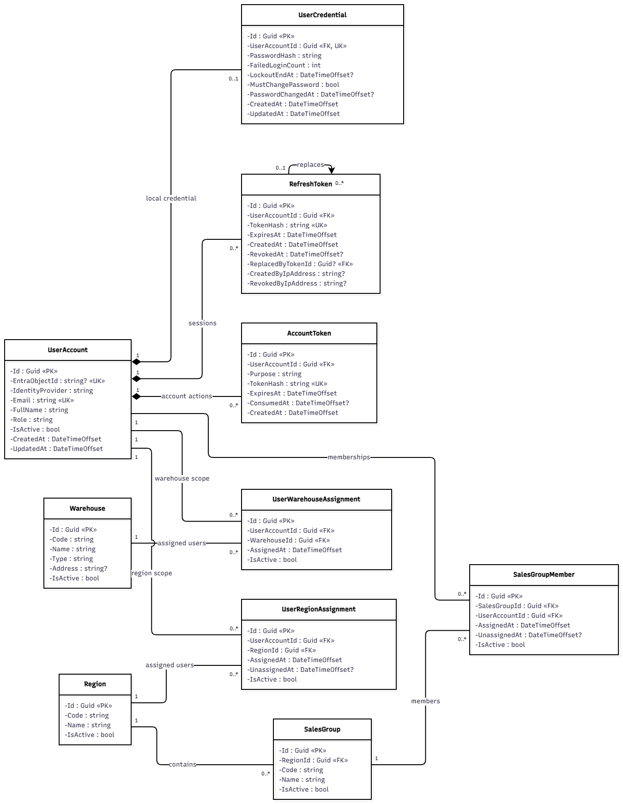
Figure 3.1.1 – Authentication & User Account Class Diagram

3.1.2 Sequence Diagram: User Authentication (System Account / Microsoft Entra ID Account)
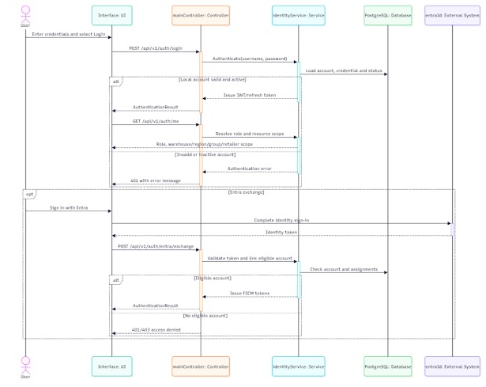
Figure 3.1.2 – User Authentication Sequence Diagram

3.1.3 Sequence Diagram: Manage User Accounts
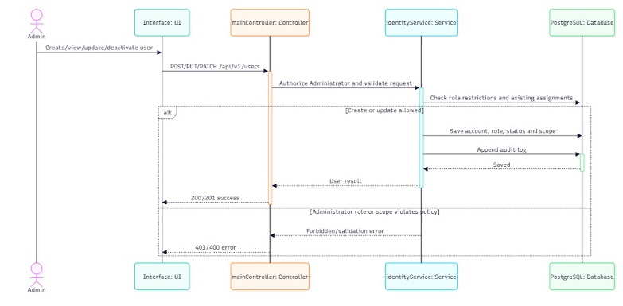
Figure 3.1.3 – Manage User Accounts Sequence Diagram

3.1.4 Transaction, Idempotency, Concurrency and Exception Handling
Authentication writes are small and frequent; the key risks are lost updates on the failed-login counter, double use of a refresh token and account changes racing with active sessions. Common conventions TX/ID/CC/EX are defined in Table 3.0; the tables below state the design of each function.
3.1.4.1 User Authentication (System Account / Google Account) (Figure 3.1.2)
Aspect | Design
Transaction boundary | Credential verification is a read. One short transaction then records the outcome: on failure it increments the failed-login counter and sets LockoutUntil on USER_CREDENTIAL; on success it resets the counter, inserts a hashed REFRESH_TOKEN and an AUDIT_LOG entry. Entra ID token and tenant validation happen before the transaction (TX-3); the first successful match stores the Entra object ID in the same transaction. Refresh rotates the token (revoke old + insert successor) in one transaction. Retailer first login: OTP issue writes a hashed ACCOUNT_TOKEN and an outbox SMS message; OTP verification, password change, token consumption and revocation of earlier refresh tokens commit together.
Idempotency | Login attempts are deliberately not idempotent: every attempt counts toward the 5-failure lockout (NFR-S03). Refresh: presenting a token already rotated within a 30-second grace window returns the same successor (double-tab or retry); outside the window the whole token family is revoked as reuse. OTP and password-reset tokens have ConsumedAt set once; a second use returns 409. Entra linking is protected by a unique index on the Entra object ID, so a repeated link is a no-op.
Concurrency control | The failed-login counter is updated atomically (UPDATE … SET FailedCount = FailedCount + 1 … RETURNING) so parallel attempts cannot lose increments. Refresh rotation uses a conditional UPDATE … WHERE RevokedAt IS NULL; of two concurrent refreshes only one wins and the other receives the grace result. Deactivation or password change updates the account SecurityStamp, which is checked on each request, so revocation takes effect at the next call (NFR-S04).
Exception handling | Wrong credentials → 401 MSG004 with a generic message (no account enumeration); inactive account → 403 MSG005; locked account → 401 MSG004 with remaining lock time; expired session → 401 MSG007. Foreign tenant or invalid Entra token → 401 and logged; Entra identity without an Active staff account → 403 MSG006 and nothing is created. Entra ID unavailable → 503 for Microsoft sign-in only; system-account login is unaffected. SMS failure → the OTP stays valid and can be resent after 60 s.
Table 3.1.4.1 – Transaction, idempotency, concurrency and exception design: User Authentication (System Account / Google Account)
3.1.4.2 Manage User Accounts (Figure 3.1.3)
Aspect | Design
Transaction boundary | Create: USER_ACCOUNT, USER_CREDENTIAL (no password yet, activation token), the scope assignments (USER_WAREHOUSE_ASSIGNMENT, SALES_GROUP_MEMBER or USER_REGION_ASSIGNMENT), AUDIT_LOG and the outbox activation message are committed in one transaction. Update and Deactivate change the account, end-date replaced assignments, revoke all refresh tokens and write the audit entry in one transaction.
Idempotency | ID-1 on create/update/deactivate. A case-insensitive unique index on e-mail and on phone prevents a second account if a different key is used (MSG003). Deactivating an already Locked account returns the current state (ID-3).
Concurrency control | CC-1 on USER_ACCOUNT. Assignment changes end the current active row conditionally and insert the new one; a partial unique index guarantees exactly one active sales group per Sales account (BR-77). Deactivation bumps the SecurityStamp so concurrent sessions are cut at their next request.
Exception handling | Non-Administrator caller → 403 MSG006; Administrator or Retailer role requested → 403 MSG008; missing required scope → 400 MSG001; delete of an account referenced by any business record → 409 with Deactivate offered (BR-77); stale version → 409 MSG021. Activation SMS/e-mail failure is retried by the outbox; the account stays Pending activation.
Table 3.1.4.2 – Transaction, idempotency, concurrency and exception design: Manage User Accounts

3.2 Retailer Registration & Assessment

3.2.1 Class Diagram
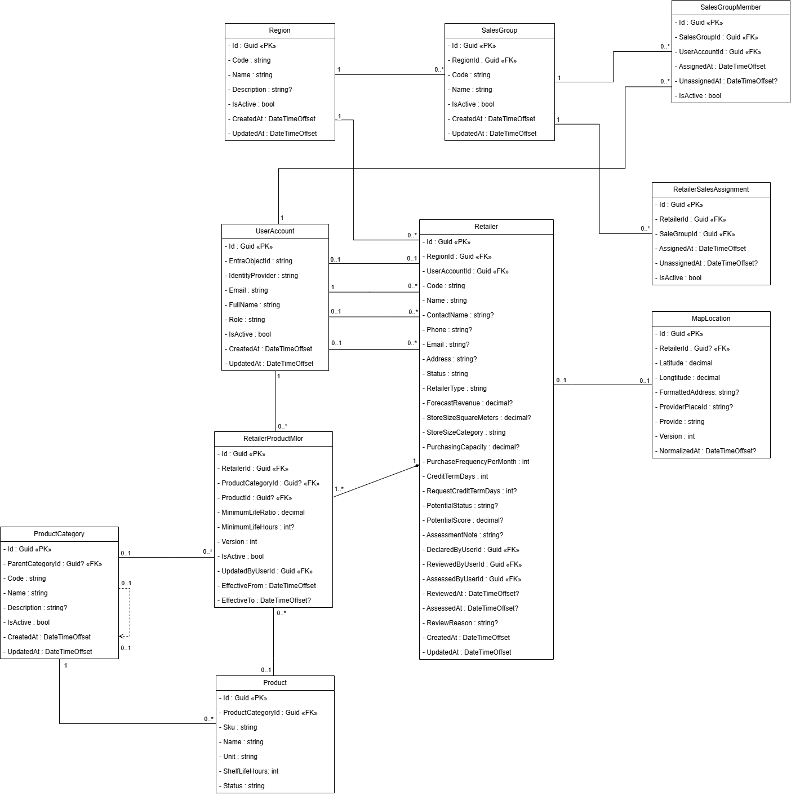
Figure 3.2.1 – Retailer Registration & Assessment Class Diagram

3.2.2 Sequence Diagram: Register Retailer and Collect Assessment
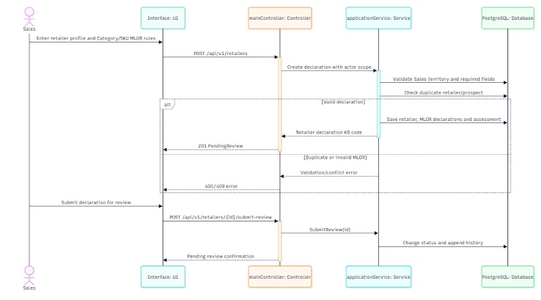
Figure 3.2.2 – Register Retailer and Collect Assessment Sequence Diagram

3.2.3 Sequence Diagram: Review Retailer Registration and Assessment
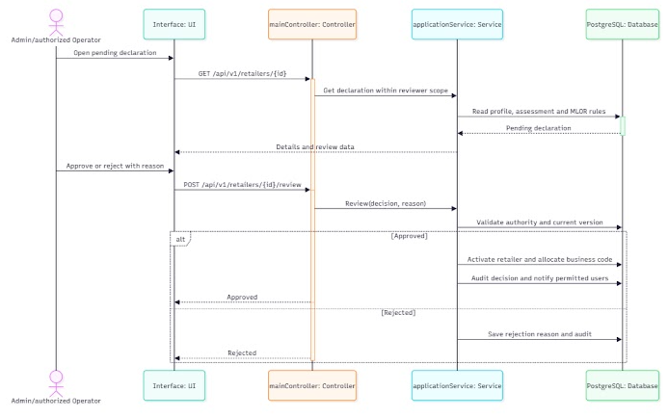
Figure 3.2.3 – Review Retailer Registration and Assessment Sequence Diagram

3.2.4 Sequence Diagram: Manage Retailer Profile
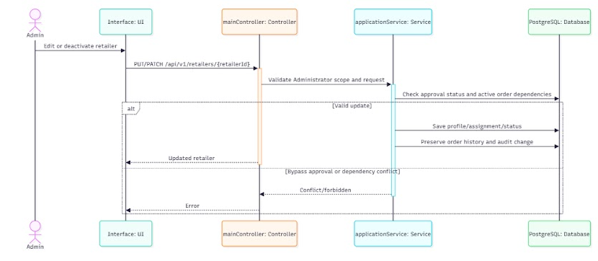
Figure 3.2.4 – Manage Retailer Profile Sequence Diagram

3.2.5 Transaction, Idempotency, Concurrency and Exception Handling
Retailer onboarding must never create two retailers for the same store, two retailer codes for one approval, or an order for a retailer that is being deactivated. Common conventions TX/ID/CC/EX are defined in Table 3.0; the tables below state the design of each function.
3.2.5.1 Register Retailer and Collect Assessment (Figure 3.2.2)
Aspect | Design
Transaction boundary | Storefront photos are uploaded to the staging container first (TX-3). One transaction then inserts RETAILER in Pending approval with the assessment fields and suggested potential class, its MAP_LOCATION, the proposed RETAILER_PRODUCT_MLOR rows, RETAILER_ATTACHMENT rows, AUDIT_LOG and the outbox notification to the Administrator (MSG010).
Idempotency | ID-1 with the key generated when Sales opens the form. Business duplicate rule: same phone, or same normalized name + address, among Pending or Active retailers. If the duplicate was created by the same request hash the existing record is returned ("repeated submission returns the existing record"); otherwise 409 MSG009.
Concurrency control | Insert-only. A race between two Sales users declaring the same store is resolved by partial unique indexes on the normalized phone and on (normalized name, normalized address) WHERE Status IN (Pending, Active); the second commit fails with a unique violation mapped to MSG009.
Exception handling | Missing field or photo → 400 MSG001; MLOR ratio not strictly between 0 and 1 → 400 MSG002; sales group outside the caller's scope → 403 MSG006; invalid file → 400 MSG049; Blob Storage unavailable → 503 before anything is saved, and the Mobile App keeps the filled form.
Table 3.2.5.1 – Transaction, idempotency, concurrency and exception design: Register Retailer and Collect Assessment
3.2.5.2 Review Retailer Registration and Assessment (Figure 3.2.3)
Aspect | Design
Transaction boundary | Approve: one transaction locks the RETAILER row, issues the 8-digit retailer code (CC-5), sets Active with the official class, priority, sales group and payment term, makes the proposed MLOR rows official, creates the Retailer USER_ACCOUNT, RETAILER_SALES_ASSIGNMENT and RETAILER_LOYALTY account, and writes AUDIT_LOG plus outbox messages (activation SMS, MSG011 to Sales). Reject sets Rejected with the reason, audit and outbox notification (MSG012). Operator pre-check notes are saved in their own transaction and do not change status.
Idempotency | ID-1 plus a conditional transition Pending → Active (ID-3). A second Approve returns the same retailer code and creates no second account (AC-3.3.2-05); unique indexes on RetailerCode and on the Retailer account phone back this up.
Concurrency control | SELECT … FOR UPDATE on RETAILER together with CC-1: the Administrator decides on the version that was displayed. If another Administrator decided first, the second request sees a changed status and receives the existing decision (same decision) or 409 (opposite decision).
Exception handling | Operator calling Approve/Reject → 403 MSG006; Reject without reason → 400 MSG001; already decided → 409 with the current decision; stale version → 409 MSG021. SMS failure does not roll back the approval; the outbox retries it.
Table 3.2.5.2 – Transaction, idempotency, concurrency and exception design: Review Retailer Registration and Assessment
3.2.5.3 Manage Retailer Profile (Figure 3.2.4)
Aspect | Design
Transaction boundary | Profile, coverage and payment-term changes are one transaction each, together with AUDIT_LOG. MLOR changes insert a new effective-dated RETAILER_PRODUCT_MLOR version and payment-term changes insert a RETAILER_PAYMENT_TERM_VERSION row instead of updating the old value, so existing orders keep their snapshots (BR-57). Deactivate re-checks blocking dependencies, sets Locked and revokes the Retailer's refresh tokens in the same transaction.
Idempotency | ID-1 on every change. Effective-dated versions are unique on (retailer, scope, target, effective from), so a replay cannot create a second version. Deactivating a Locked retailer is a no-op (ID-3).
Concurrency control | CC-1 for profile edits. Deactivation takes FOR UPDATE on RETAILER while order creation takes FOR KEY SHARE on the same row (CC-3); the two are therefore serialized and a retailer cannot be deactivated while an order for it is being accepted, nor receive an order after its deactivation commits.
Exception handling | Delete of a retailer with history → 409 offering Deactivate; deactivation with an open order, outstanding balance or pending refund → 409 listing the blocking records; Sales/Sales Manager outside scope → 403 MSG006; stale version → 409 MSG021; invalid term or ratio → 400 MSG002.
Table 3.2.5.3 – Transaction, idempotency, concurrency and exception design: Manage Retailer Profile

3.3 Product & Category Management

3.3.1 Class Diagram
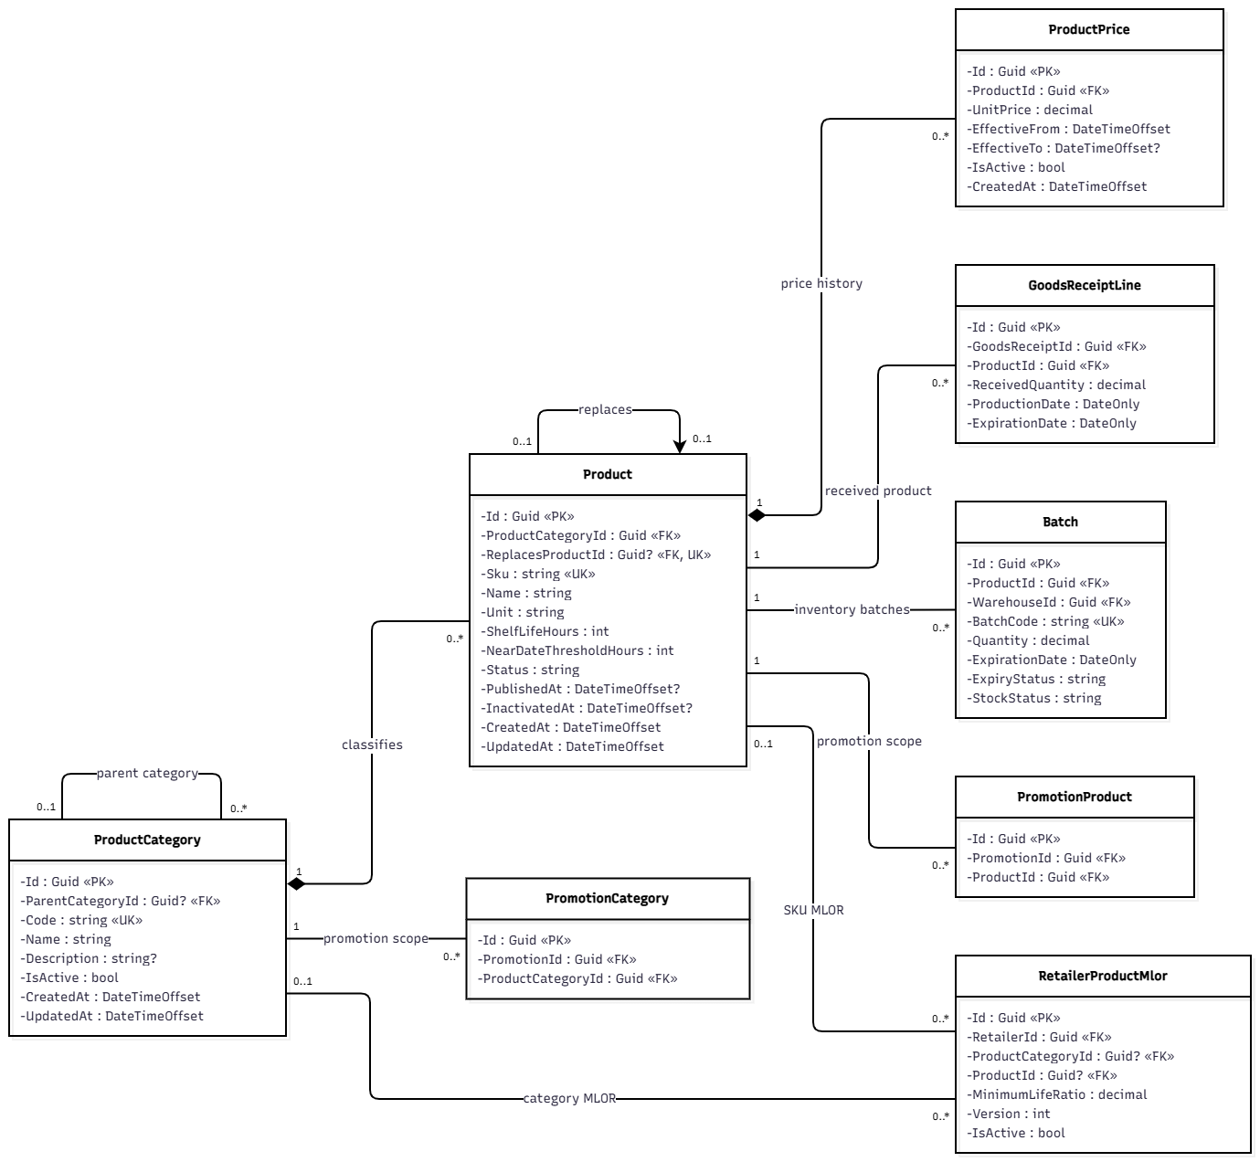
Figure 3.3.1 – Product & Category Management Class Diagram

3.3.2 Sequence Diagram: Manage Product Category Tree
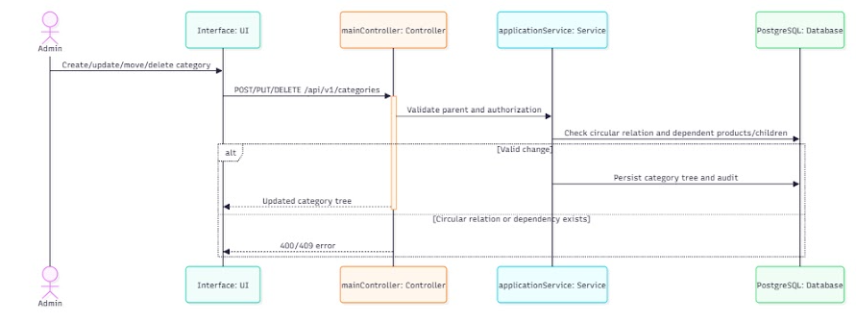
Figure 3.3.2 – Manage Product Category Tree Sequence Diagram

3.3.3 Sequence Diagram: Create and Publish Product
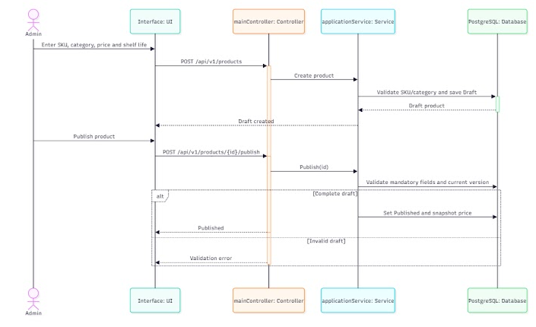
Figure 3.3.3 – Create and Publish Product Sequence Diagram

3.3.4 Sequence Diagram: View Product Catalog and Best-Selling Products
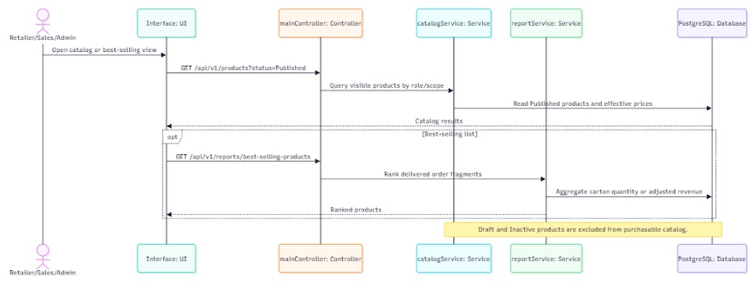
Figure 3.3.4 – View Product Catalog and Best-Selling Products Sequence Diagram

3.3.5 State Machine Diagram: Product
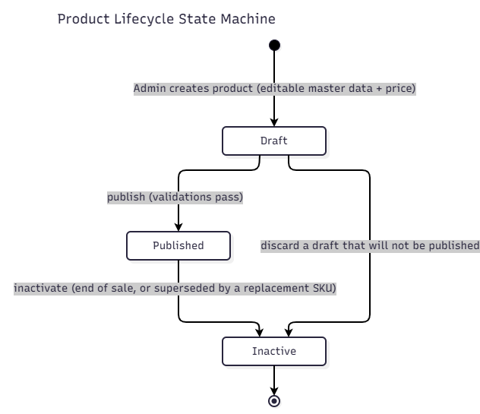
Figure 3.3.5 – Product State Machine Diagram

3.3.6 Transaction, Idempotency, Concurrency and Exception Handling
Catalog changes are rare but structural: the category tree must stay acyclic and at most 3 levels deep, and a Published product must never change in place (BR-07). Common conventions TX/ID/CC/EX are defined in Table 3.0; the tables below state the design of each function.
3.3.6.1 Manage Product Category Tree (Figure 3.3.2)
Aspect | Design
Transaction boundary | Each create, rename, move, deactivate or delete is one transaction with its AUDIT_LOG row. A move validates the new parent, recomputes the level of the moved subtree and stores it in the same transaction. Delete checks all dependencies (children, products including Inactive, promotions, discount tiers, retailer MLOR) in the same transaction.
Idempotency | ID-1. Deactivating an already inactive category, or repeating a move to the same parent, returns the current tree state (ID-3).
Concurrency control | Structural changes take a transaction-scoped advisory lock on the category tree, so two concurrent moves cannot each pass the cycle check and together create a cycle. Foreign keys with ON DELETE RESTRICT are the final guard against deleting a category that gained a dependent after the check. Name edits use CC-1.
Exception handling | Cycle or depth > 3 → 422; delete with dependents → 409 MSG015 with Deactivate offered; product assigned to a non-leaf category → 422; duplicate name under the same parent → 409 MSG003; stale version → 409 MSG021.
Table 3.3.6.1 – Transaction, idempotency, concurrency and exception design: Manage Product Category Tree
3.3.6.2 Create and Publish Product (Figure 3.3.3)
Aspect | Design
Transaction boundary | Create Draft inserts PRODUCT (SKU from CC-5), PRODUCT_PRICE and audit in one transaction. Publish validates all mandatory fields and sets Published in one transaction. Create new version inserts a Draft with ReplacesProductId; publishing that successor and setting the predecessor Inactive happen in the same transaction, so the catalog never shows both or neither.
Idempotency | ID-1. Publish is a conditional transition WHERE Status = 'Draft'; publishing a Published product returns it unchanged. A unique index on ReplacesProductId (for non-Inactive rows) prevents two successors of one product.
Concurrency control | CC-1 on PRODUCT: an Administrator editing a Draft while another publishes it receives 409 MSG021. Goods receipts and order creation read product status with FOR KEY SHARE, so a product cannot become Inactive half-way through those transactions.
Exception handling | Edit of a locked field on a Published product → 409 MSG013; missing mandatory field → 400 MSG001; non-leaf category → 422; duplicate SKU → 409 MSG003; MLOR ratio outside (0, 1) → 400 MSG002.
Table 3.3.6.2 – Transaction, idempotency, concurrency and exception design: Create and Publish Product
3.3.6.3 View Product Catalog and Best-Selling Products (Figure 3.3.4)
Aspect | Design
Transaction boundary | Read-only (TX-4). The best-selling ranking (Delivered/Completed quantities net of approved adjustments) is computed in one READ ONLY query over the viewer's scope; no write transaction is opened.
Idempotency | GET requests are safe and repeatable. Responses carry an ETag derived from scope, period and the latest relevant data change, so the Portal and Mobile App can revalidate cached catalog pages cheaply.
Concurrency control | No locks. MVCC gives each query a consistent snapshot; the ranking may lag a commit by at most the query time, which is acceptable for a report. The Mobile App catalog cache is refreshed in full and replaces the previous cache atomically in SQLite.
Exception handling | Out-of-scope filter → 403 MSG006; invalid period → 400 MSG002; query exceeding the timeout is cancelled and returns 503 (retryable); offline, the Mobile App shows the cached catalog with its age and a warning after 24 h (NFR-O01).
Table 3.3.6.3 – Transaction, idempotency, concurrency and exception design: View Product Catalog and Best-Selling Products

3.4 Promotion & Batch Discount Management

3.4.1 Class Diagram
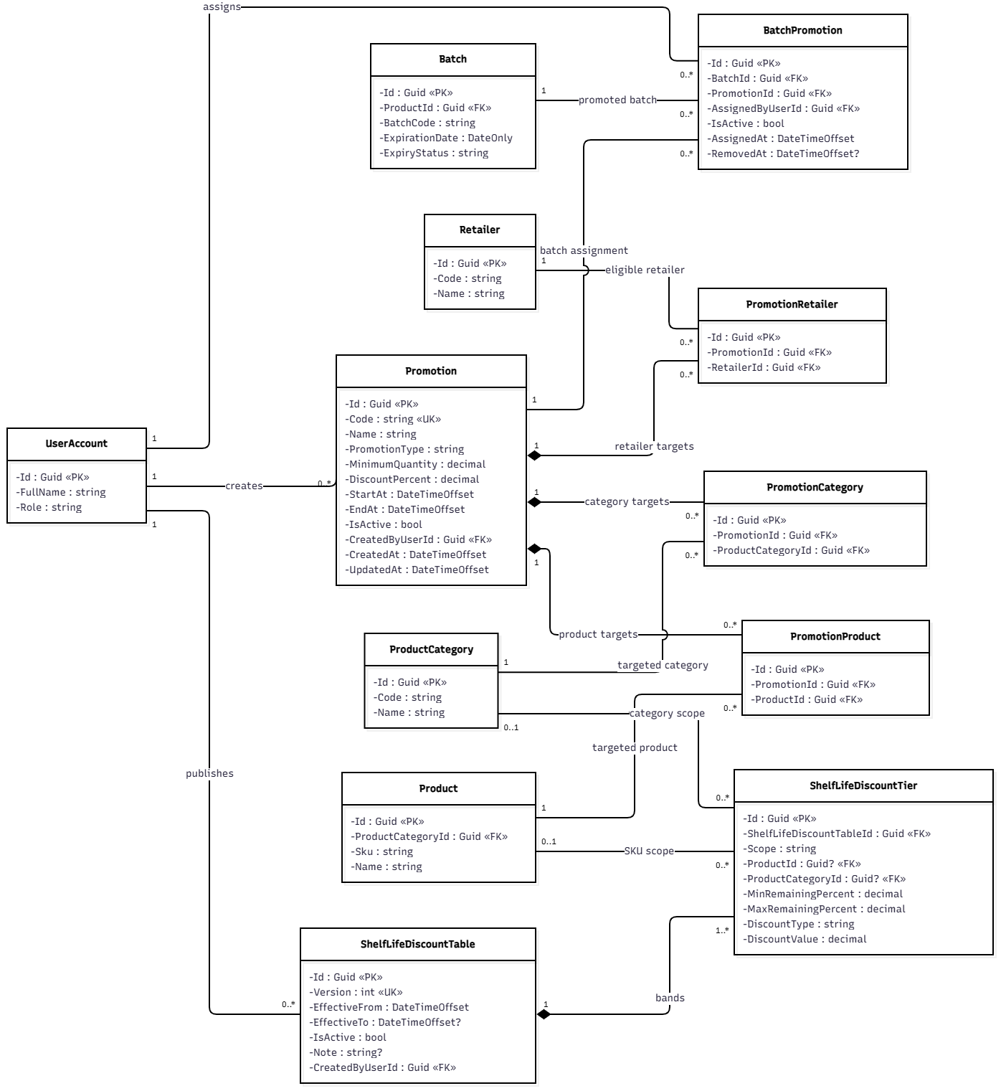
Figure 3.4.1 – Promotion & Batch Discount Management Class Diagram

3.4.2 Sequence Diagram: Manage Promotion Rules
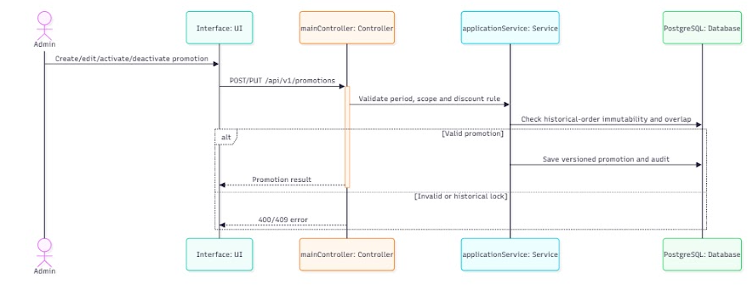
Figure 3.4.2 – Manage Promotion Rules Sequence Diagram

3.4.3 Sequence Diagram: Scan Near-Expiry Batches and Configure Shelf-Life Discount Rule
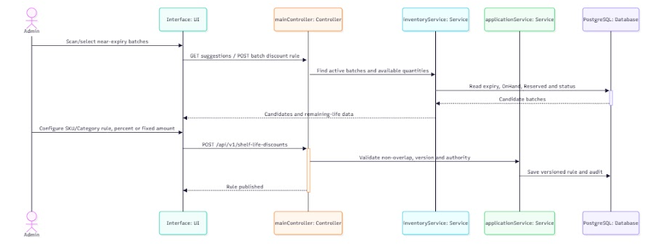
Figure 3.4.3 – Scan Near-Expiry Batches and Configure Shelf-Life Discount Rule Sequence Diagram

3.4.4 Transaction, Idempotency, Concurrency and Exception Handling
Ordinary promotion data are read by order pricing at server acceptance and copied into ORDER_PROMOTION, so edits never rewrite historical results (BR-19). The near-expiry scan of 3.4.3 only configures remaining-shelf-life discount tiers (designed in 3.14). Near-expiry offers with an accepted MLOR override are future scope; NEAR_EXPIRY_OFFER is not used. Common conventions TX/ID/CC/EX are defined in Table 3.0; the tables below state the design of each function.
3.4.4.1 Manage Promotion Rules (Figure 3.4.2)
Aspect | Design
Transaction boundary | Create/edit writes PROMOTION and its PROMOTION_PRODUCT / PROMOTION_CATEGORY / PROMOTION_RETAILER rows plus AUDIT_LOG in one transaction (the junction set is replaced as a whole). Pause and resume are separate single-row transactions.
Idempotency | ID-1; unique promotion code (KM-000). Pause on a paused promotion and resume on an active one are no-ops (ID-3).
Concurrency control | CC-1 on PROMOTION. Order pricing reads committed promotion data and copies the applied promotion into ORDER_PROMOTION, so a later edit or pause cannot change an accepted order; an order accepted in the same instant as a pause sees either the old or the new committed state, never a mixture.
Exception handling | Ordinary promotion discount must be a percentage strictly between 0 and 100 % → otherwise 400 MSG002 (fixed amounts are allowed only for shelf-life discount tiers, 3.14.5.1); end before start → 400 MSG002; delete of a promotion already used by an order → 409 with Pause offered; stale version → 409 MSG021.
Table 3.4.4.1 – Transaction, idempotency, concurrency and exception design: Manage Promotion Rules
3.4.4.2 Scan Near-Expiry Batches and Configure Shelf-Life Discount Rule (Figure 3.4.3)
Aspect | Design
Transaction boundary | The scan step is read-only (TX-4): candidate near-expiry batches, expiry, OnHand, Reserved and status are read without locks. Saving the SKU or Category rule (Percentage or FixedPerUnit) is the single transaction of 3.14.5.1. No offer, customer acceptance or MLOR override is created; NEAR_EXPIRY_OFFER stays unused (future scope).
Idempotency | Scan: safe GET. Save: ID-1 and unique rule code, as in 3.14.5.1.
Concurrency control | Scan: none (MVCC). Save: exclusion constraint on overlapping ranges and CC-1, as in 3.14.5.1. A batch that changes state between scan and save does not matter, because the rule is applied only at the next run pricing point after MLOR filtering.
Exception handling | As 3.14.5.1: overlapping range → 422; Percentage outside (0, 100 %) or FixedPerUnit ≤ 0 → 400 MSG002; non-Administrator → 403 MSG006. A discount never makes an ineligible batch eligible (BR-18).
Table 3.4.4.2 – Transaction, idempotency, concurrency and exception design: Scan Near-Expiry Batches and Configure Shelf-Life Discount Rule

3.5 Purchase Order & Offline Synchronization

3.5.1 Class Diagram
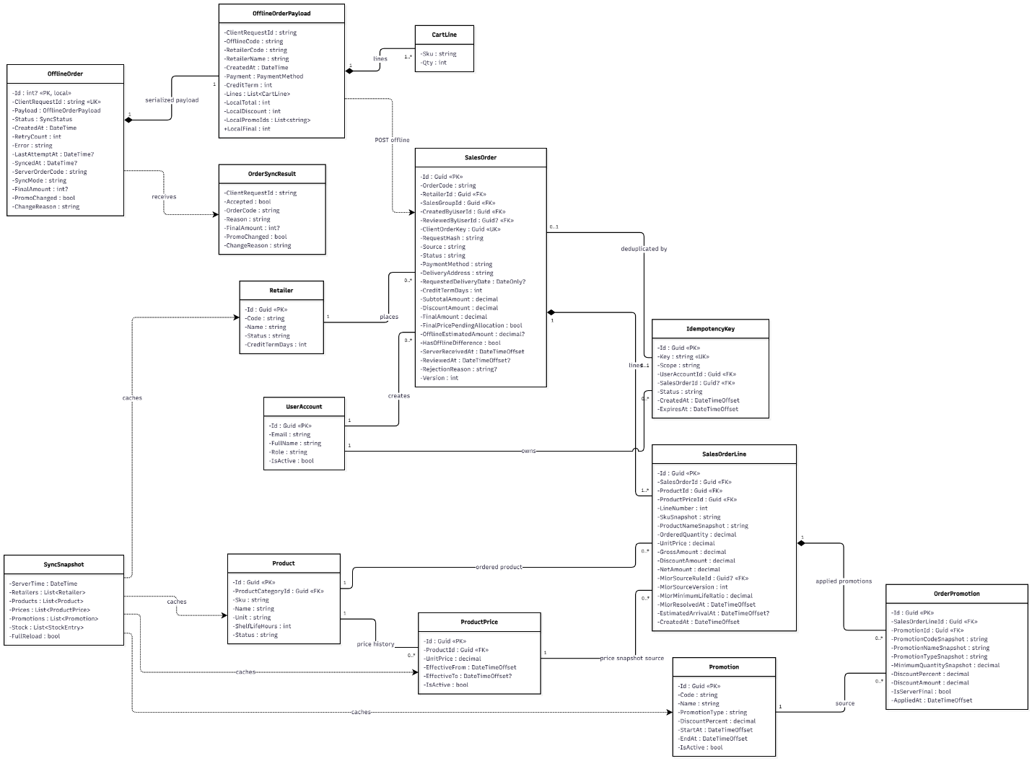
Figure 3.5.1 – Purchase Order & Offline Synchronization Class Diagram

3.5.2 Sequence Diagram: Create Purchase Order for Retailer
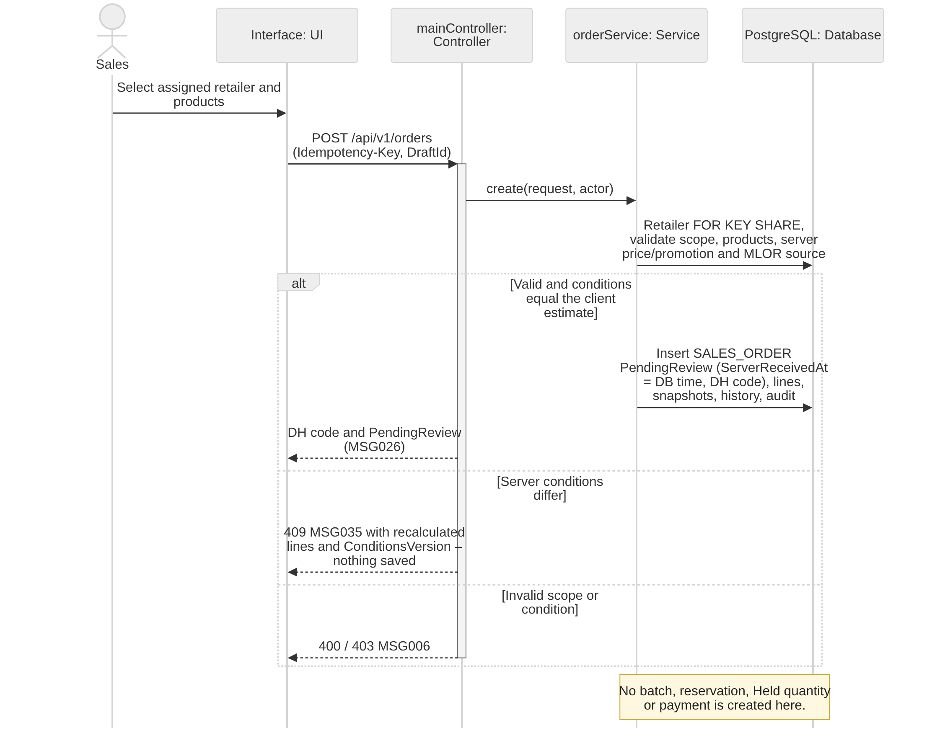
Figure 3.5.2 – Create Purchase Order for Retailer Sequence Diagram

3.5.3 Sequence Diagram: Synchronize Offline Purchase Orders
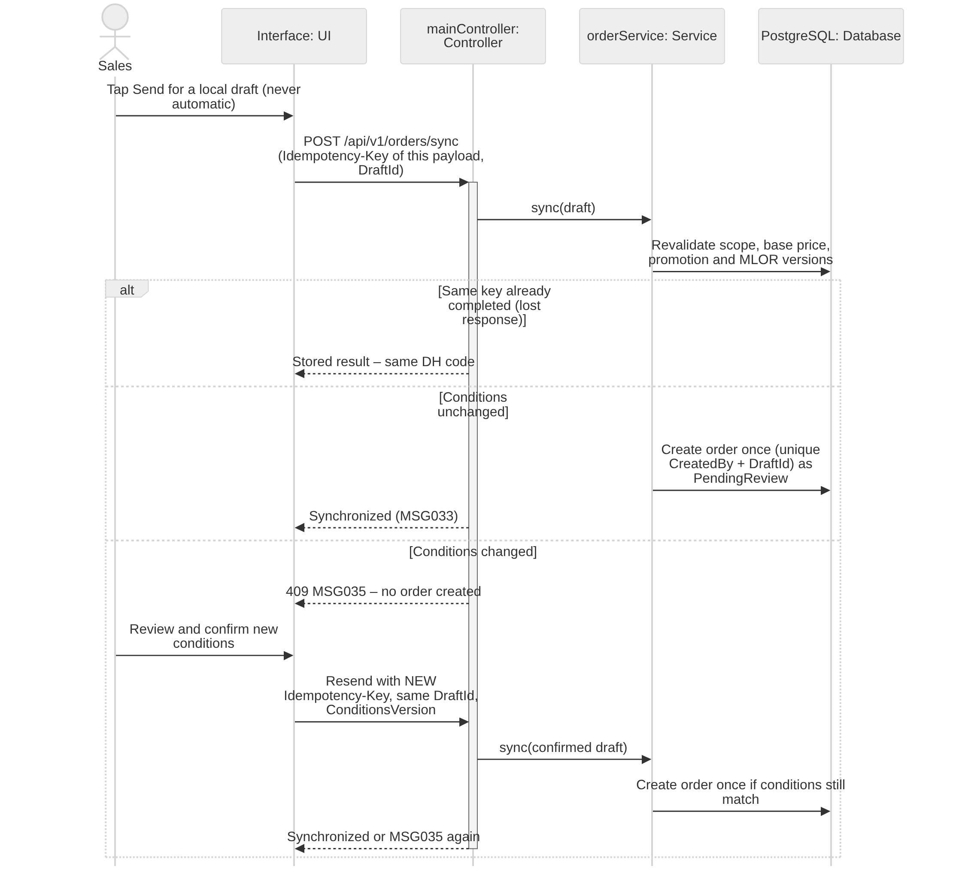
Figure 3.5.3 – Synchronize Offline Purchase Orders Sequence Diagram

3.5.4 Sequence Diagram: Process Purchase Order Request
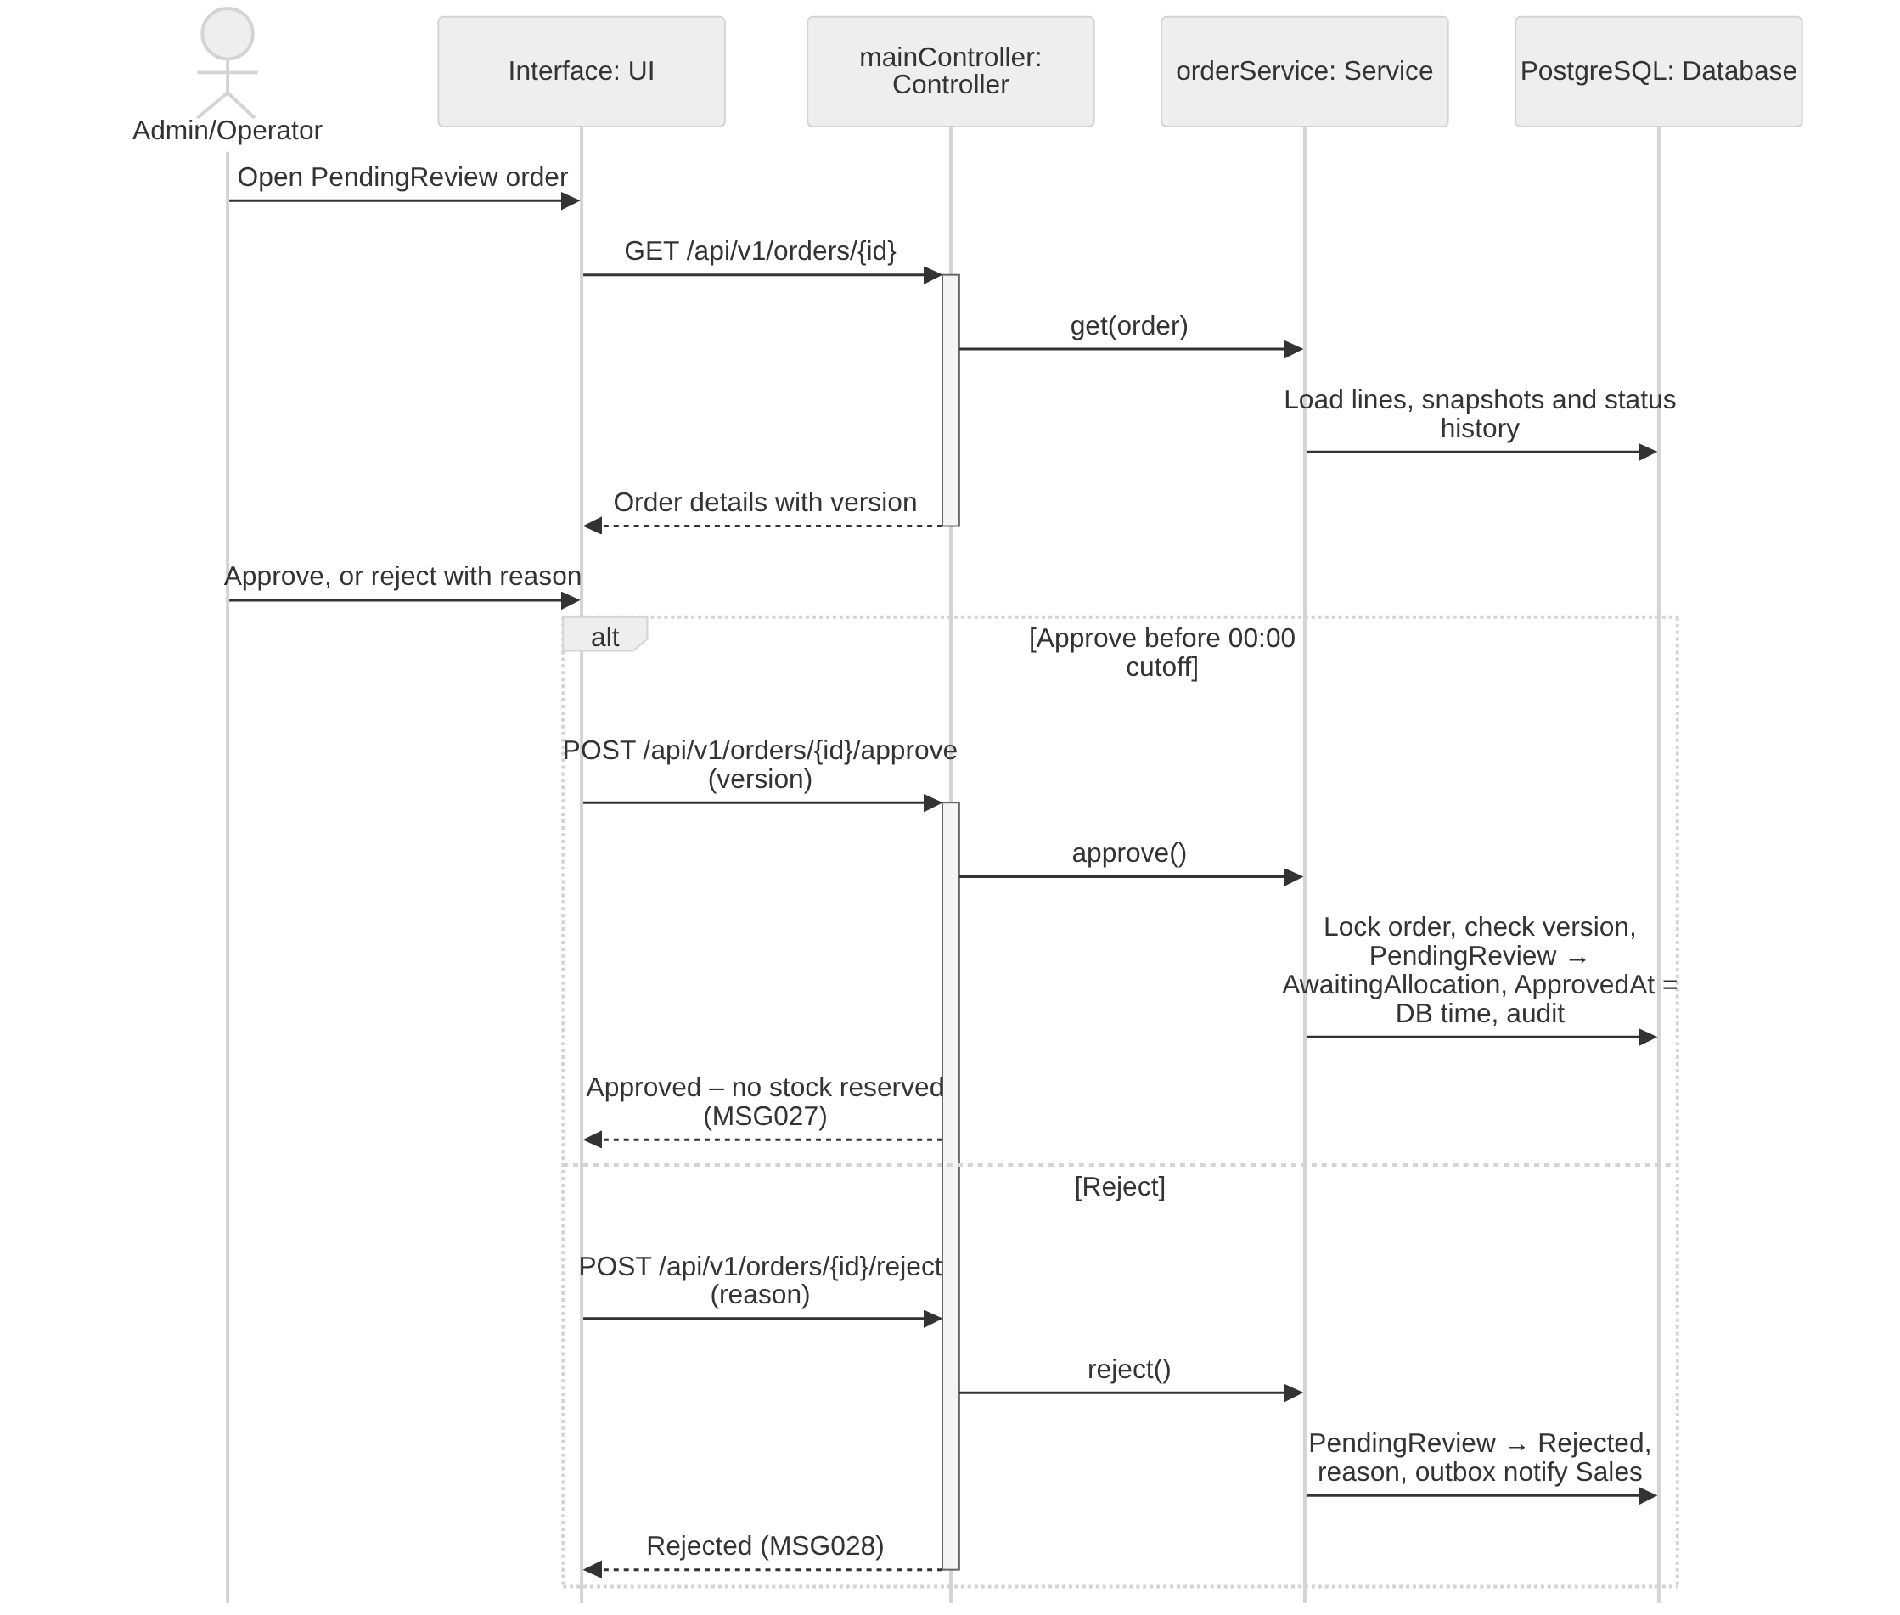
Figure 3.5.4 – Process Purchase Order Request Sequence Diagram

3.5.5 Sequence Diagram: Cancel Purchase Order with Evidence
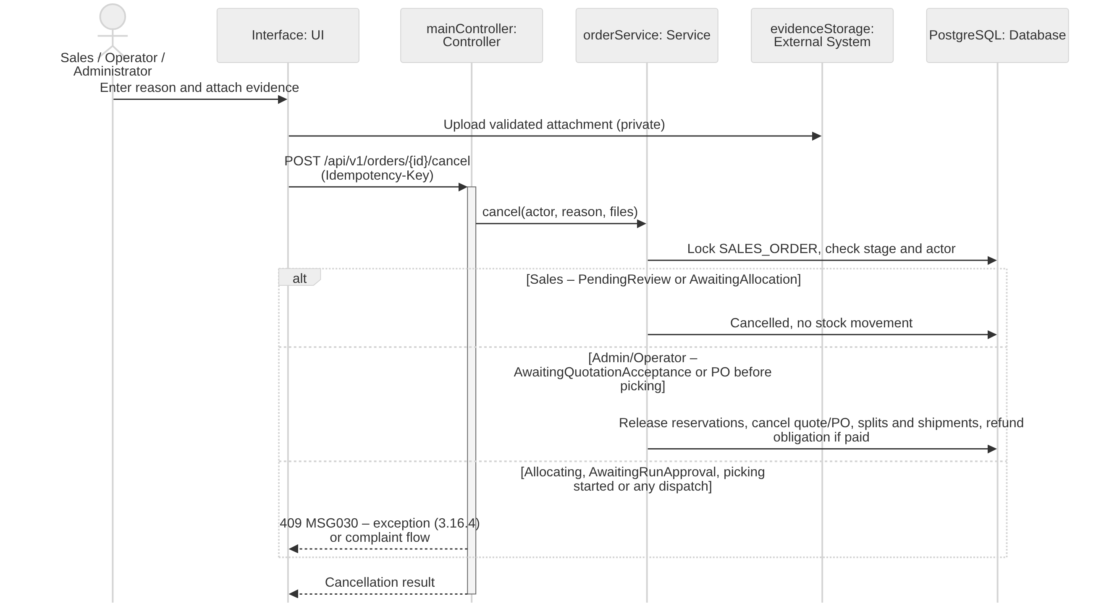
Figure 3.5.5 – Cancel Purchase Order with Evidence Sequence Diagram

3.5.6 Sequence Diagram: View Order Status and History
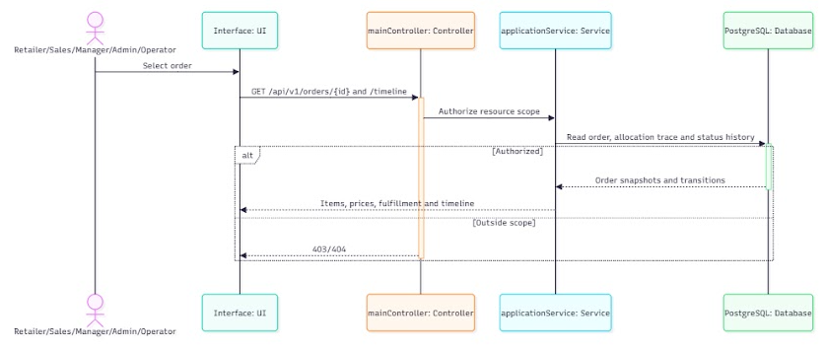
Figure 3.5.6 – View Order Status and History Sequence Diagram

3.5.7 State Machine Diagram: SalesOrder
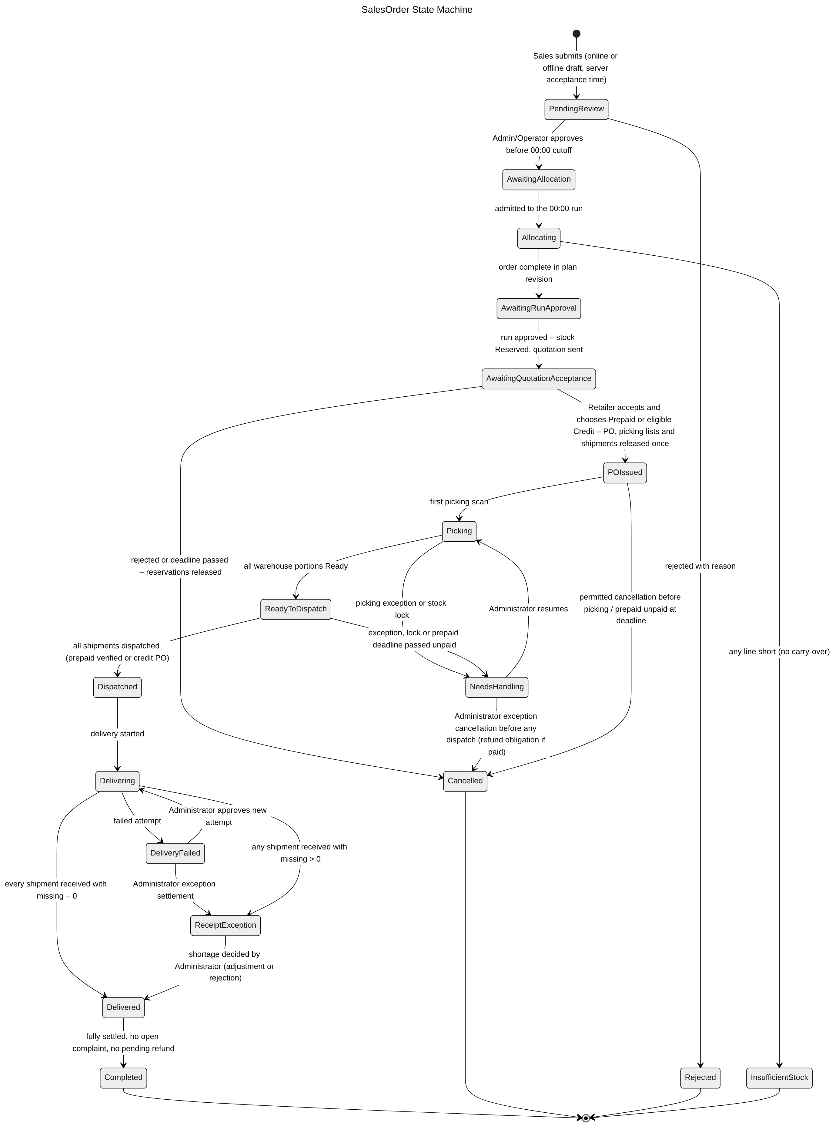
Figure 3.5.7 – SalesOrder State Machine Diagram

3.5.8 Transaction, Idempotency, Concurrency and Exception Handling
Orders are created online and from the offline queue, reviewed before cutoff and cancelled under stage rules. Order creation never touches stock (BR-22); priority is the database acceptance time (BR-24); repeated sends of one draft must create exactly one order (BR-23, NFR-O03). Common conventions TX/ID/CC/EX are defined in Table 3.0; the tables below state the design of each function.
3.5.8.1 Create Purchase Order for Retailer (Figure 3.5.2)
Aspect | Design
Transaction boundary | One transaction: read the retailer with FOR KEY SHARE and validate scope and status; recalculate prices and the best promotion on the server; resolve effective MLOR and its source; insert SALES_ORDER (Pending review) with ServerReceivedAt = transaction timestamp, SALES_ORDER_LINE, ORDER_PROMOTION (IsServerFinal), the input snapshots, ORDER_STATUS_HISTORY and AUDIT_LOG; issue the DH code (CC-5). No INVENTORY_BALANCE, reservation or payment row is written (BR-22).
Idempotency | Each send carries an Idempotency-Key for that exact payload (ID-2) and the DraftId of the order request (the same UUID the device uses offline, BR-23). A unique index on SALES_ORDER (CreatedByUserId, ClientDraftId) guarantees one order per draft: a technical retry with the same key returns the stored result; a confirmed or corrected payload is sent with a new key and the same DraftId, and if that draft already produced an order the server returns the existing DH code instead of creating another.
Concurrency control | Insert-only, so no optimistic token is needed. FOR KEY SHARE on RETAILER serializes with deactivation (3.2.4). ServerReceivedAt comes from the database clock inside the transaction, so priority is deterministic and independent of the device clock; ties are ordered by DH code.
Exception handling | Retailer outside area or not Active → 403 MSG006; missing/invalid line → 400 MSG001/MSG002. If server prices or promotions differ from the device estimate, nothing is saved and 409 MSG035 returns the recalculated lines with a ConditionsVersion; the key is closed with that result. After Sales confirms, the app sends the confirmed payload (ConditionsVersion included) with a NEW key and the same DraftId; the server creates the order only if the conditions are still those confirmed, otherwise it returns MSG035 again.
Table 3.5.8.1 – Transaction, idempotency, concurrency and exception design: Create Purchase Order for Retailer
3.5.8.2 Synchronize Offline Purchase Orders (Figure 3.5.3)
Aspect | Design
Transaction boundary | Server side: each draft is processed by the create use case above in its own transaction, so one failing draft never affects the others. Device side: the SQLite queue changes a draft from Pending sync → Sending before the call and to Accepted / Conflict / Rejected after the response, each in a local SQLite transaction, so an app kill never loses or duplicates a draft (NFR-O02).
Idempotency | The draft UUID is the DraftId and is kept for 7 days on the server; each send of a given payload uses its own Idempotency-Key, stored in the SQLite queue with the draft. A lost response followed by a manual retry reuses the same key and returns the same DH code (AC-3.6.2-02). After an MSG035 confirmation the draft is re-sent with a new key and the same DraftId, and still produces at most one order. Drafts older than 7 days are flagged Stale and must be refreshed before sending (NFR-O05).
Concurrency control | Drafts are sent sequentially in creation order, one request in flight per device, only when Sales taps Send (BR-23). The server acceptance time, not the device time, sets priority (BR-24). Changed price, promotion, MLOR or retailer status between cache and send is detected by comparing the cached versions and returns MSG035 instead of silently accepting new conditions (NFR-O04).
Exception handling | Network failure or timeout → draft stays Pending sync, MSG034, no accepted state shown, retry with the same key; 409 MSG035 → Conflict, Sales reviews and confirms, the confirmed payload goes out with a new key and the same DraftId; 403 (retailer moved out of area) → Rejected with reason, kept locally and never deleted automatically; 401 → token refresh then resend with the same key; 5xx → manual retry with the same key.
Table 3.5.8.2 – Transaction, idempotency, concurrency and exception design: Synchronize Offline Purchase Orders
3.5.8.3 Process Purchase Order Request (Figure 3.5.4)
Aspect | Design
Transaction boundary | Approve or Reject is one transaction: conditional transition Pending review → Awaiting allocation (ApprovedAt = transaction timestamp) or → Rejected with reason, ORDER_STATUS_HISTORY entry for the review stage, AUDIT_LOG and outbox notification to Sales. No stock or payment row is touched.
Idempotency | ID-1 plus ID-3: a second Approve returns Awaiting allocation unchanged; Approve after Reject (or the reverse) returns 409.
Concurrency control | SELECT … FOR UPDATE on SALES_ORDER with CC-1 on the version shown to the reviewer. The 00:00 ICT consolidation for business date D admits only orders whose committed ServerReceivedAt and ApprovedAt are before 00:00 of D, so an approval committing at 00:00:00 or later waits for the next run and there is no race at the boundary.
Exception handling | Reject without reason → 400 MSG001; order cancelled, already decided or locked by a running run → 409 MSG030; outside caller authority → 403 MSG006; stale version → 409 MSG021.
Table 3.5.8.3 – Transaction, idempotency, concurrency and exception design: Process Purchase Order Request
3.5.8.4 Cancel Purchase Order with Evidence (Figure 3.5.5)
Aspect | Design
Transaction boundary | Evidence is uploaded first (TX-3). One transaction then locks SALES_ORDER and checks the stage. Before run inclusion: status Cancelled, attachments, history, audit. After reservation and before picking: additionally move every RESERVATION in status Reserved to Released, decrease Reserved on the locked INVENTORY_BALANCE rows (CC-2) with INVENTORY_TRANSACTION ReserveRelease, cancel the quotation, remove the order's not-started picking splits and shipments, and create a Pending MANUAL_REFUND if money was received (BR-66). Notifications go through the outbox.
Idempotency | ID-1; the transition to Cancelled is conditional (ID-3). Reservation release uses WHERE Status = 'Reserved', so stock is released once. A unique index on MANUAL_REFUND (SalesOrderId, Source = Cancellation) prevents a second refund obligation.
Concurrency control | The order row lock (CC-3) serializes cancellation with the run admission (which locks the same rows), with picking start (which sets Picking under the same lock) and with dispatch. Stock rows are then locked in BatchId order.
Exception handling | Missing reason/evidence → 400 MSG029; invalid file → 400 MSG049; stage not allowed (Allocating, Awaiting run approval, picking started) → 409 MSG030; any shipment dispatched → 409 directing to the complaint workflow (BR-26); Blob Storage unavailable → 503, nothing saved.
Table 3.5.8.4 – Transaction, idempotency, concurrency and exception design: Cancel Purchase Order with Evidence
3.5.8.5 View Order Status and History (Figure 3.5.6)
Aspect | Design
Transaction boundary | Read-only (TX-4). Order, lines, prices after discount and status timeline are loaded in one READ ONLY transaction so the header status and the timeline cannot disagree.
Idempotency | Safe GET with ETag; scope filtering is part of the query, not a post-filter.
Concurrency control | No locks; MVCC snapshot. The Mobile App caches the last result and labels it with its age when offline.
Exception handling | Order outside the caller's scope → 403 MSG006 (AC-3.6.5-01); unknown id → 404; invalid filter → 400 MSG002.
Table 3.5.8.5 – Transaction, idempotency, concurrency and exception design: View Order Status and History

3.6 FEFO–MLOR Allocation & Availability

3.6.1 Class Diagram
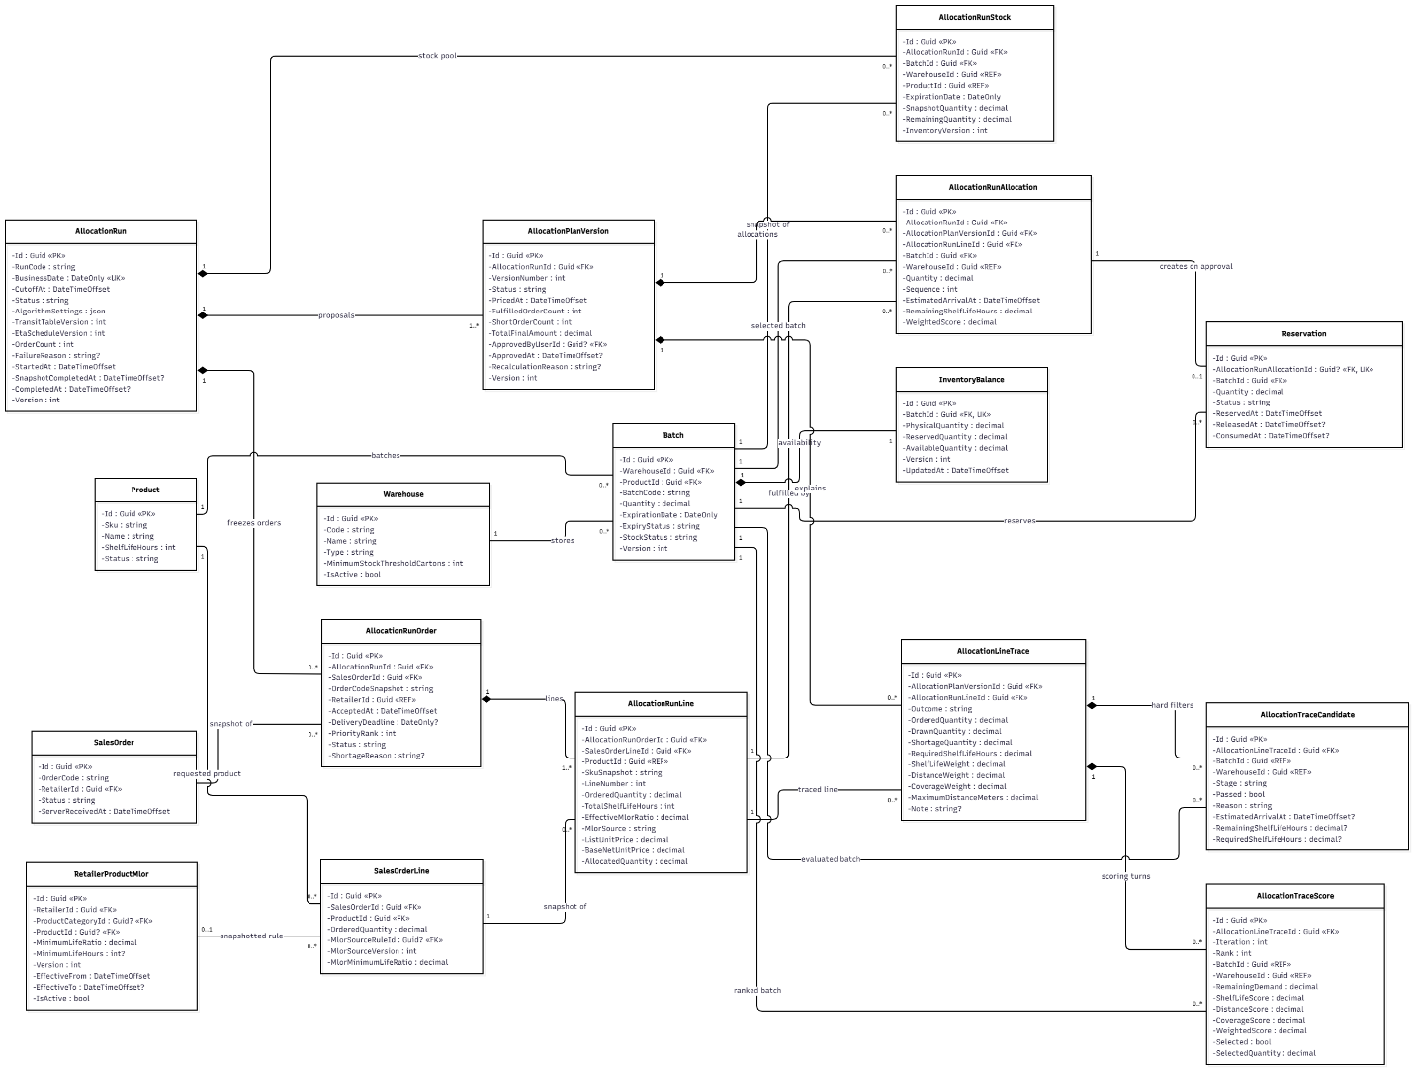
Figure 3.6.1 – FEFO–MLOR Allocation & Availability Class Diagram

3.6.2 Sequence Diagram: Allocate Inventory across Warehouses (including Receipt-Time Estimation)
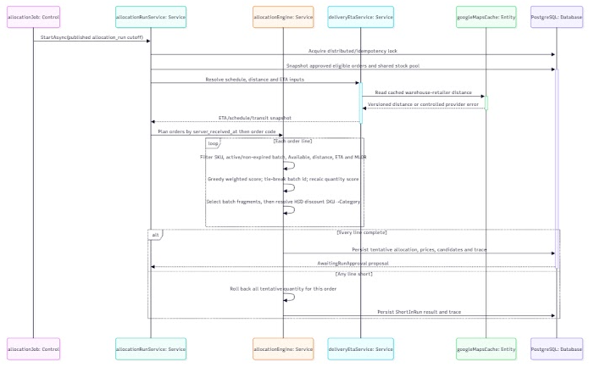
Figure 3.6.2 – Allocate Inventory across Warehouses Sequence Diagram

3.6.3 Sequence Diagram: Revalidate and Commit Stock Reservations
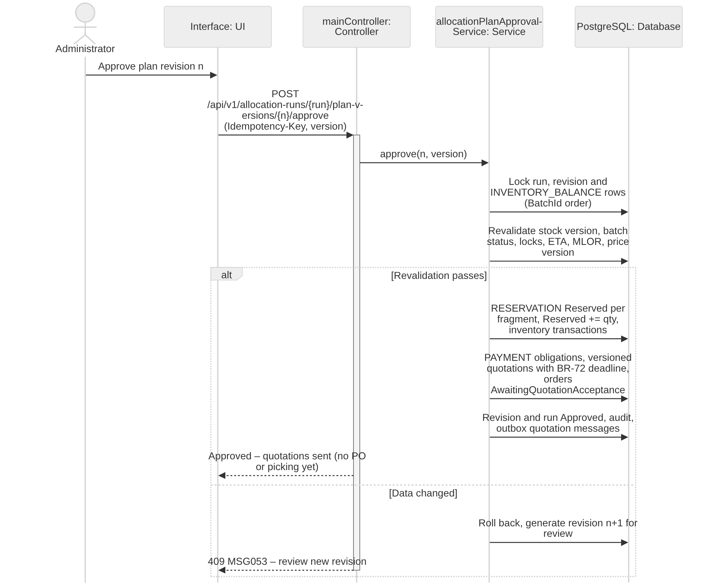
Figure 3.6.3 – Revalidate and Commit Stock Reservations Sequence Diagram

3.6.4 State Machine Diagram: AllocationRun
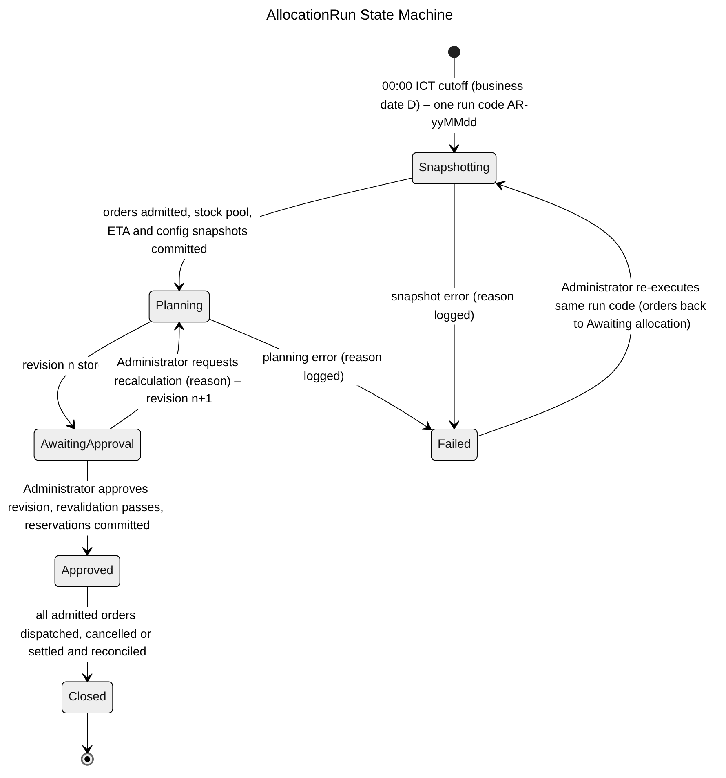
Figure 3.6.4 – AllocationRun State Machine Diagram

3.6.5 State Machine Diagram: AllocationPlanVersion
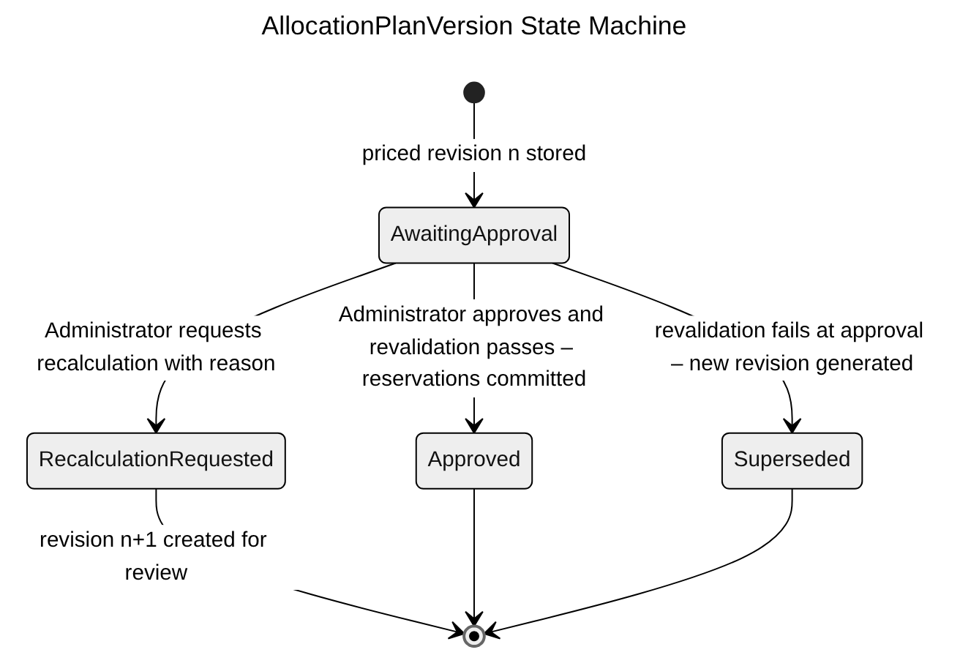
Figure 3.6.5 – AllocationPlanVersion State Machine Diagram

3.6.6 State Machine Diagram: AllocationRunOrder
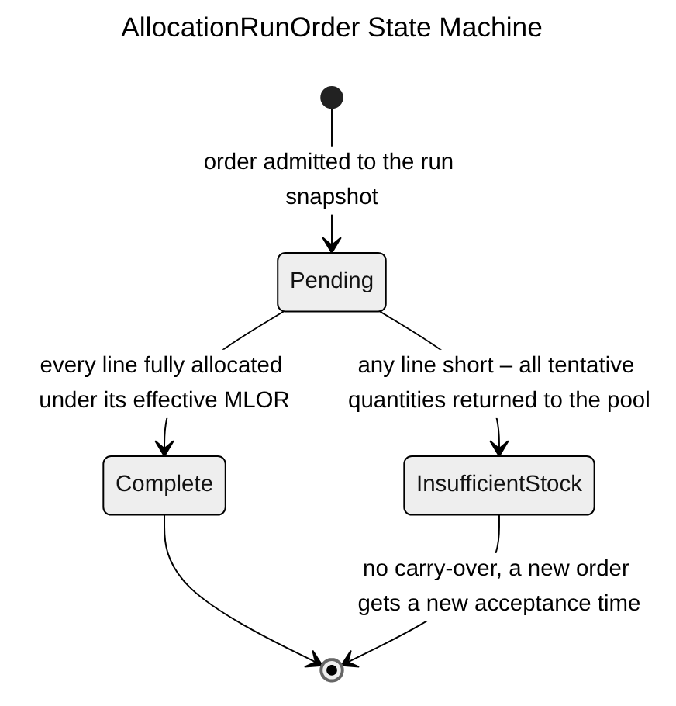
Figure 3.6.6 – AllocationRunOrder State Machine Diagram

3.6.7 State Machine Diagram: Reservation
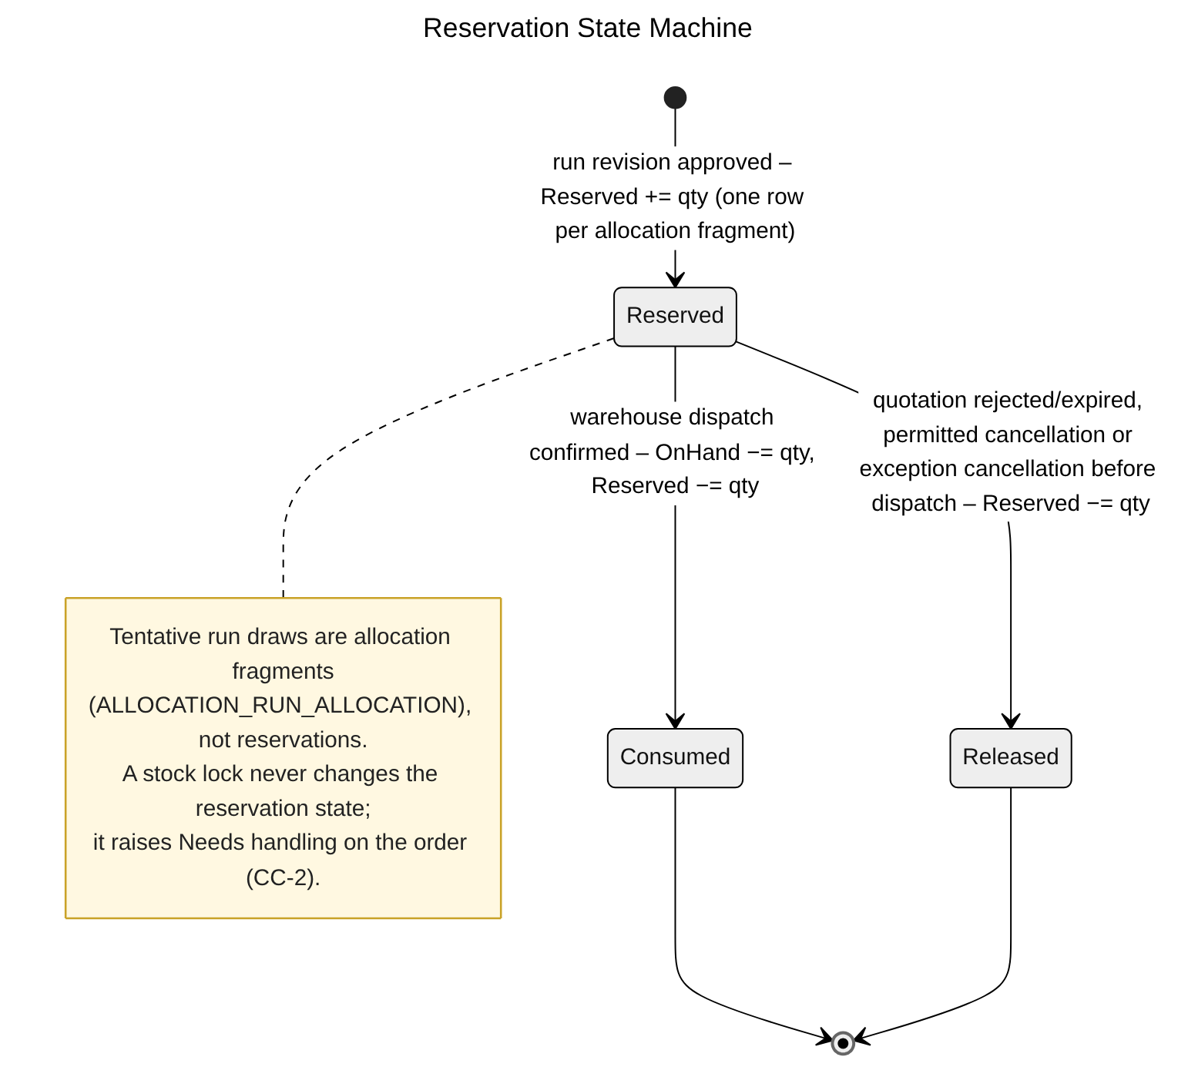
Figure 3.6.7 – Reservation State Machine Diagram

3.6.8 Transaction, Idempotency, Concurrency and Exception Handling
The allocation computes on an immutable snapshot and changes no stock; only run approval reserves stock, in one atomic transaction after revalidation (BR-22, BR-28, BR-38, BR-41). Common conventions TX/ID/CC/EX are defined in Table 3.0; the tables below state the design of each function.
3.6.8.1 Allocate Inventory across Warehouses (including Receipt-Time Estimation) (Figure 3.6.2)
Aspect | Design
Transaction boundary | Stages follow the AllocationRun state machine (3.6.4). Snapshotting – one transaction: create ALLOCATION_RUN for the business date, lock and admit the eligible orders (status Allocating), write ALLOCATION_RUN_ORDER / ALLOCATION_RUN_LINE and ALLOCATION_RUN_STOCK with Available (CC-2) and each balance's version, plus weights, Dmax, transit table and MLOR snapshots. Planning – computation in memory by FSCM.Domain.Allocation, outside any transaction; road distances and ETAs come from MAP_DISTANCE_CACHE keyed by location versions; then one result transaction inserts ALLOCATION_PLAN_VERSION (AwaitingApproval) with fragments, prices, traces and the strict-FEFO evaluation and sets the run AwaitingApproval. INVENTORY_BALANCE is never written.
Idempotency | Unique ALLOCATION_RUN (BusinessDate) and run code AR-yyMMdd, so a second trigger finds the existing run (AC-3.7.1-01). Recalculation uses an Idempotency-Key and creates revision n + 1 under unique (RunId, RevisionNo). The computation is deterministic (priority, score, tie-break by expiry, distance, batch code), so re-running a revision on the same snapshot gives the same plan.
Concurrency control | CC-4 advisory lock per business date. The snapshot transaction runs at REPEATABLE READ so all stock rows come from one consistent view, and locks the admitted SALES_ORDER rows so review or cancellation cannot change them while they are admitted (BR-28). Later stock changes are not blocked; they are detected at approval by comparing the stored balance versions.
Exception handling | A failure in Snapshotting or Planning rolls back the open transaction only; a separate transaction sets the run Failed with the reason, increments the JOB_RUN retry count and returns the admitted orders to Awaiting allocation. The Administrator re-executes the same run code (Failed → Snapshotting, NFR-R05); an alert fires if the run is not AwaitingApproval by 00:15. A missing distance or an unserved location is not an exception: the candidate is excluded with a logged reason (MSG022 – MSG024).
Table 3.6.8.1 – Transaction, idempotency, concurrency and exception design: Allocate Inventory across Warehouses (including Receipt-Time Estimation)
3.6.8.2 Revalidate and Commit Stock Reservations (Figure 3.6.3)
Aspect | Design
Transaction boundary | Approval is one transaction: lock ALLOCATION_RUN and the reviewed ALLOCATION_PLAN_VERSION, lock all affected INVENTORY_BALANCE rows (CC-2), revalidate stock version, batch status, locks, ETA at approval time, effective MLOR and the approved price version, then insert one RESERVATION (status Reserved) per fragment, increase Reserved, append INVENTORY_TRANSACTION, create the PAYMENT obligation and the versioned SALES_ORDER_QUOTE with its BR-72 deadline, move orders to Awaiting quotation acceptance, mark plan and run Approved and write AUDIT_LOG and outbox quotation messages. Target ≤ 30 s (NFR-P03).
Idempotency | ID-1 plus unique RESERVATION (AllocationRunAllocationId) and unique SALES_ORDER_QUOTE (SalesOrderId, PlanVersionId). Approve on an Approved revision returns the existing result; no duplicate reservation, quotation or picking list is created (AC-3.7.2-03).
Concurrency control | Pessimistic locks (CC-2, CC-3) plus CC-1 on the plan version: the Administrator approves exactly the revision that was reviewed. If revalidation finds any change, the transaction is rolled back and a new revision is generated in a separate transaction for renewed review; an earlier approval is never applied to a changed plan (BR-38).
Exception handling | Changed proposal → 409 MSG053; non-Administrator → 403 MSG006; superseded revision → 409 MSG053; transient deadlock/serialization errors retried up to 3 times (BR-38, EX-2); after the third failure the run stays Awaiting approval, nothing is reserved and an alert is raised.
Table 3.6.8.2 – Transaction, idempotency, concurrency and exception design: Revalidate and Commit Stock Reservations

3.7 Warehouse Receiving & Batch Inventory

3.7.1 Class Diagram
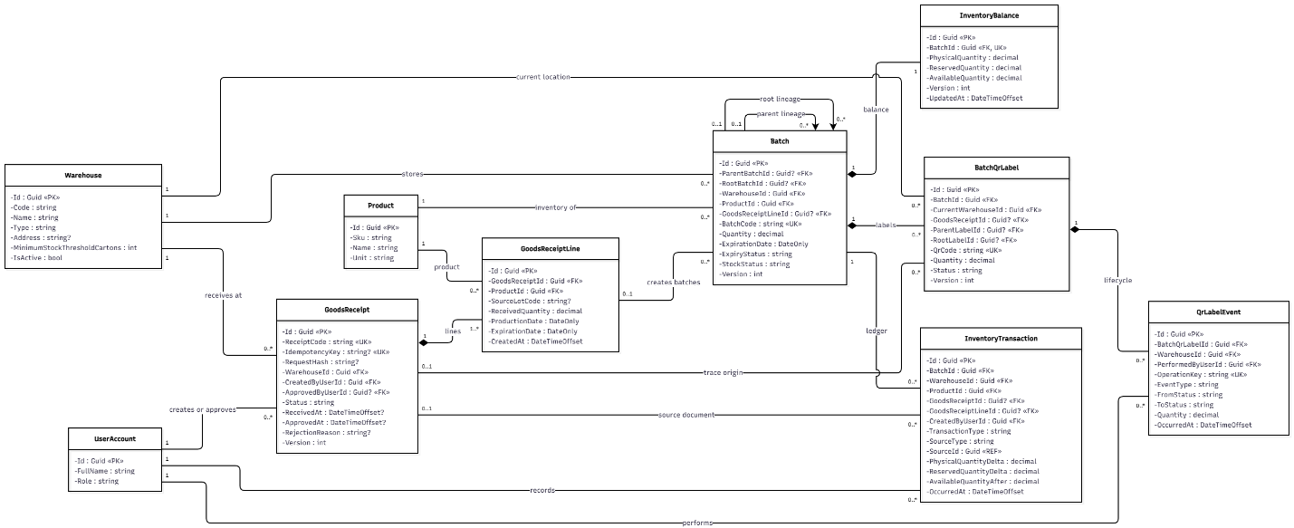
Figure 3.7.1 – Warehouse Receiving & Batch Inventory Class Diagram

3.7.2 Sequence Diagram: Create and Process Goods Receipt
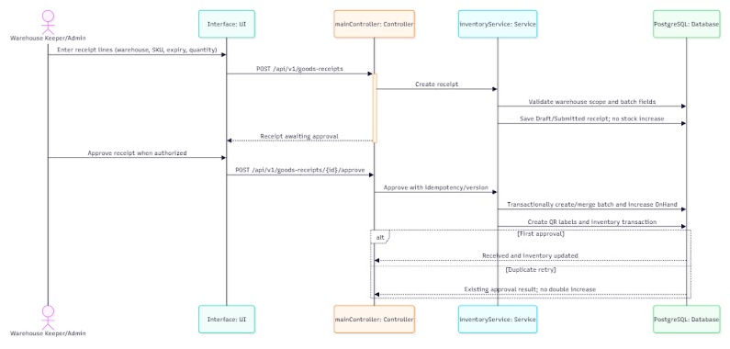
Figure 3.7.2 – Create and Process Goods Receipt Sequence Diagram

3.7.3 Sequence Diagram: View Warehouse Inventory and Batch Details
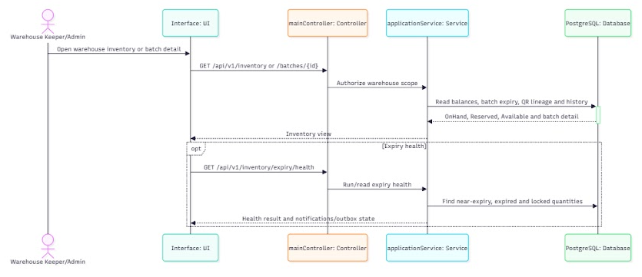
Figure 3.7.3 – View Warehouse Inventory and Batch Details Sequence Diagram

3.7.4 Sequence Diagram: Manage Warehouse Inventory Write-Off
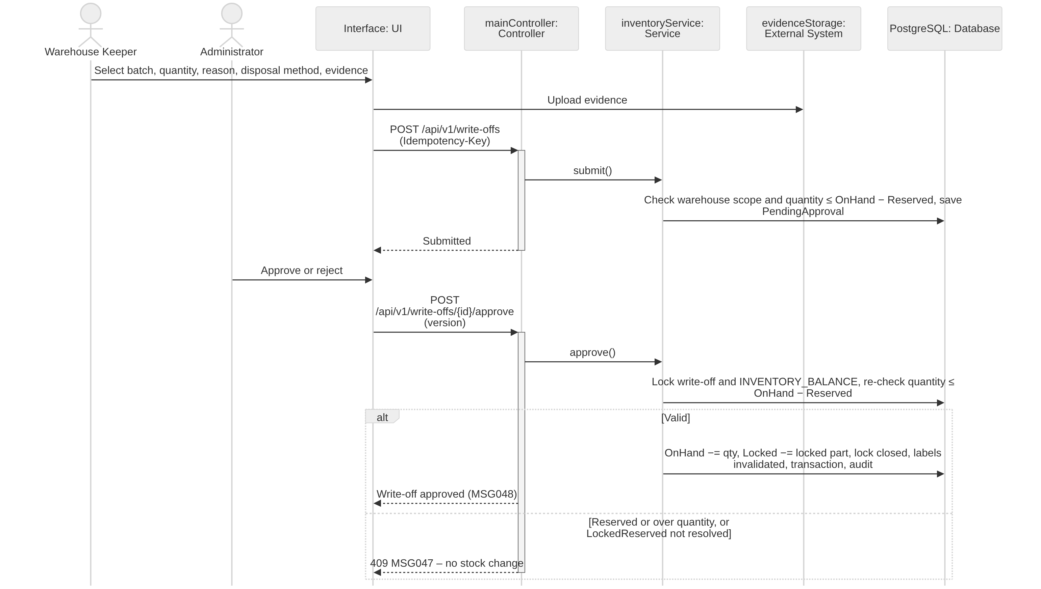
Figure 3.7.4 – Manage Warehouse Inventory Write-Off Sequence Diagram

3.7.5 State Machine Diagram: GoodsReceipt
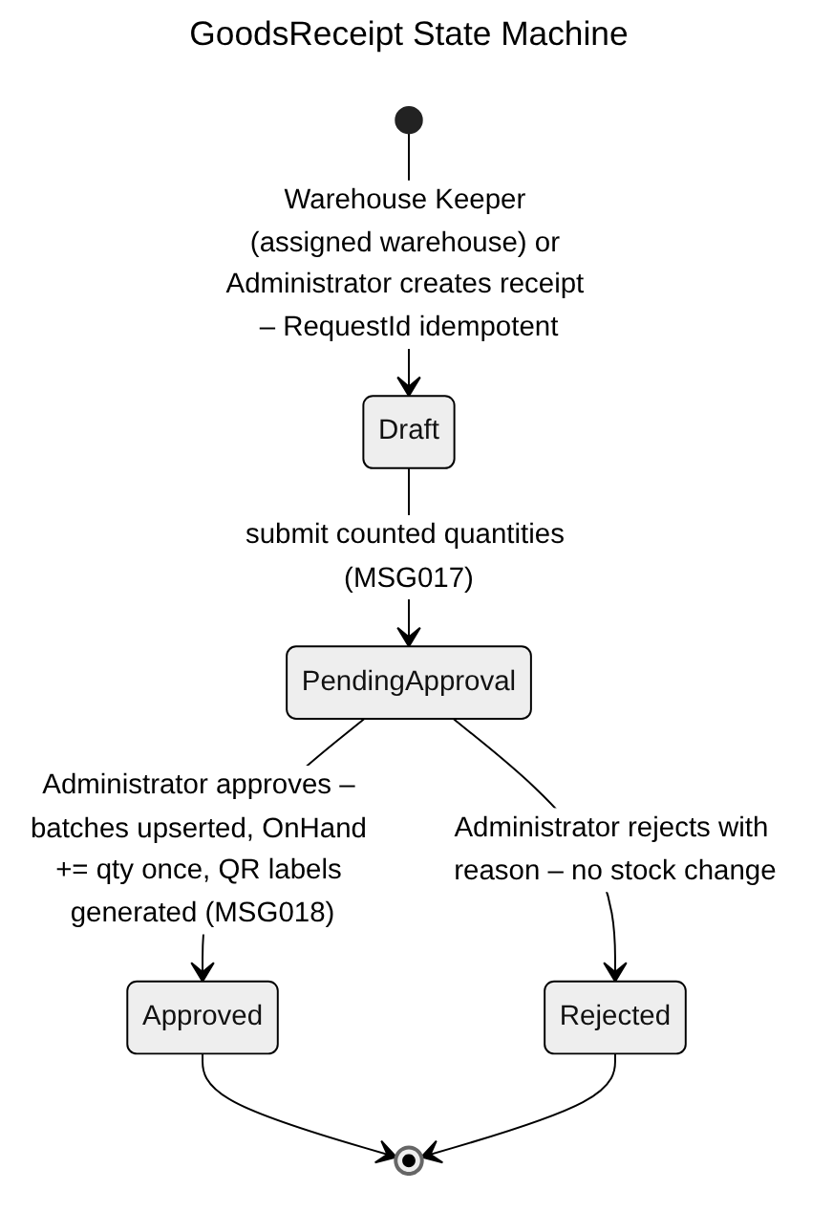
Figure 3.7.5 – GoodsReceipt State Machine Diagram

3.7.6 State Machine Diagram: WriteOff
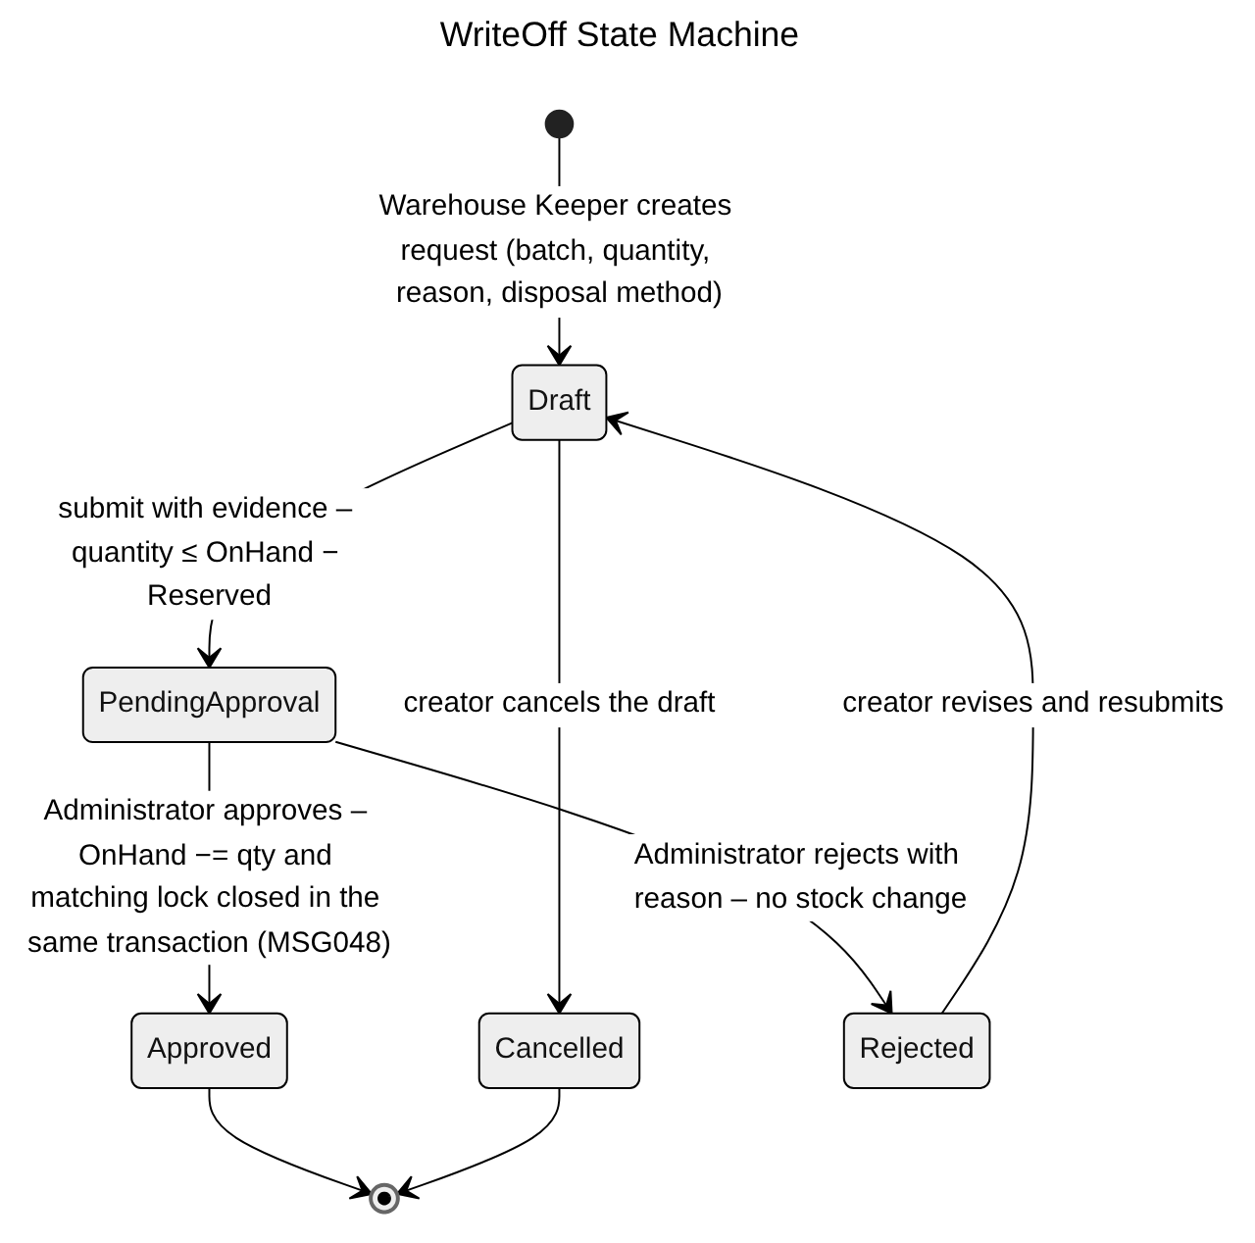
Figure 3.7.6 – WriteOff State Machine Diagram

3.7.7 Transaction, Idempotency, Concurrency and Exception Handling
Stock enters only through an approved goods receipt and leaves only through dispatch or an approved write-off; each must change OnHand exactly once (BR-42, BR-44, CR-07). Common conventions TX/ID/CC/EX are defined in Table 3.0; the tables below state the design of each function.
3.7.7.1 Create and Process Goods Receipt (Figure 3.7.2)
Aspect | Design
Transaction boundary | Create/submit: GOODS_RECEIPT and its lines in one transaction (Draft → Pending approval). Approve: one transaction locks the receipt, sets Approved, and for each line upserts the BATCH by (WarehouseId, ProductId, ExpiryDate) with INSERT … ON CONFLICT (BR-09), locks INVENTORY_BALANCE, increases OnHand, appends INVENTORY_TRANSACTION (source = receipt line), generates BATCH_QR_LABEL rows and QR_LABEL_EVENTs, and writes AUDIT_LOG and outbox notifications.
Idempotency | Submission uses the RequestId and RequestHash stored on GOODS_RECEIPT (ID-1), so a resubmission returns the same PN code. Approval is conditional (Pending approval → Approved) and protected by unique INVENTORY_TRANSACTION (GoodsReceiptLineId, MovementType = Receipt): a second Approve cannot add stock again (AC-3.8.1-03).
Concurrency control | SELECT … FOR UPDATE on GOODS_RECEIPT plus CC-1 so a keeper cannot edit lines while the Administrator approves. Two receipts for the same batch approved concurrently are serialized by the unique batch key and the balance row lock (CC-2).
Exception handling | Production date not before expiry or in the future → 400 MSG016; product not Published → 422 (BR-08); warehouse not assigned to the keeper → 403 MSG006; reject without reason → 400 MSG001; repeated approve → 200 with the existing Approved result (MSG018).
Table 3.7.7.1 – Transaction, idempotency, concurrency and exception design: Create and Process Goods Receipt
3.7.7.2 View Warehouse Inventory and Batch Details (Figure 3.7.3)
Aspect | Design
Transaction boundary | Read-only (TX-4). OnHand, Reserved, Locked and Available are read from the same INVENTORY_BALANCE row, so Available = OnHand − Reserved − Locked is always internally consistent; tentative run quantities are read from the current plan revision and shown separately (AC-3.8.2-04).
Idempotency | Safe GET; QR lookup by label code is also a read and can be repeated freely.
Concurrency control | No locks; MVCC. A displayed value may be superseded by a later commit; every stock-changing command re-reads and locks the row before acting (CC-2), so a stale screen cannot cause an incorrect movement.
Exception handling | Unassigned warehouse → 403 MSG006 (AC-3.8.2-05); unknown batch or label → 404; expired batch shown with MSG019.
Table 3.7.7.2 – Transaction, idempotency, concurrency and exception design: View Warehouse Inventory and Batch Details
3.7.7.3 Manage Warehouse Inventory Write-Off (Figure 3.7.4)
Aspect | Design
Transaction boundary | Create/submit: WRITE_OFF, WRITE_OFF_ITEM and WRITE_OFF_ATTACHMENT references in one transaction after evidence upload (TX-3). Approve: one transaction locks the write-off and the affected INVENTORY_BALANCE rows (CC-2), re-checks quantity ≤ OnHand − Reserved, decreases OnHand, decreases Locked by the written-off locked quantity and closes the matching INVENTORY_LOCK, invalidates the related QR labels, appends INVENTORY_TRANSACTION and writes AUDIT_LOG. LockedReserved quantity cannot be written off until the affected order is resolved (3.13.5 / 3.16.4).
Idempotency | ID-1; conditional Pending Admin approval → Approved; unique INVENTORY_TRANSACTION (WriteOffItemId, MovementType = WriteOff). Stock decreases exactly once (AC-3.8.3-01).
Concurrency control | Balance rows are locked and re-checked at approval time, so a reservation committed by a run approval between submission and approval is detected and the approval fails instead of writing off reserved stock.
Exception handling | Quantity above OnHand − Reserved → 409 MSG047; missing evidence or disposal method → 400 MSG001; non-Administrator approval → 403 MSG006; reject without reason → 400 MSG001; check-constraint violation → 409 MSG021.
Table 3.7.7.3 – Transaction, idempotency, concurrency and exception design: Manage Warehouse Inventory Write-Off

3.8 Picking & Retailer Receipt Confirmation

3.8.1 Class Diagram
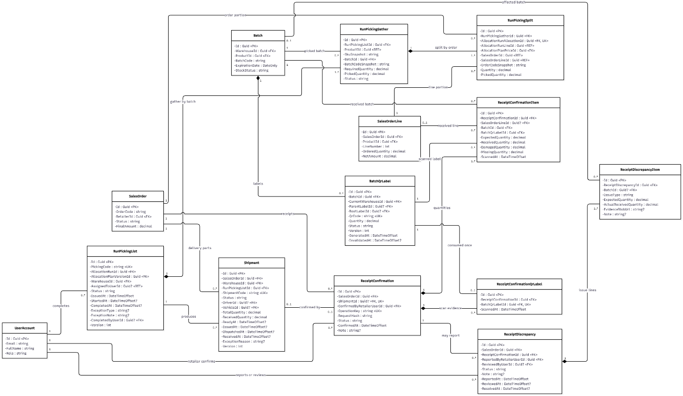
Figure 3.8.1 – Picking & Retailer Receipt Confirmation Class Diagram

3.8.2 Sequence Diagram: Scan Batch QR and Confirm Picking List
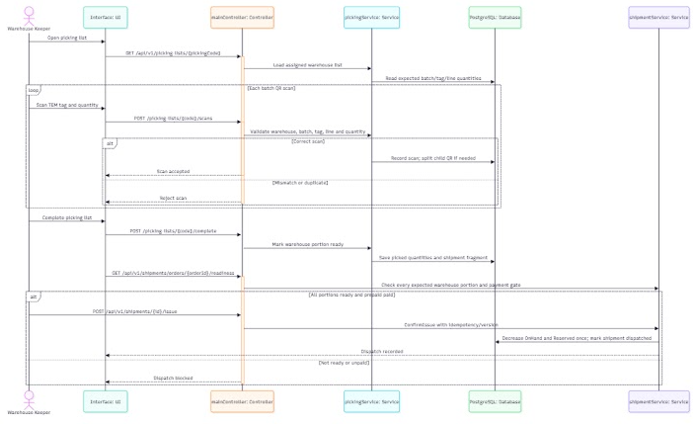
Figure 3.8.2 – Scan Batch QR and Confirm Picking List Sequence Diagram

3.8.3 Sequence Diagram: Confirm Retailer Receipt by QR
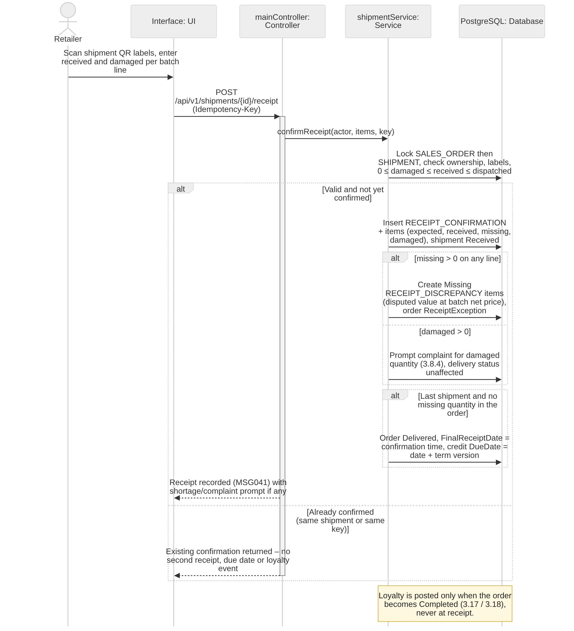
Figure 3.8.3 – Confirm Retailer Receipt by QR Sequence Diagram

3.8.4 Sequence Diagram: Report Receipt Discrepancy
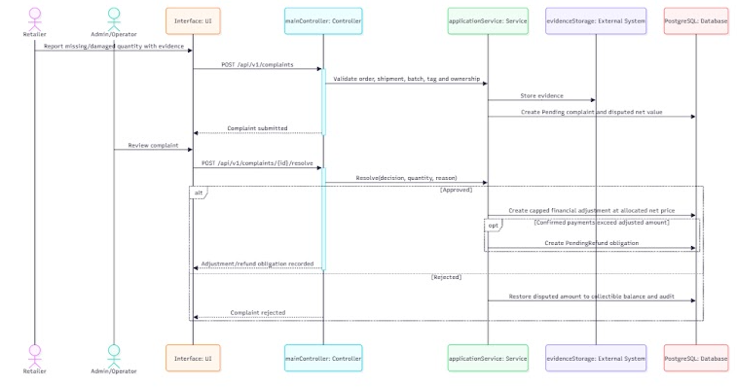
Figure 3.8.4 – Report Receipt Discrepancy Sequence Diagram

3.8.5 State Machine Diagram: RunPickingList
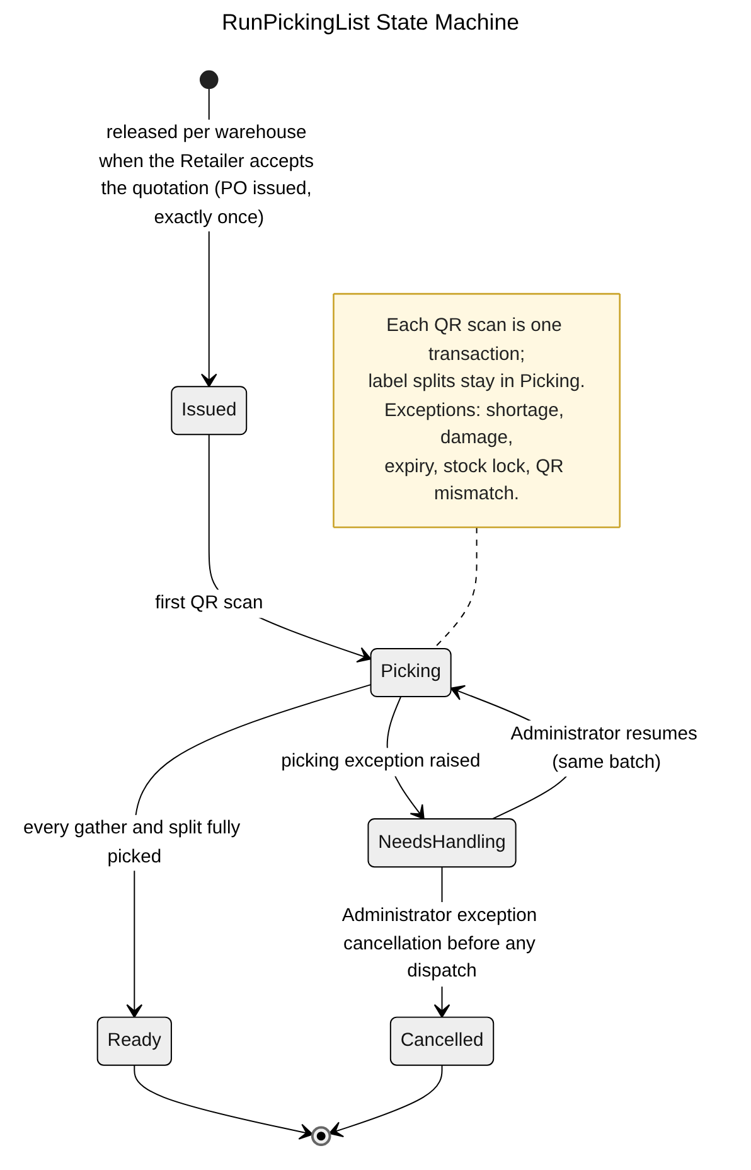
Figure 3.8.5 – RunPickingList State Machine Diagram

3.8.6 State Machine Diagram: Shipment
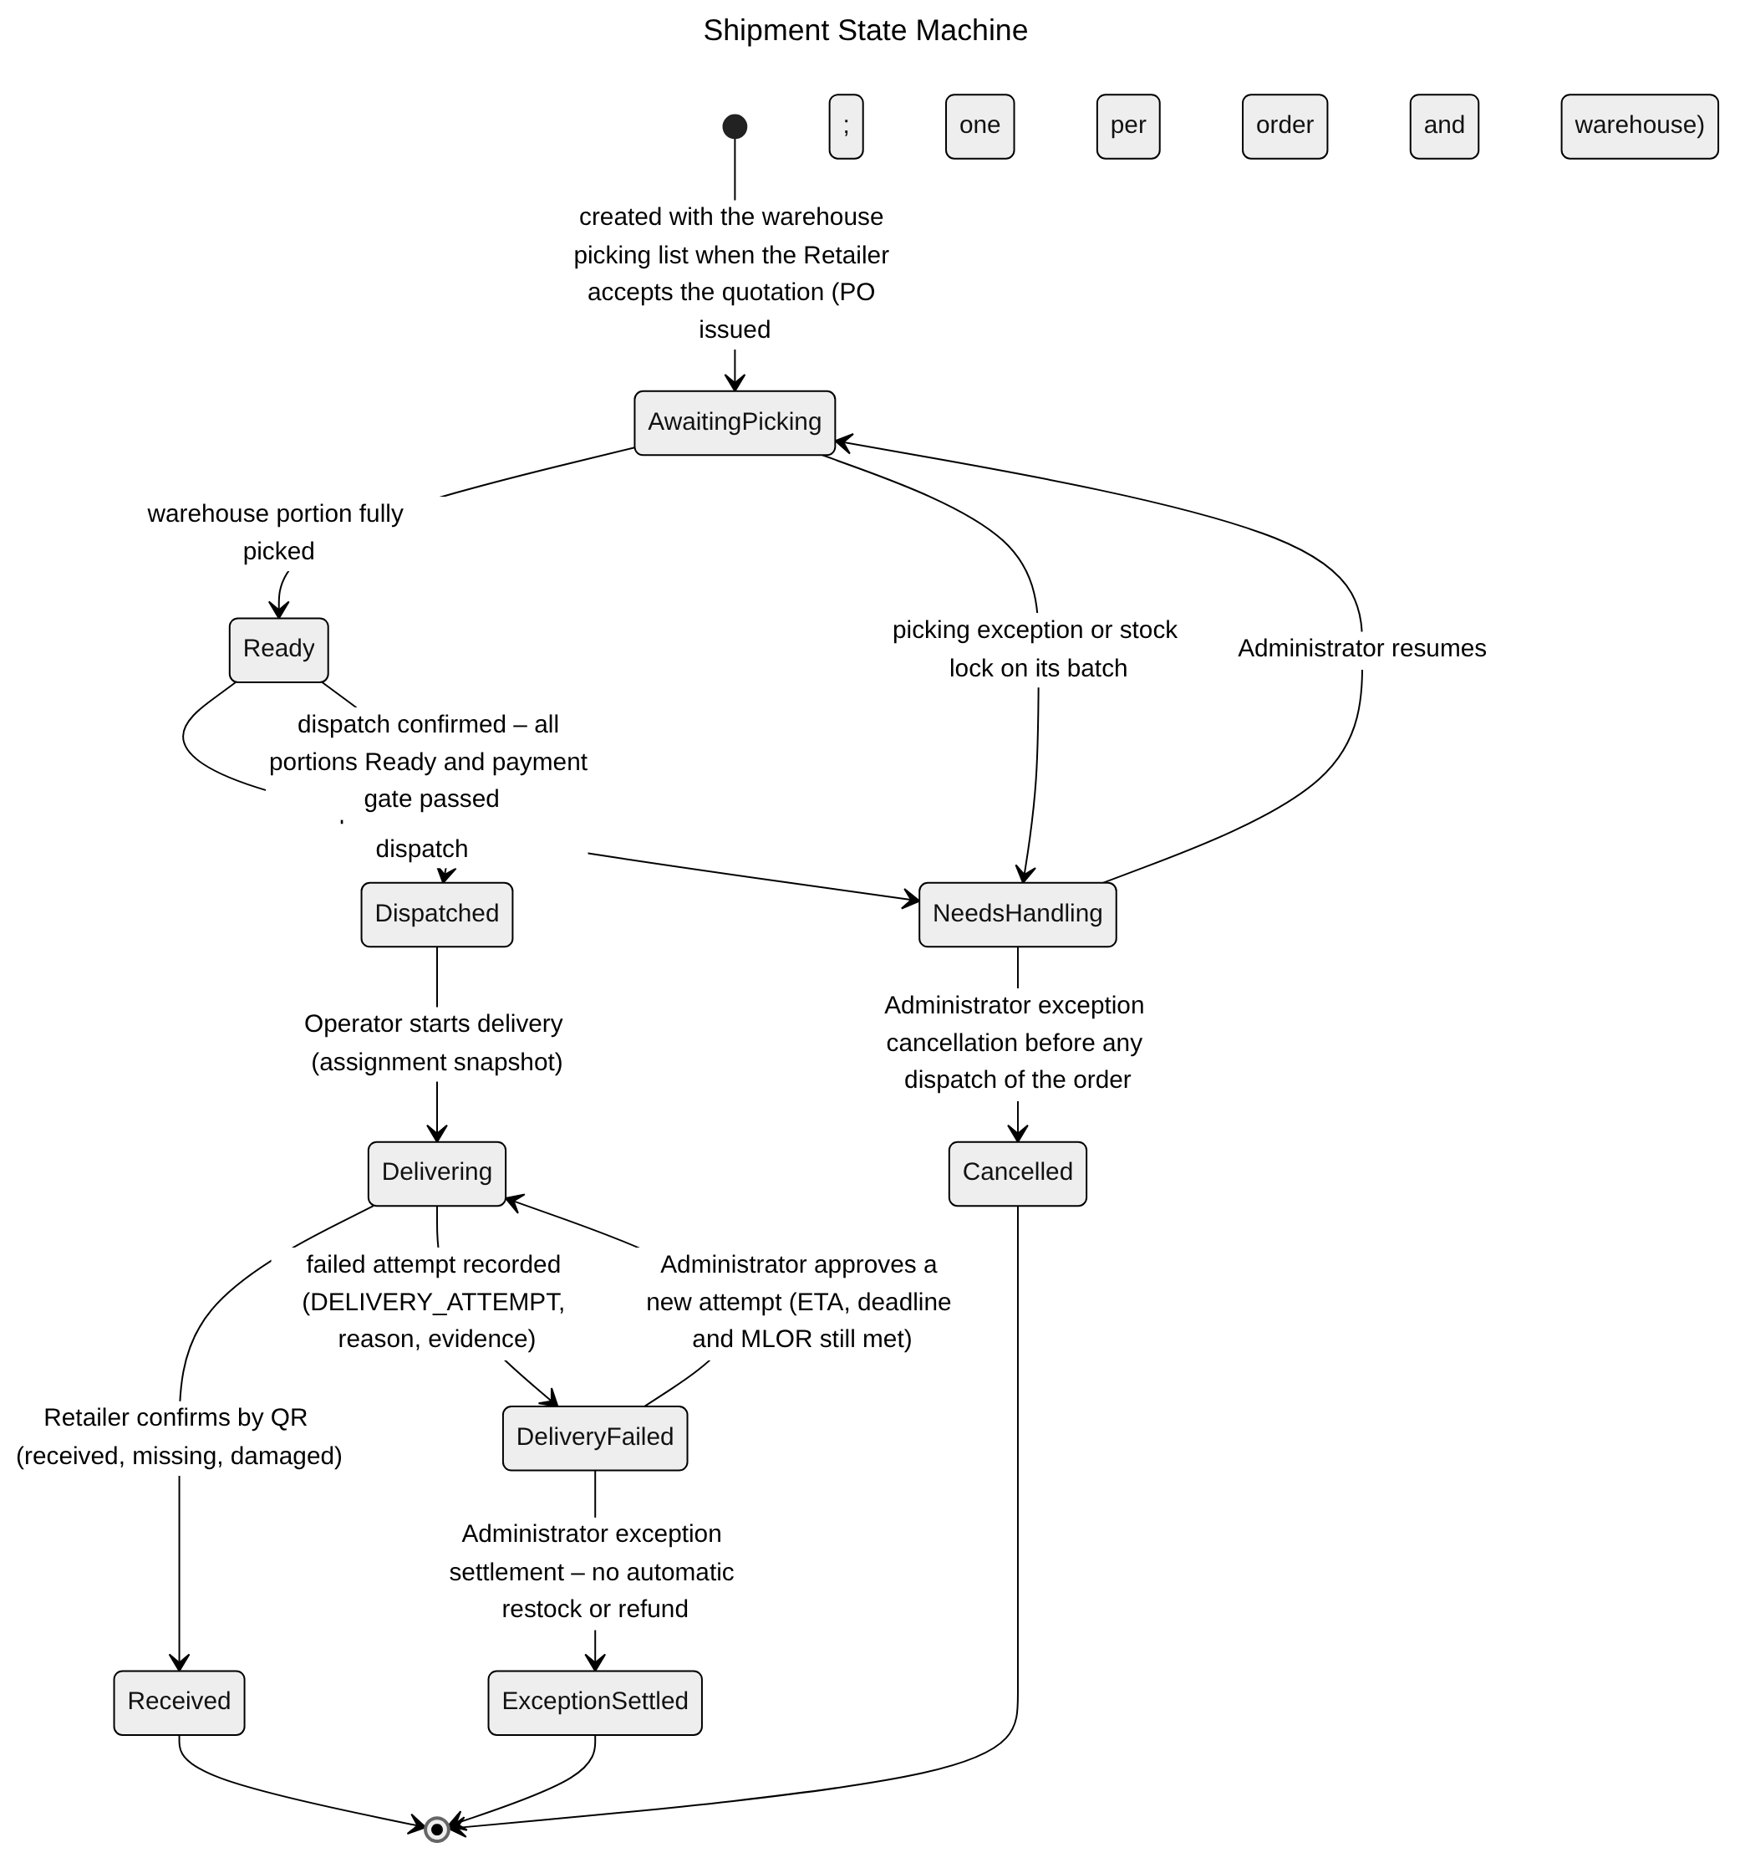
Figure 3.8.6 – Shipment State Machine Diagram

3.8.7 State Machine Diagram: Complaint
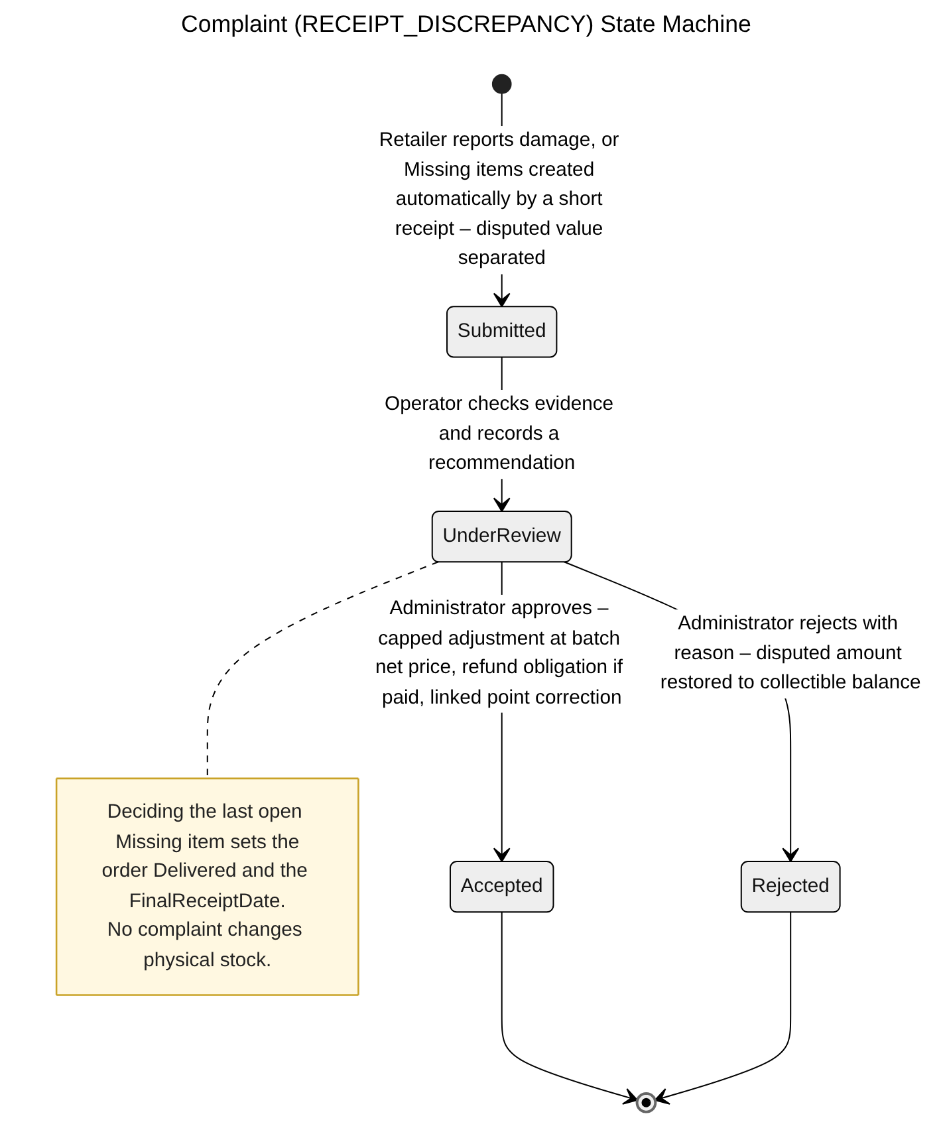
Figure 3.8.7 – Complaint State Machine Diagram

3.8.8 Transaction, Idempotency, Concurrency and Exception Handling
Picking scans record readiness but never issue stock (CR-13); receipt is confirmed once per shipment; a complaint changes only financial status, never stock (BR-50). Common conventions TX/ID/CC/EX are defined in Table 3.0; the tables below state the design of each function.
3.8.8.1 Scan Batch QR and Confirm Picking List (Figure 3.8.2)
Aspect | Design
Transaction boundary | Each scan is one transaction: lock the RUN_PICKING_GATHER row and the scanned BATCH_QR_LABEL, validate warehouse, batch and list, increase picked quantity, split the label when fewer cartons are taken (child label + parent quantity decrease, BR-10) and append QR_LABEL_EVENT. Confirm completion is one transaction that sets the splits and the warehouse portion (SHIPMENT) Ready when every quantity matches. No INVENTORY_BALANCE change.
Idempotency | Each scan carries a client scan id (UUID) used as Idempotency-Key and stored in PICKING_SCAN with a unique index on (RunPickingListId, ClientScanId); a resent scan returns the earlier result. Re-scanning the same label in a session is ignored. Confirm completion is a conditional transition, so a second confirm is a no-op.
Concurrency control | Row locks on the gather line and the label prevent two keepers from over-picking the same line or using the same label for two lists; picked quantity ≤ required quantity is also a check constraint. Completion locks the RUN_PICKING_LIST row (CC-3).
Exception handling | Wrong batch, warehouse or list → 422 MSG038; quantity above the listed quantity → 422 MSG038; shortage, damage or expiry found while picking → the keeper raises a PICKING_EXCEPTION (3.16.4) instead of substituting a batch; order not a PO or list not assigned → 409/403 MSG006; network loss → the app keeps the scan pending and resends it with the same scan id.
Table 3.8.8.1 – Transaction, idempotency, concurrency and exception design: Scan Batch QR and Confirm Picking List
3.8.8.2 Confirm Retailer Receipt by QR (Figure 3.8.3)
Aspect | Design
Transaction boundary | Label scans in the receipt session are validated by read calls. The final submission is one transaction: lock SALES_ORDER then the SHIPMENT (CC-3); insert RECEIPT_CONFIRMATION with its items (expected, received, missing = expected − received, damaged) and scanned labels; set the labels Received and the shipment Received. If any line has missing > 0, the same transaction creates Missing RECEIPT_DISCREPANCY items valued at the batch final unit price, adds that value to the PAYMENT pending disputed amount and sets the order ReceiptException. Only when this is the last shipment and the order has no missing quantity does it set the order Delivered with FinalReceiptDate = confirmation time and, for Credit, DueDate = FinalReceiptDate + term days of the stored RETAILER_PAYMENT_TERM_VERSION. Damaged quantity does not block Delivered; it prompts a complaint (3.8.4). No loyalty event is emitted at receipt (points are earned at Completed).
Idempotency | Unique RECEIPT_CONFIRMATION (ShipmentId) plus ID-1: a resent confirmation returns the existing record and creates no second receipt, discrepancy, due date or loyalty event (AC-3.9.2-05). A shipment is confirmed once; a confirmed receipt is not edited – differences found later are handled as a complaint (3.18).
Concurrency control | Locking the order row before the shipment row makes the "last shipment" decision safe when two shipments of one order are confirmed at the same time: the second transaction waits, then sees the first confirmation and sets Delivered.
Exception handling | Label of another order or retailer → 422 (AC-3.9.2-02); damaged > received or received > dispatched → 400 MSG002; shipment not Dispatched/Delivering → 409; not the Retailer's order → 403 MSG006. A shortage is accepted and recorded (order ReceiptException, MSG041 with the shortage shown); it is never rejected and never recorded as fully received.
Table 3.8.8.2 – Transaction, idempotency, concurrency and exception design: Confirm Retailer Receipt by QR
3.8.8.3 Report Receipt Discrepancy (Figure 3.8.4)
Aspect | Design
Transaction boundary | Evidence upload first (TX-3). One transaction inserts RECEIPT_DISCREPANCY (KN code), its items and RECEIPT_DISCREPANCY_ATTACHMENT rows, with disputed value = affected quantity × the final unit price from ALLOCATION_PLAN_PRICE (whole VND, half-up), increases the pending disputed amount on PAYMENT, keeps the order from Completed and writes audit and outbox notifications to Operator and Administrator. No stock row is touched.
Idempotency | ID-1. The total complaint quantity per (shipment, batch line) is capped by the dispatched quantity, so a duplicate submission with a new key is rejected by the cap rather than doubling the dispute.
Concurrency control | PAYMENT is locked FOR UPDATE (shared with payment recording and adjustments, CC-3) so collectible amount and disputed amount change consistently; the shipment line is locked while the cap is checked.
Exception handling | Quantity above dispatched → 422 (AC-3.9.3-02); shipment not yet received → 409; not own order → 403 MSG006; missing evidence → 400 MSG001; invalid file → 400 MSG049.
Table 3.8.8.3 – Transaction, idempotency, concurrency and exception design: Report Receipt Discrepancy

3.9 Payment & Loyalty Management

3.9.1 Class Diagram
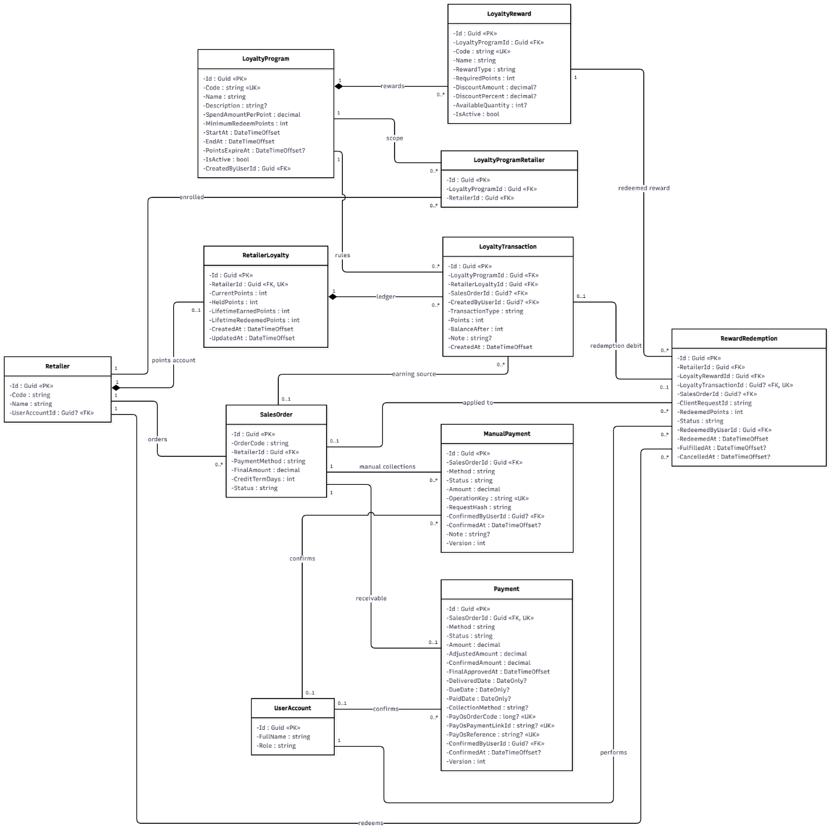
Figure 3.9.1 – Payment & Loyalty Management Class Diagram

3.9.2 Sequence Diagram: Record Order Payment (Cash / QR / Bank Transfer)
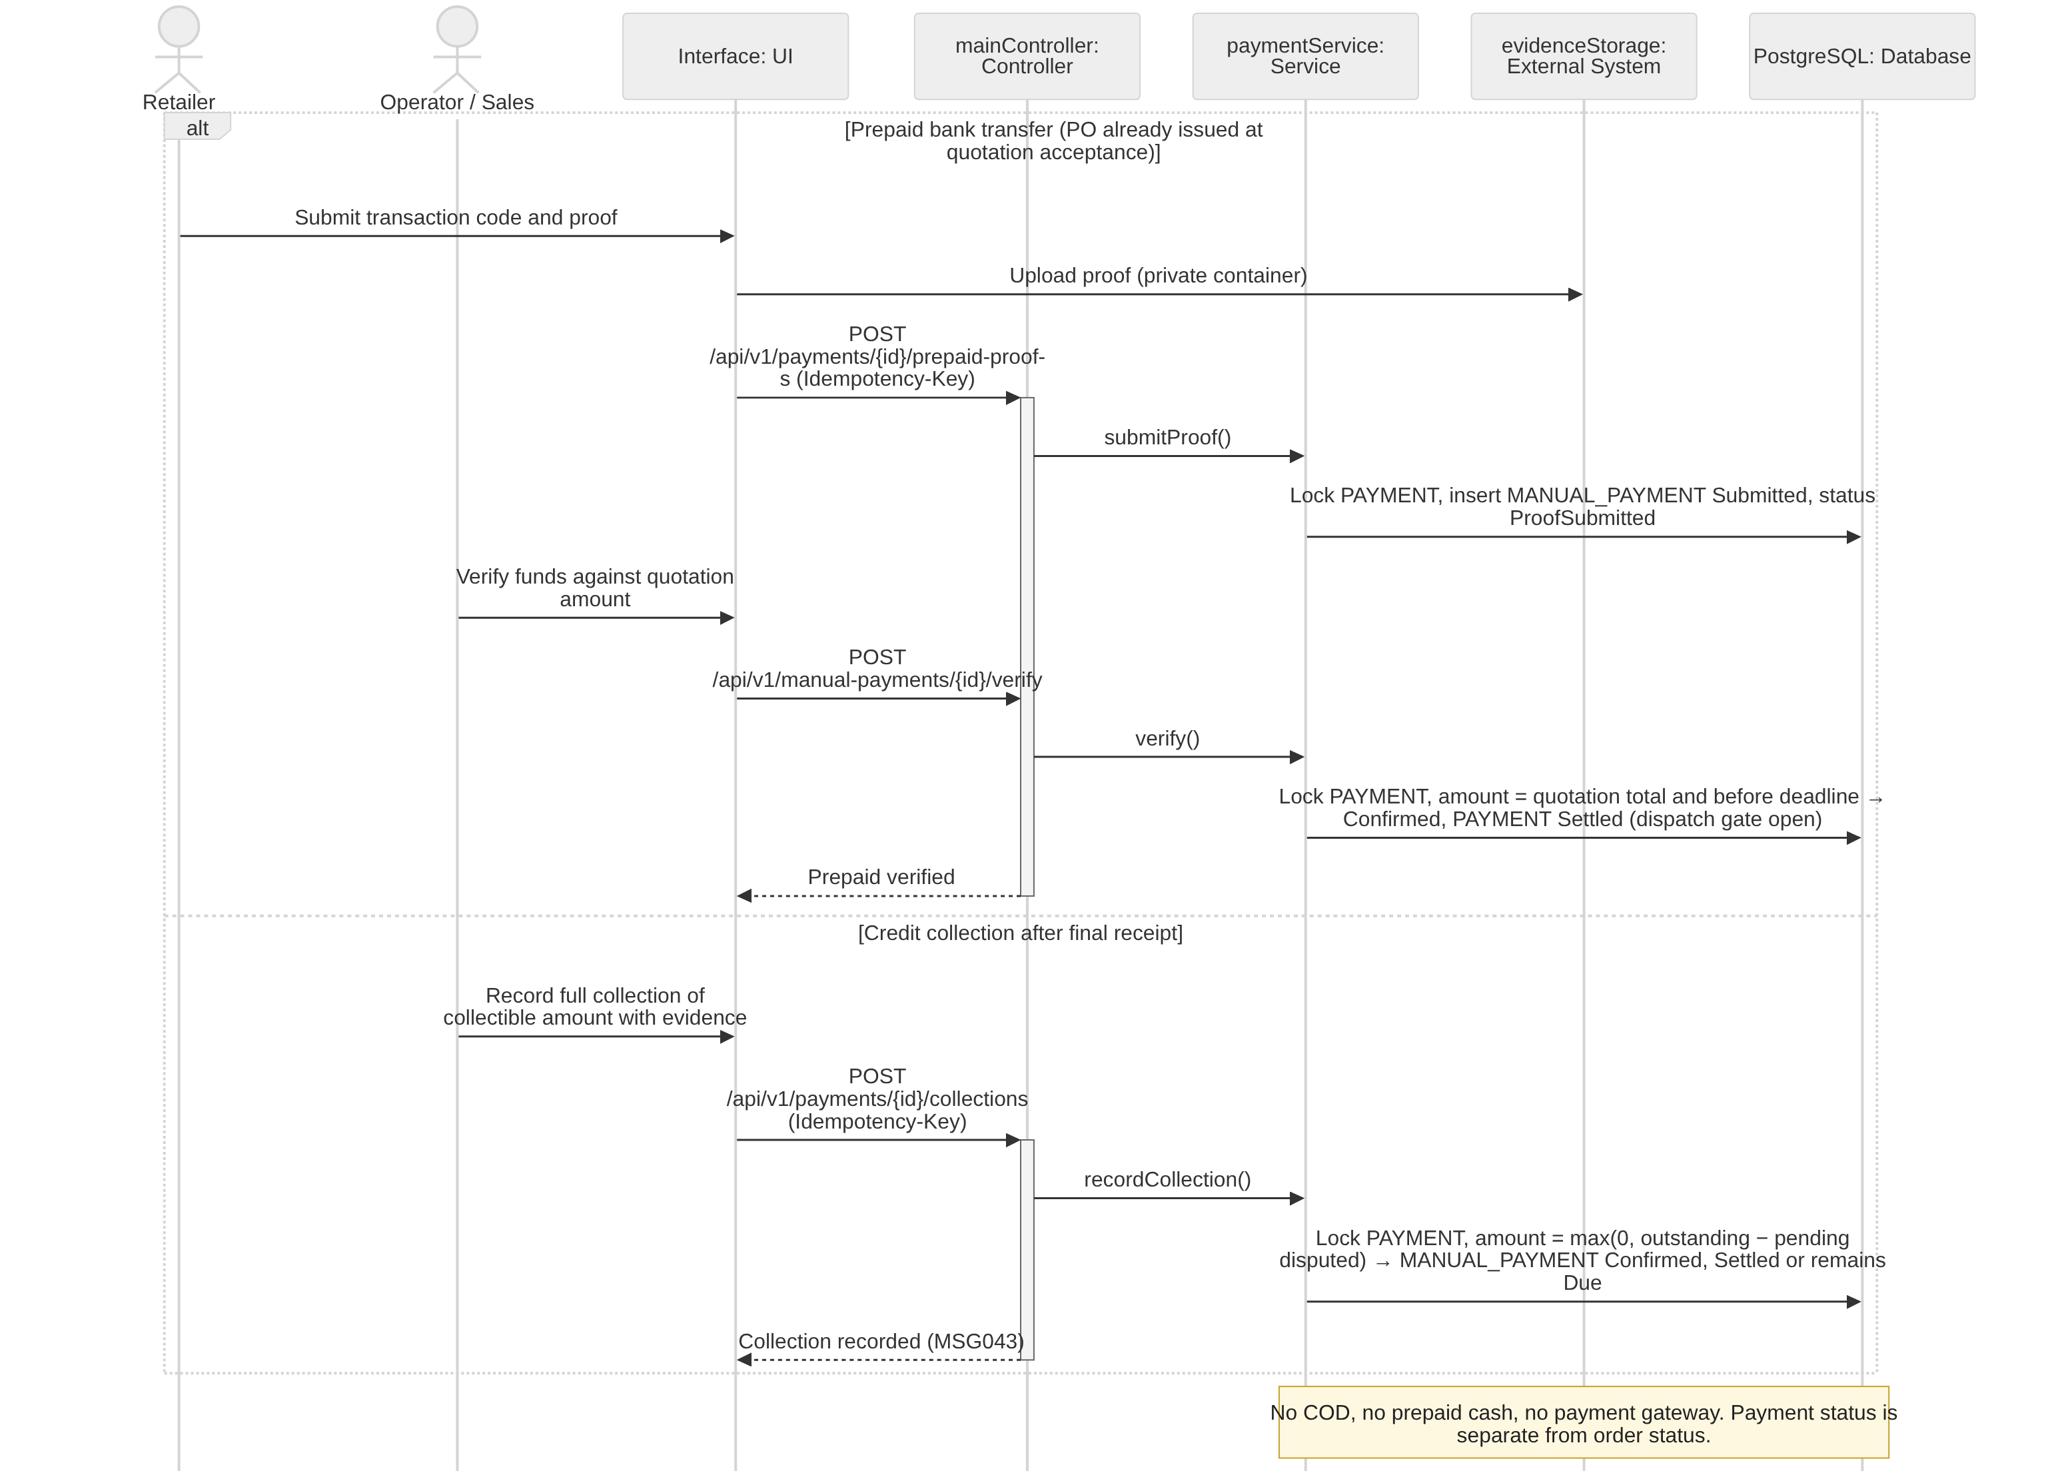
Figure 3.9.2 – Record Order Payment Sequence Diagram

3.9.3 Sequence Diagram: View Retailer Loyalty Points
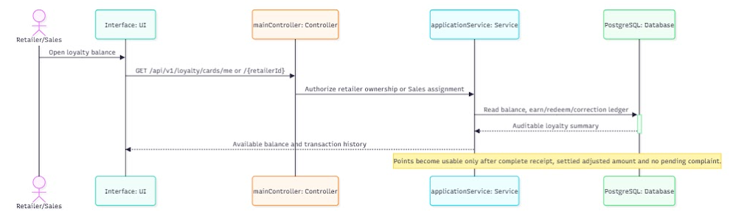
Figure 3.9.3 – View Retailer Loyalty Points Sequence Diagram

3.9.4 Sequence Diagram: Redeem Loyalty Reward / Points
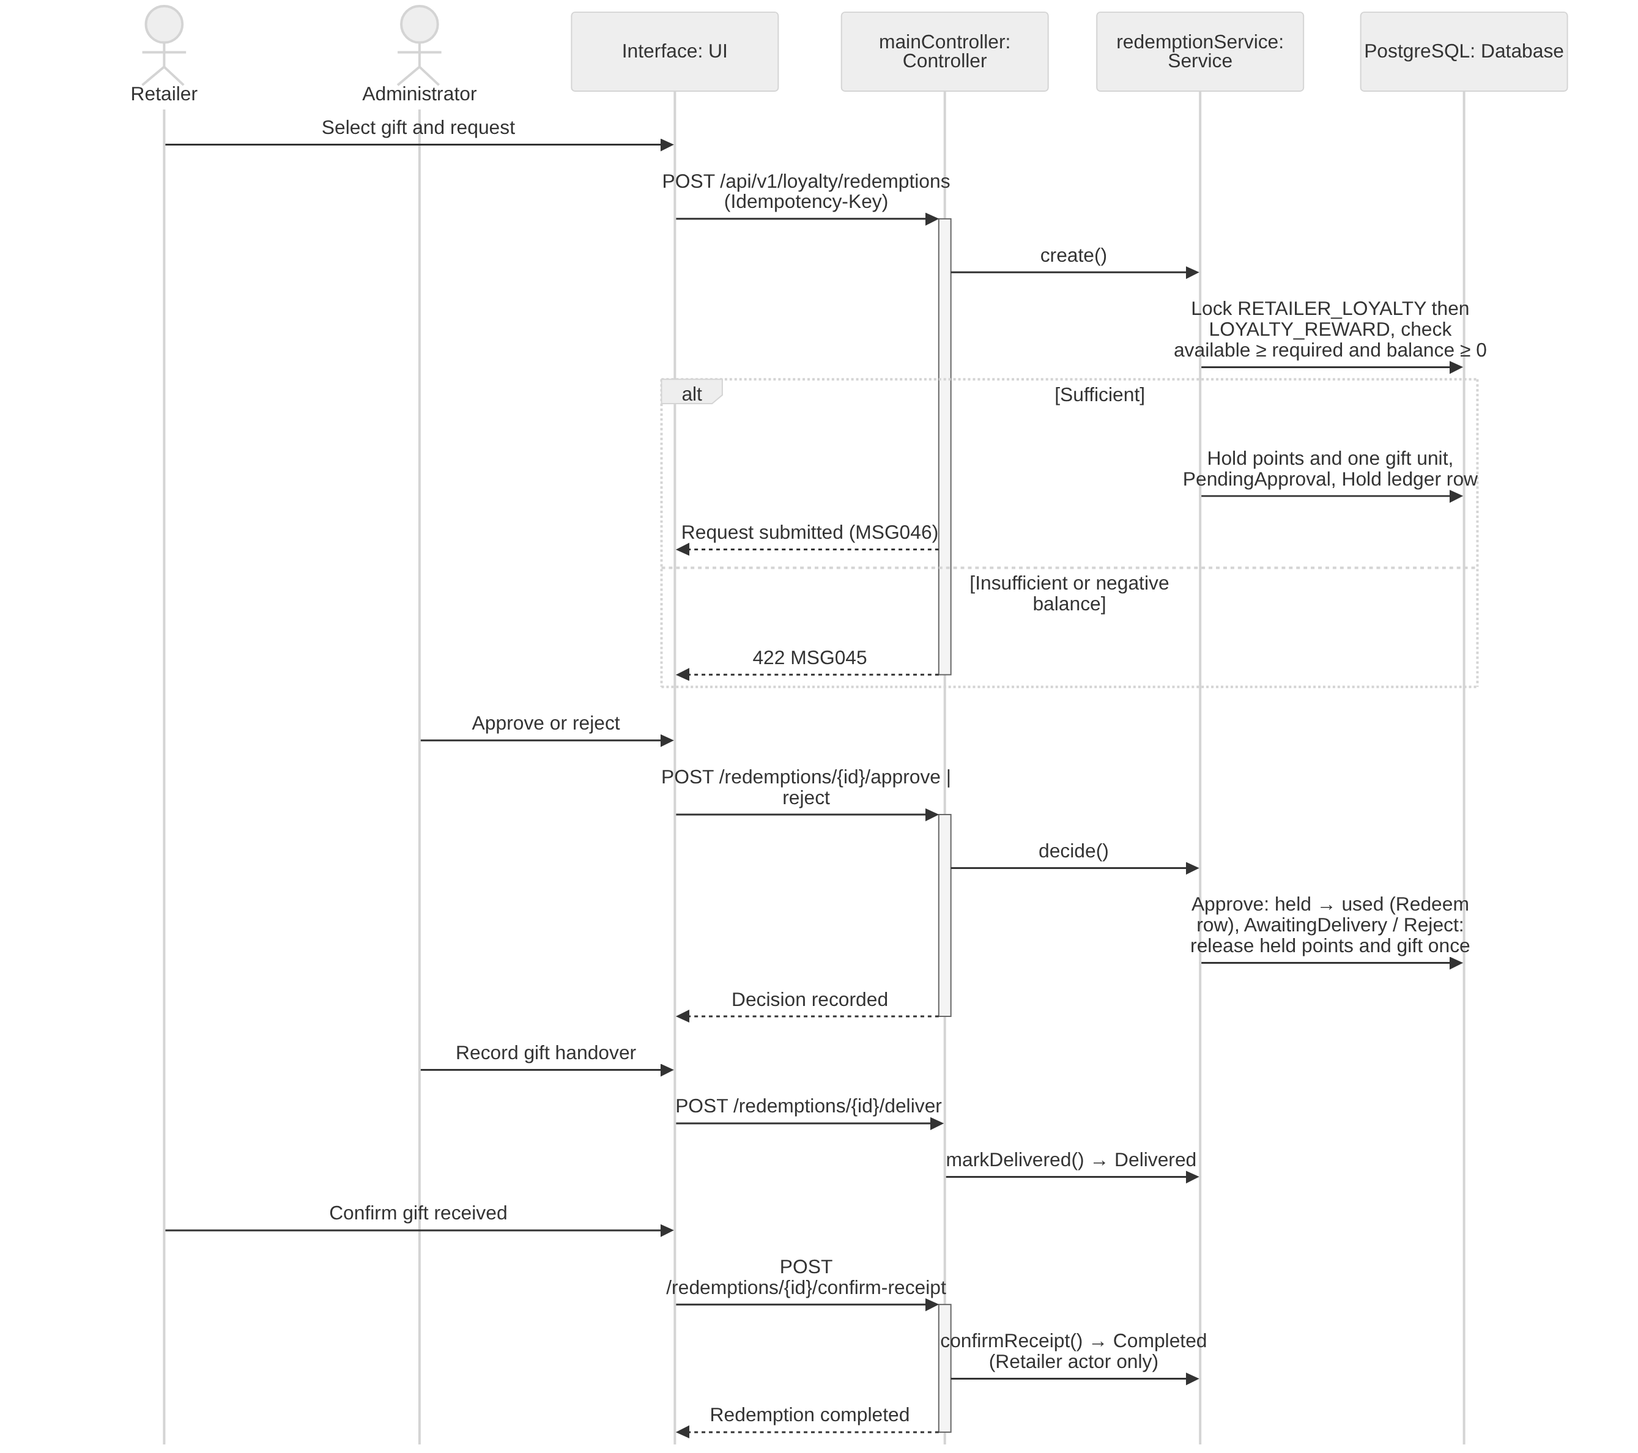
Figure 3.9.4 – Redeem Loyalty Reward _ Points Sequence Diagram

3.9.5 State Machine Diagram: ManualRefund
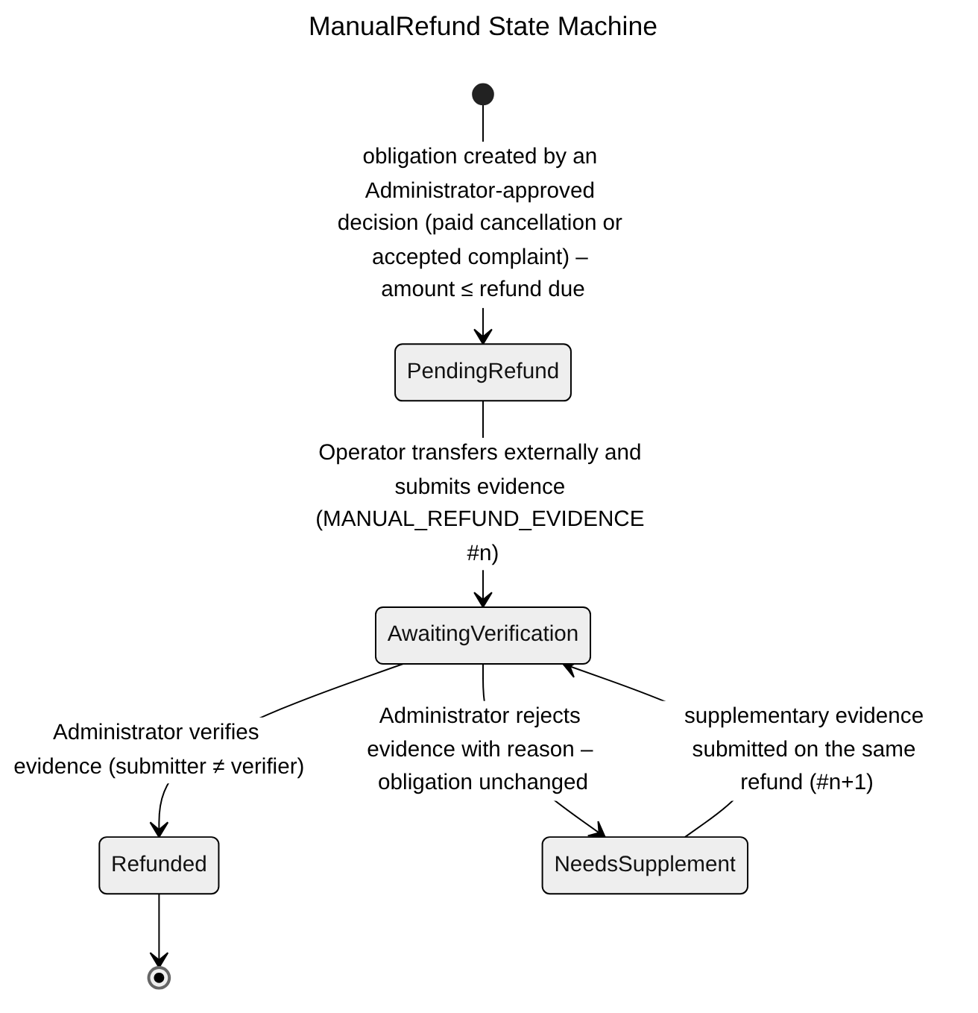
Figure 3.9.5 – ManualRefund State Machine Diagram

3.9.6 State Machine Diagram: RewardRedemption
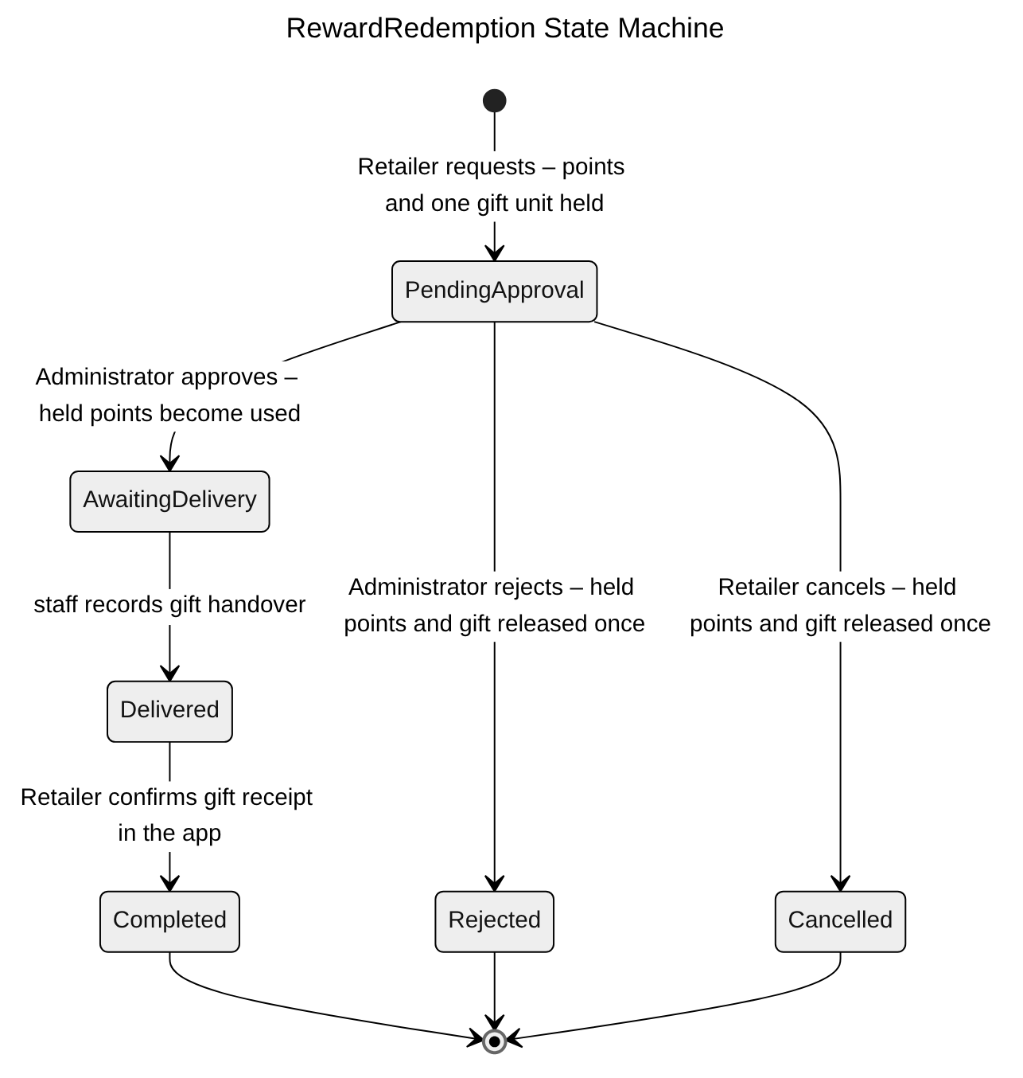
Figure 3.9.6 – RewardRedemption State Machine Diagram

3.9.7 Transaction, Idempotency, Concurrency and Exception Handling
Money and points must never be counted twice (NFR-R03, NFR-D04). Every movement is a separate immutable ledger row; balances are updated under a row lock in the same transaction. Common conventions TX/ID/CC/EX are defined in Table 3.0; the tables below state the design of each function.
3.9.7.1 Record Order Payment (Cash / QR / Bank Transfer) (Figure 3.9.2)
Aspect | Design
Transaction boundary | Prepaid: the PO already exists (issued at quotation acceptance, 3.16.2). Proof submission inserts MANUAL_PAYMENT (Submitted) with the evidence reference and sets PAYMENT ProofSubmitted. Verification is one transaction: lock PAYMENT, check amount = quotation total and transaction time ≤ quotation deadline (BR-72), set MANUAL_PAYMENT Confirmed and PAYMENT Settled, which opens the dispatch payment gate (3.16.5.2). Credit: the collection transaction locks PAYMENT, computes collectible now = max(0, outstanding − pending disputed) (BR-69), inserts MANUAL_PAYMENT Confirmed and updates the confirmed amount and status. Every step writes AUDIT_LOG and outbox events.
Idempotency | ID-1; unique (PaymentId, TransactionReference) for transfers; a partial unique index allows only one confirmed full settlement per payment obligation (AC-3.10.1-04). Verify on an already verified proof is a no-op (ID-3).
Concurrency control | SELECT … FOR UPDATE on PAYMENT serializes collection with complaint disputes and adjustments, so the amount accepted is the collectible amount at that instant. CC-1 on MANUAL_PAYMENT for Operator verification.
Exception handling | Order still Awaiting final price or quotation not accepted → 409 (BR-66); prepaid amount ≠ quotation total or credit amount ≠ collectible now → 422 (full settlement only, BR-52); duplicate transaction reference → 409 MSG003; Sales outside retailer scope → 403 MSG006; prepaid transfer after the quotation deadline → the order has been cancelled by the expiry job (3.13.7.4) and the money becomes a refund obligation; it never revives the order (BR-72).
Table 3.9.7.1 – Transaction, idempotency, concurrency and exception design: Record Order Payment (Cash / QR / Bank Transfer)
3.9.7.2 View Retailer Loyalty Points (Figure 3.9.3)
Aspect | Design
Transaction boundary | Read-only (TX-4). Current, held and available points come from the single RETAILER_LOYALTY row; the ledger is paged with keyset pagination over LOYALTY_TRANSACTION.
Idempotency | Safe GET.
Concurrency control | No locks; available = current − held is computed from one row version, so it is always consistent.
Exception handling | Sales not assigned to the retailer → 403 MSG006; negative corrected balance shown as negative with redemption disabled (AC-3.10.2-03).
Table 3.9.7.2 – Transaction, idempotency, concurrency and exception design: View Retailer Loyalty Points
3.9.7.3 Redeem Loyalty Reward / Points (Figure 3.9.4)
Aspect | Design
Transaction boundary | Request: one transaction locks RETAILER_LOYALTY then LOYALTY_REWARD, checks available ≥ required and balance ≥ 0, increases held points, decreases gift stock, inserts REWARD_REDEMPTION (PendingApproval) and a Hold ledger row. Approve: held → used with a Redeem row (AwaitingDelivery). Reject, or Retailer cancel, only before approval: release held points and gift stock with Release rows. Staff record the handover (Delivered); only the Retailer's confirmation of receipt sets Completed (RetailerConfirmedAt/By). Each step writes AUDIT_LOG and an outbox notification.
Idempotency | ID-1; conditional transitions; unique ledger row per (RedemptionId, movement type), so points are used once and released once (AC-3.10.3-03, AC-3.10.3-05); a repeated Retailer confirmation returns Completed unchanged.
Concurrency control | Fixed lock order RETAILER_LOYALTY → LOYALTY_REWARD avoids deadlocks; check constraints HeldPoints ≥ 0 and gift AvailableQuantity ≥ 0 are the final guard against two parallel requests taking the last gift.
Exception handling | Insufficient points → 422 MSG045; negative corrected balance → 422 (BR-54); gift out of stock → 409; decision on a request already decided → 409 with the current state; rejection after approval → 409; Completed requested by staff → 403 (Retailer confirmation only).
Table 3.9.7.3 – Transaction, idempotency, concurrency and exception design: Redeem Loyalty Reward / Points

3.10 Sales Groups & Operational Reporting

3.10.1 Class Diagram
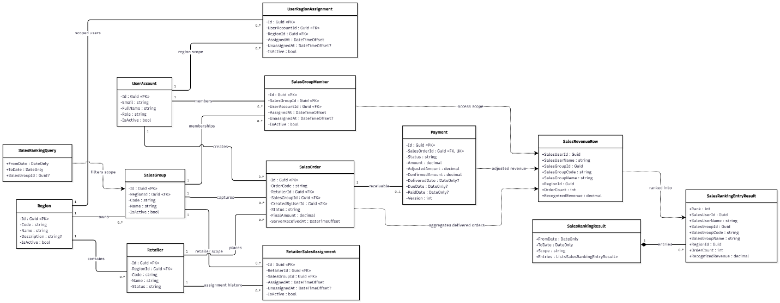
Figure 3.10.1 – Sales Groups & Operational Reporting Class Diagram

3.10.2 Sequence Diagram: Manage Sales Groups and Coverage
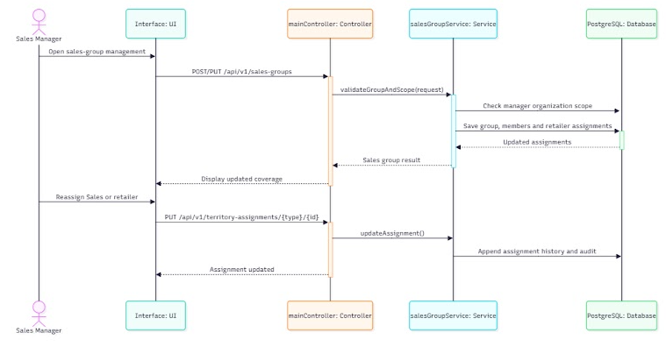
Figure 3.10.2 – Manage Sales Groups and Coverage Sequence Diagram

3.10.3 Sequence Diagram: View Sales and Management Dashboards
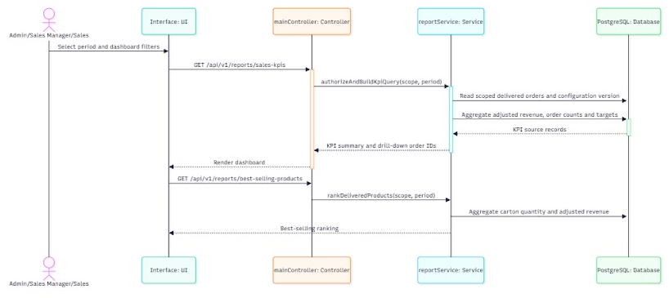
Figure 3.10.3 – View Sales and Management Dashboards Sequence Diagram

3.10.4 Transaction, Idempotency, Concurrency and Exception Handling
Coverage changes alter visibility for later actions only; historical orders keep their creator and group snapshots. Reports are read-only and consistent within one snapshot. Common conventions TX/ID/CC/EX are defined in Table 3.0; the tables below state the design of each function.
3.10.4.1 Manage Sales Groups and Coverage (Figure 3.10.2)
Aspect | Design
Transaction boundary | Group create/update/delete and each member or retailer reassignment (end-date the active row, insert the new one) are single transactions with AUDIT_LOG.
Idempotency | ID-1; partial unique indexes allow one active group per Sales user and one active group per retailer, so a replayed reassignment cannot create two active assignments.
Concurrency control | CC-1 on SALES_GROUP. Delete locks the group row and re-checks members and retailers in the same transaction; a concurrent assignment into that group waits on the lock and then fails the foreign-key check.
Exception handling | Delete with members or retailers → 409 (AC-3.11.1-01); group outside the manager's region → 403 MSG006; stale version → 409 MSG021.
Table 3.10.4.1 – Transaction, idempotency, concurrency and exception design: Manage Sales Groups and Coverage
3.10.4.2 View Sales and Management Dashboards (Figure 3.10.3)
Aspect | Design
Transaction boundary | Read-only. All widgets of one dashboard load in one READ ONLY REPEATABLE READ transaction (TX-4) so revenue, order counts and KPI score come from the same snapshot.
Idempotency | Safe GET with ETag. Pre-aggregated figures, if used, are maintained by outbox consumers that record the processed event id (ID-5), so a replayed event cannot double-count revenue.
Concurrency control | No locks; MVCC.
Exception handling | Scope outside the caller → 403 MSG006; invalid period → 400 MSG002; query over the time budget (NFR-P04) cancelled → 503 retryable.
Table 3.10.4.2 – Transaction, idempotency, concurrency and exception design: View Sales and Management Dashboards

3.11 System Configuration & Notifications

3.11.1 Class Diagram
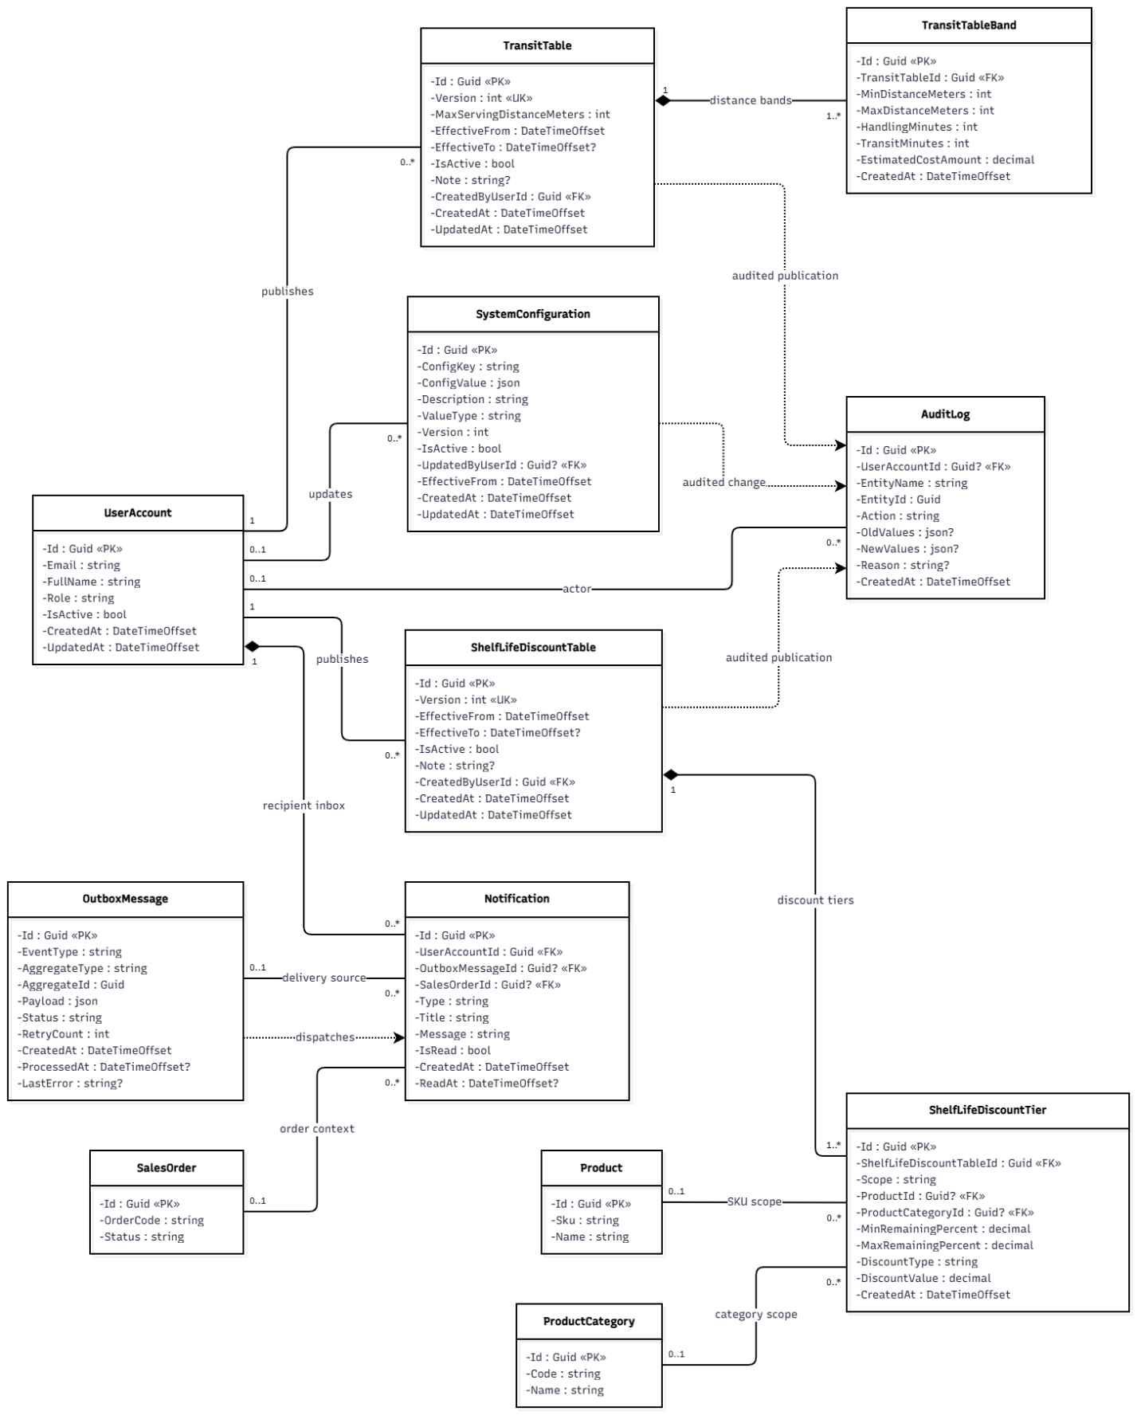
Figure 3.11.1 – System Configuration & Notifications Class Diagram

3.11.2 Sequence Diagram: Manage Warehouse Location and Service Configuration
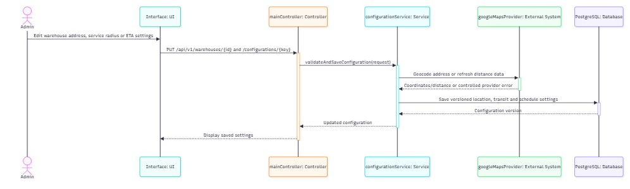
Figure 3.11.2 – Manage Warehouse Location and Service Configuration Sequence Diagram

3.11.3 Sequence Diagram: Send Operational Notifications
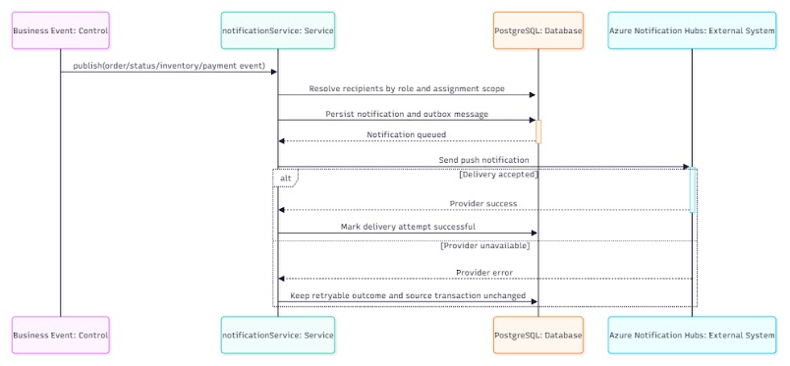
Figure 3.11.3 – Send Operational Notifications Sequence Diagram

3.11.4 Transaction, Idempotency, Concurrency and Exception Handling
Configuration is versioned and effective-dated, never updated in place; running runs use their snapshot (BR-28, BR-57). Notifications are produced from the outbox and never affect the source transaction. Common conventions TX/ID/CC/EX are defined in Table 3.0; the tables below state the design of each function.
3.11.4.1 Manage Warehouse Location and Service Configuration (Figure 3.11.2)
Aspect | Design
Transaction boundary | Saving a location inserts a new MAP_LOCATION version, repoints the warehouse and writes AUDIT_LOG and an outbox LocationChanged event in one transaction; road distances are recomputed afterwards by a consumer that writes MAP_DISTANCE_CACHE keyed by the new location versions. Configuration changes (weights, Dmax, transit bands, cutoff, deadlines) insert a new SYSTEM_CONFIGURATION / TRANSIT_TABLE version and close the previous one in the same transaction.
Idempotency | ID-1; unique (ConfigKey, EffectiveFrom) and (TransitTableId, band range); distance cache rows are upserted on (origin version, destination version), so replays are harmless.
Concurrency control | CC-1 on the active version: two Administrators editing the same setting cannot both win. An exclusion constraint prevents overlapping effective periods. A run in progress keeps its snapshot values (AC-3.12.1-02).
Exception handling | Weights not summing to 1 → 422 (AC-3.12.1-01); Dmax outside 1 – 100 km or overlapping/gapped bands → 422; Operator save → 403 MSG006; distance recomputation failure → retried by the outbox, the next run waits for complete distances or excludes the location with a logged reason.
Table 3.11.4.1 – Transaction, idempotency, concurrency and exception design: Manage Warehouse Location and Service Configuration
3.11.4.2 Send Operational Notifications (Figure 3.11.3)
Aspect | Design
Transaction boundary | Producers only write OUTBOX_MESSAGE inside their business transaction (TX-2). The dispatcher processes each message in its own transaction: resolve recipients by role and assignment, insert NOTIFICATION rows, mark the message Processed. Push to Azure Notification Hubs happens after that commit.
Idempotency | Unique NOTIFICATION (OutboxMessageId, RecipientUserId) gives one notification per recipient even if the event is processed twice (AC-3.12.2-04); the dispatcher also records the message in PROCESSED_MESSAGE (ID-5); the push uses the notification id as dedupe tag.
Concurrency control | Workers fetch messages with FOR UPDATE SKIP LOCKED (CC-4), so several App Service instances can run the dispatcher without double processing.
Exception handling | Hub unavailable → in-app record kept, push retried after 1, 5 and 15 minutes, then logged as failed without touching the source transaction (NFR-R06); a message failing 3 times is marked Failed and alerts operations.
Table 3.11.4.2 – Transaction, idempotency, concurrency and exception design: Send Operational Notifications

3.12 Delivery Operations

3.12.1 Class Diagram
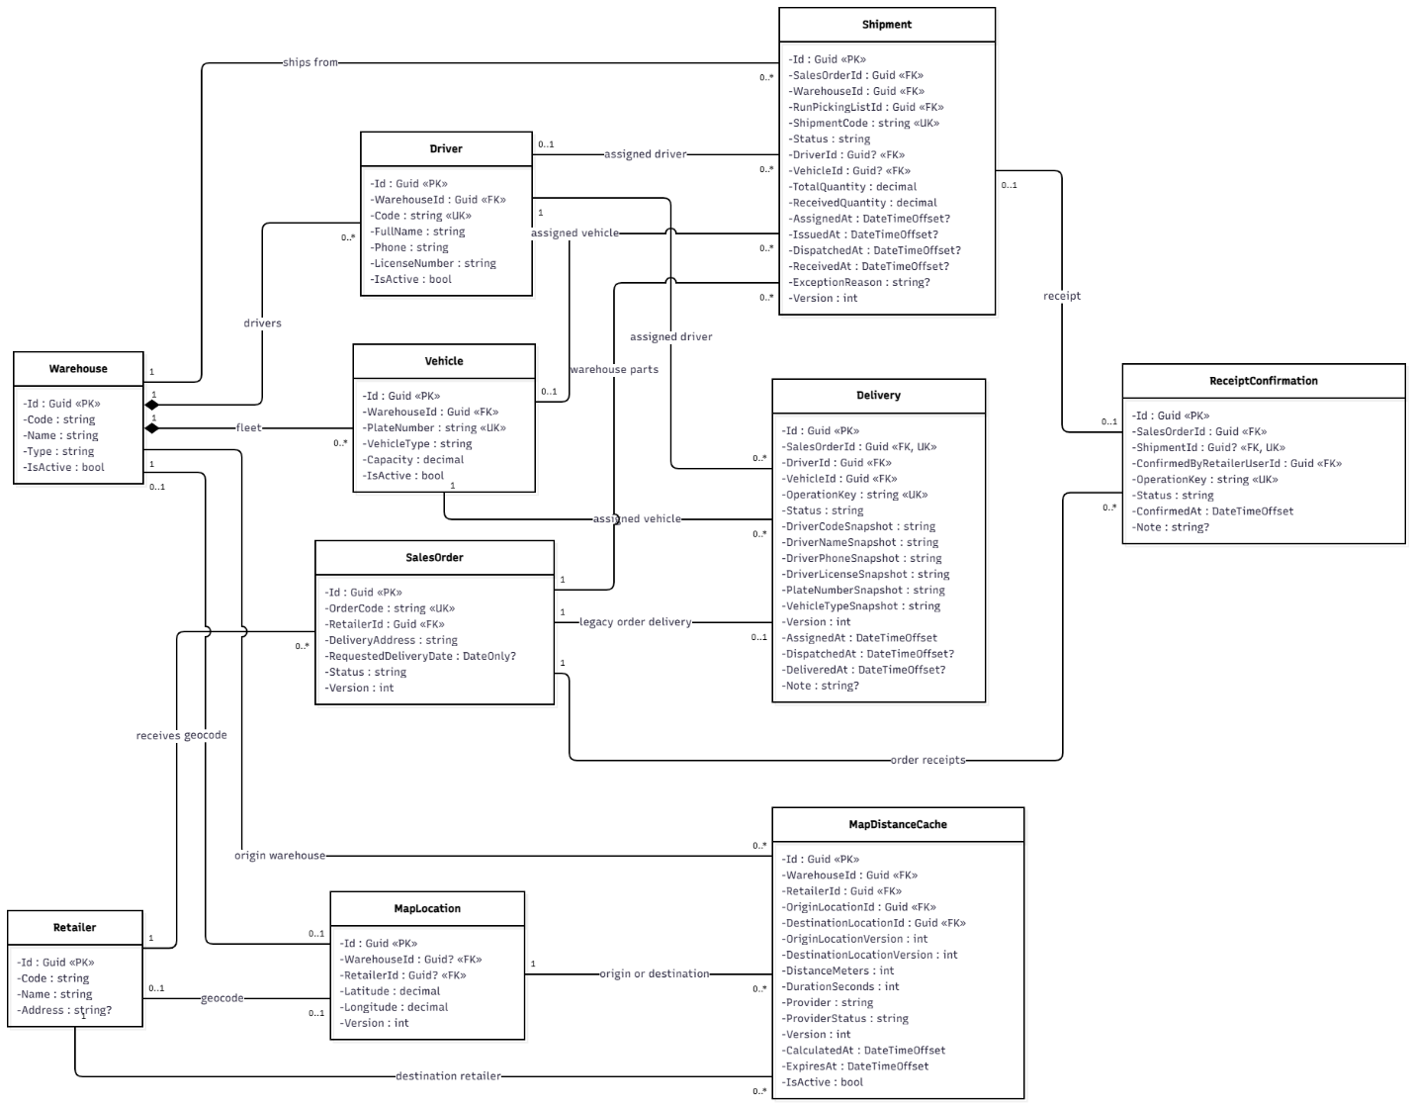
Figure 3.12.1 – Delivery Operations Class Diagram

3.12.2 Sequence Diagram: Process Delivery Assignment
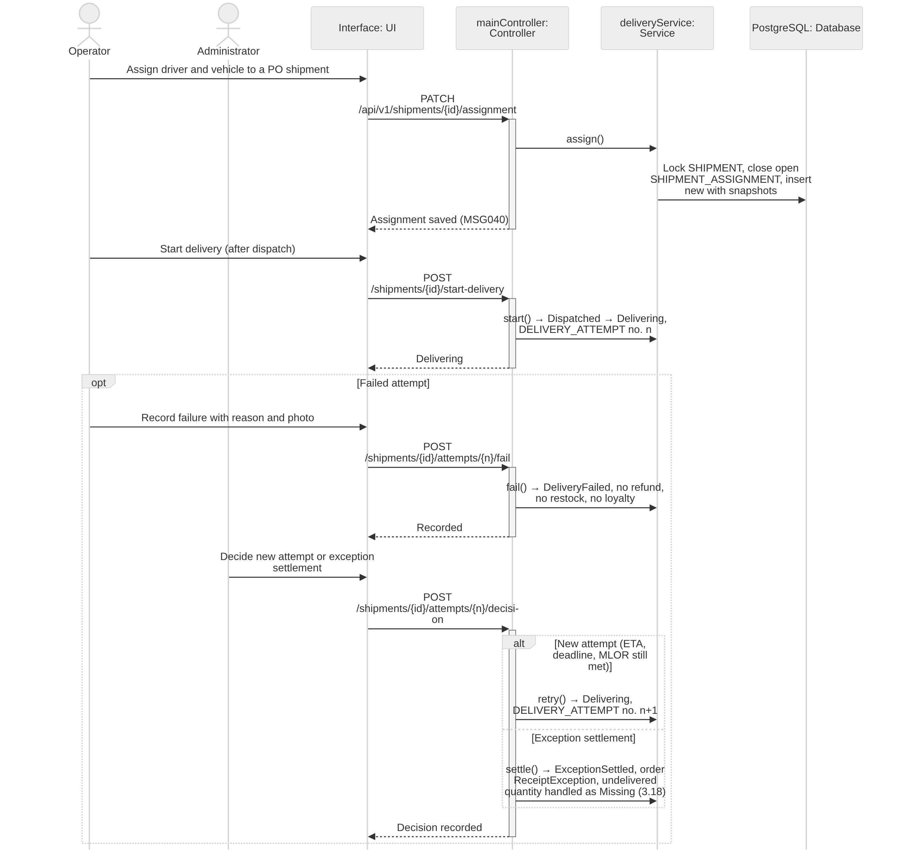
Figure 3.12.2 – Process Delivery Assignment Sequence Diagram

3.12.3 Transaction, Idempotency, Concurrency and Exception Handling
Delivery assignment changes only shipment data; it never changes stock, payment or loyalty (BR-76). Common conventions TX/ID/CC/EX are defined in Table 3.0; the tables below state the design of each function.
3.12.3.1 Process Delivery Assignment (Figure 3.12.2)
Aspect | Design
Transaction boundary | Assign: one transaction locks the SHIPMENT, validates that the order is a PO and that driver and vehicle are active in the same warehouse, closes the current SHIPMENT_ASSIGNMENT row and inserts the new one with driver/vehicle snapshots. Start delivery: Dispatched → Delivering, a new DELIVERY_ATTEMPT row and order status recomputation in one transaction. Record failure: evidence uploaded first (SHIPMENT_ATTACHMENT), then the attempt outcome, reason, Delivering → DeliveryFailed, history, audit and outbox notifications. The Administrator decision (new attempt or exception settlement) is stored on the DELIVERY_ATTEMPT in its own transaction (3.8.6).
Idempotency | ID-1; conditional transitions; unique (ShipmentId, AttemptNo) on DELIVERY_ATTEMPT and one open SHIPMENT_ASSIGNMENT per shipment; re-assigning the same driver and vehicle is a no-op.
Concurrency control | CC-1 on SHIPMENT; driver and vehicle rows are read FOR KEY SHARE so they cannot be deactivated during the assignment. Start delivery and dispatch confirmation lock the same shipment row, so Delivering can never precede Dispatched.
Exception handling | Shipment of a non-PO order → 409 (AC-3.13.1-01); inactive driver/vehicle → 422; Start delivery before dispatch → 409 (AC-3.13.1-03); failure without reason or evidence → 400 MSG001; invalid file → 400 MSG049; new attempt only while ETA, deadline and MLOR are still met, otherwise 422 and the Administrator must settle. Settlement consequences: dispatched stock is not restored, the undelivered quantity becomes a Missing discrepancy decided in 3.18 (adjustment, refund obligation if paid), the order stays ReceiptException until that decision and no loyalty is posted.
Table 3.12.3.1 – Transaction, idempotency, concurrency and exception design: Process Delivery Assignment

3.13 Daily Allocation Run, Approval & Reservation

3.13.1 Class Diagram
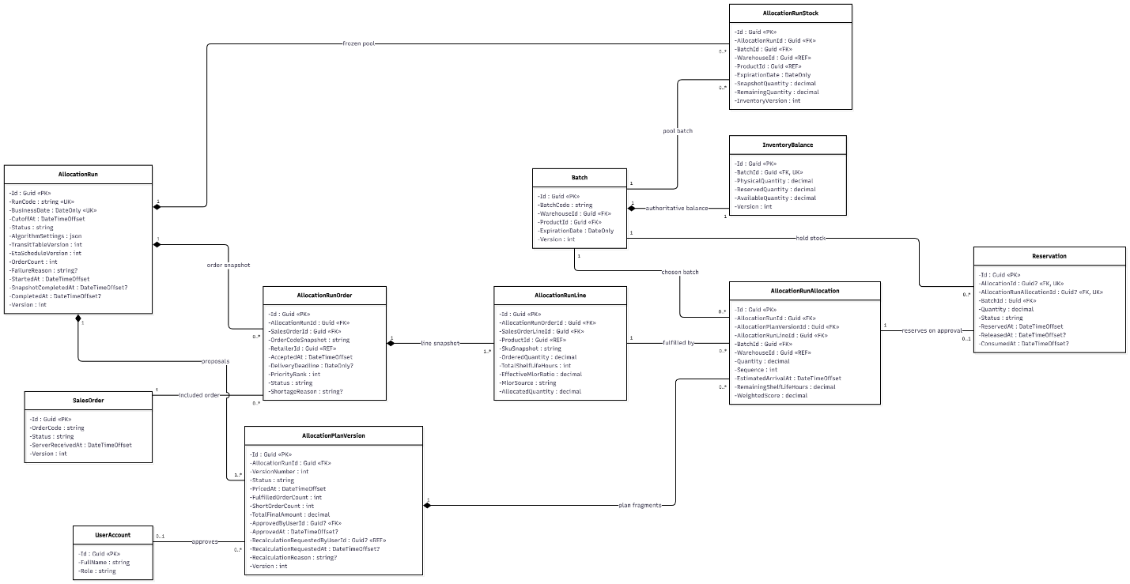
Figure 3.13.1 – Daily Allocation Run, Approval & Reservation Class Diagram

3.13.2 Sequence Diagram: Execute Daily Allocation Run and Generate Proposal
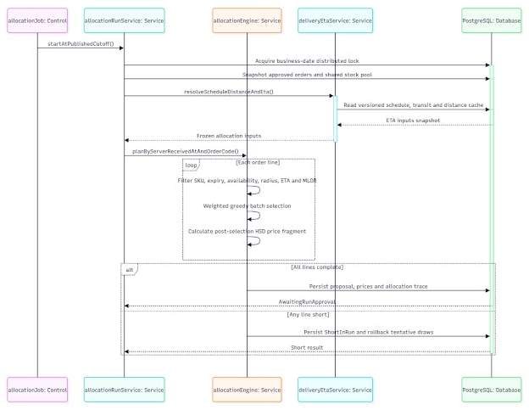
Figure 3.13.2 – Execute Daily Allocation Run and Generate Proposal Sequence Diagram

3.13.3 Sequence Diagram: Review, Approve or Recalculate Allocation Plan
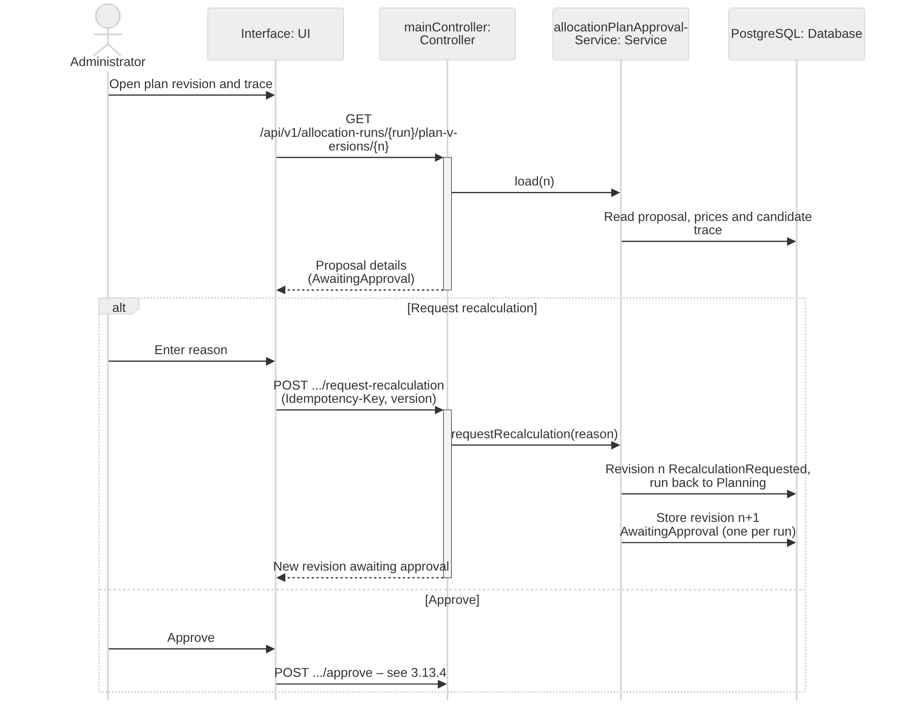
Figure 3.13.3 – Review, Approve or Recalculate Allocation Plan Sequence Diagram

3.13.4 Sequence Diagram: Revalidate and Atomically Commit Reservations
Figure 3.13.4 – Revalidate and Atomically Commit Reservations Sequence Diagram

3.13.5 Sequence Diagram: Cancel Reserved Order Before Picking and Release Reservation
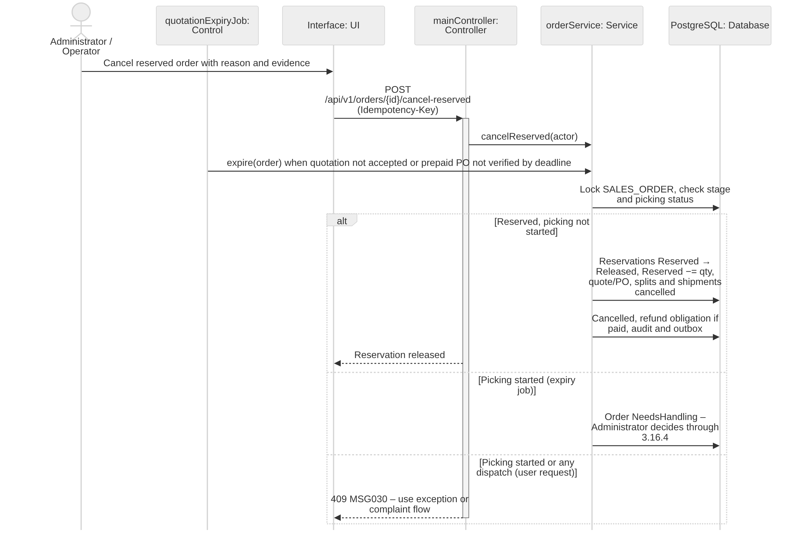
Figure 3.13.5 – Cancel Reserved Order Before Picking and Release Reservation Sequence Diagram

3.13.6 Sequence Diagram: Close Allocation Run and Report Outcomes
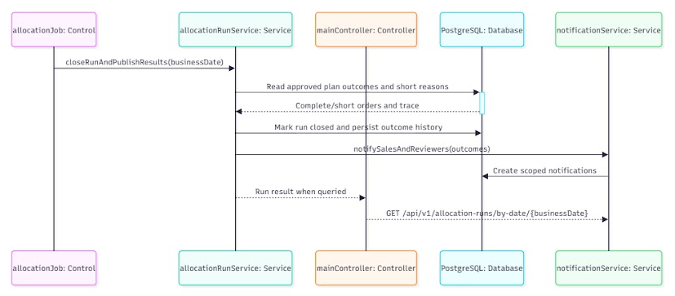
Figure 3.13.6 – Close Allocation Run and Report Outcomes Sequence Diagram

3.13.7 Transaction, Idempotency, Concurrency and Exception Handling
The daily run is the most concurrency-sensitive flow: one run per day, deterministic proposals, atomic reservation with revalidation and a bounded retry (BR-27, BR-28, BR-37, BR-38, NFR-R04, NFR-R05). Common conventions TX/ID/CC/EX are defined in Table 3.0; the tables below state the design of each function.
3.13.7.1 Execute Daily Allocation Run and Generate Proposal (Figure 3.13.2)
Aspect | Design
Transaction boundary | Triggered at 00:00 Asia/Ho_Chi_Minh (cutoff of business date D) by the job host, recorded in JOB_RUN. Stages follow the AllocationRun state machine (3.6.4): Snapshotting (snapshot transaction) → Planning (computation, then result transaction) → AwaitingApproval, or Failed (separate transaction with reason). Order admission, snapshots and plan revision 1 are persisted exactly as in 3.6.8.1.
Idempotency | Unique run code AR-yyMMdd, unique ALLOCATION_RUN (BusinessDate) and unique JOB_RUN (job, business date); a second trigger the same day returns the existing run. A crashed run resumes from its last committed stage; a Failed run is re-executed by the Administrator under the same run code (Failed → Snapshotting).
Concurrency control | CC-4 advisory lock per business date. Admitted orders are locked so they cannot be edited or cancelled while the run is Running (BR-28, AC-3.6.4-02). Stock is read at REPEATABLE READ; it is not locked during computation, and changes are caught at approval through the stored versions.
Exception handling | Snapshot or result failure → run Failed with reason, orders back to Awaiting allocation, alert if the run is not AwaitingApproval by 00:15 (NFR-R05). An order that cannot be fully allocated is a normal result (AllocationRunOrder InsufficientStock, MSG025), not an error.
Table 3.13.7.1 – Transaction, idempotency, concurrency and exception design: Execute Daily Allocation Run and Generate Proposal
3.13.7.2 Review, Approve or Recalculate Allocation Plan (Figure 3.13.3)
Aspect | Design
Transaction boundary | Recalculate: one transaction records the reason and sets the reviewed ALLOCATION_PLAN_VERSION RecalculationRequested and the run back to Planning; the new revision is computed outside the transaction and stored in a second transaction as AwaitingApproval (the run returns to AwaitingApproval). Approve delegates to 3.13.4.
Idempotency | ID-1 on Recalculate; unique (RunId, RevisionNo); a partial unique index allows only one AwaitingApproval revision per run, so a double click cannot produce two competing revisions.
Concurrency control | CC-1 on ALLOCATION_PLAN_VERSION and FOR UPDATE on ALLOCATION_RUN: the Administrator acts only on the revision that was displayed; acting on a superseded revision fails.
Exception handling | Recalculate without reason → 400 MSG001; superseded revision → 409 MSG053; non-Administrator → 403 MSG006; run not Awaiting approval → 409.
Table 3.13.7.2 – Transaction, idempotency, concurrency and exception design: Review, Approve or Recalculate Allocation Plan
3.13.7.3 Revalidate and Atomically Commit Reservations (Figure 3.13.4)
Aspect | Design
Transaction boundary | One transaction, as specified in 3.6.3: lock run, revision and affected balances; revalidate; insert reservations, increase Reserved, append inventory transactions, create payment obligations and versioned quotations with the BR-72 deadline, set orders Awaiting quotation acceptance, mark revision and run Approved, audit and outbox. Picking lists and shipments are not created here; they are released only when the Retailer accepts the quotation and the PO is issued (3.16.2).
Idempotency | ID-1 on the approval command; unique RESERVATION per fragment and unique quotation per (order, revision). Repeated approval or retry after timeout returns the committed result (AC-3.7.2-03).
Concurrency control | Balance rows locked in BatchId order (CC-2); revision version compared with the reviewed version (CC-1). If any check fails nothing is reserved and a new revision is produced for renewed review (BR-38, BR-64).
Exception handling | Changed stock, batch status, lock, ETA, MLOR or price version → 409 MSG053; transient database errors retried up to 3 times (BR-38); after that the run stays Awaiting approval, nothing is reserved and an alert is raised; MSG021 if a check constraint is hit.
Table 3.13.7.3 – Transaction, idempotency, concurrency and exception design: Revalidate and Atomically Commit Reservations
3.13.7.4 Cancel Reserved Order Before Picking and Release Reservation (Figure 3.13.5)
Aspect | Design
Transaction boundary | One transaction locks SALES_ORDER, then the affected INVENTORY_BALANCE rows, moves every RESERVATION in status Reserved to Released, decreases Reserved, appends ReserveRelease inventory transactions, cancels the quotation and, if a PO exists, the PO with its not-started picking splits and shipments, creates a Pending MANUAL_REFUND if payment was received (BR-66) and writes history, audit and outbox messages. The quotation-expiry job (BR-72) calls the same use case with the system actor when a quotation is not accepted by its deadline or a prepaid PO is not verified by that deadline; if picking has already started it sets the order NeedsHandling instead and the Administrator cancels through 3.16.4.
Idempotency | ID-1 for user cancellations; the job uses the key (job, order id, quotation version). Release is conditional WHERE Status = 'Reserved', so expiry and a manual cancel racing on the same order release stock once; unique refund per (order, cancellation).
Concurrency control | The order lock serializes cancellation with picking start and with quotation acceptance: whichever commits first wins, and the other sees the new status (e.g. acceptance after expiry → 409).
Exception handling | Picking already started → 409 MSG030 for ordinary cancellation (Administrator uses 3.16.4); any shipment dispatched → 409 MSG030 (BR-26); missing evidence → 400 MSG029; caller not Administrator/Operator → 403 MSG006; money received after cancellation → refund obligation only.
Table 3.13.7.4 – Transaction, idempotency, concurrency and exception design: Cancel Reserved Order Before Picking and Release Reservation
3.13.7.5 Close Allocation Run and Report Outcomes (Figure 3.13.6)
Aspect | Design
Transaction boundary | One transaction locks ALLOCATION_RUN, verifies that every admitted order is in a terminal state for the run (dispatched, cancelled with reconciliation, insufficient stock, or exception settled), stores the outcome counters and sets the run Closed with AUDIT_LOG.
Idempotency | ID-3: closing a Closed run returns it unchanged.
Concurrency control | FOR UPDATE on ALLOCATION_RUN; order transitions that belong to the run take FOR KEY SHARE on the run row, so they cannot commit between the check and the close.
Exception handling | Unreconciled orders → 409 listing them (BR-40); open refund obligations remain visible in review lists and do not block closing (BR-70).
Table 3.13.7.5 – Transaction, idempotency, concurrency and exception design: Close Allocation Run and Report Outcomes

3.14 Batch Pricing & Price Traceability

3.14.1 Class Diagram
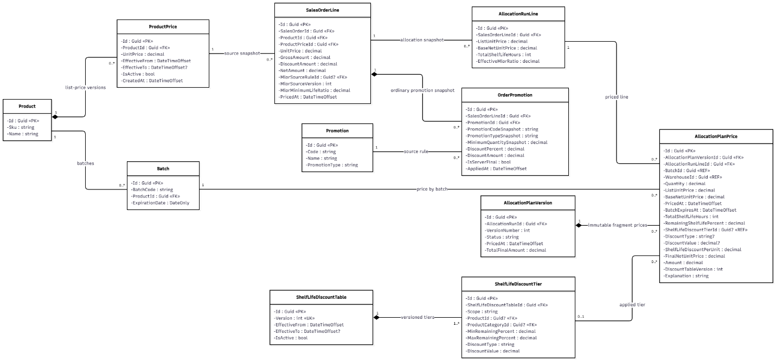
Figure 3.14.1 – Batch Pricing & Price Traceability Class Diagram

3.14.2 Sequence Diagram: Configure Remaining-Shelf-Life Discount Rules
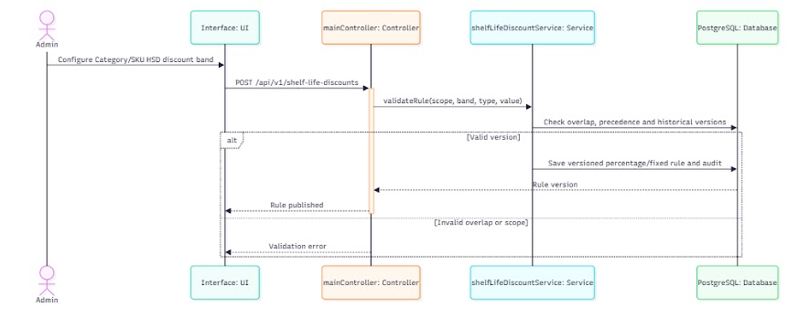
Figure 3.14.2 – Configure Remaining-Shelf-Life Discount Rules Sequence Diagram

3.14.3 Sequence Diagram: Calculate Batch-Specific Final Prices after Allocation
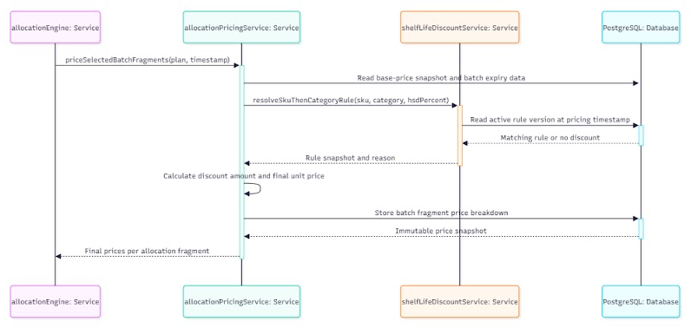
Figure 3.14.3 – Calculate Batch-Specific Final Prices after Allocation Sequence Diagram

3.14.4 Sequence Diagram: Persist and Retrieve Immutable Batch Price Trace
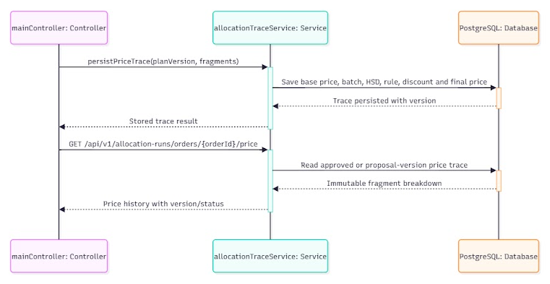
Figure 3.14.4 - Persist and Retrieve Immutable Batch Price Trace Sequence Diagram

3.14.5 Transaction, Idempotency, Concurrency and Exception Handling
Batch prices are computed deterministically at the run pricing point and stored as an immutable trace (BR-19, BR-79, NFR-D01, NFR-D02). Common conventions TX/ID/CC/EX are defined in Table 3.0; the tables below state the design of each function.
3.14.5.1 Configure Remaining-Shelf-Life Discount Rules (Figure 3.14.2)
Aspect | Design
Transaction boundary | Each create, edit, pause or activate of a SHELF_LIFE_DISCOUNT_TIER is one transaction with AUDIT_LOG; an edit of a tier already used by a priced plan creates a new SHELF_LIFE_DISCOUNT_TABLE version instead of updating it. Each tier stores scope (SKU or Category), remaining-life range [from %, to %), DiscountType (Percentage | FixedPerUnit) and DiscountValue.
Idempotency | ID-1; unique rule code (HG-nn).
Concurrency control | A PostgreSQL exclusion constraint on (scope, target, numrange[from %, to %)) for Active rules rejects overlapping ranges even when two Administrators save at the same time; CC-1 for edits.
Exception handling | Overlapping range → 422 (AC-3.5.4-04); Percentage not strictly between 0 and 100 % → 400 MSG002; FixedPerUnit ≤ 0 → 400 MSG002; a FixedPerUnit value that would make the final unit price of any active SKU in scope ≤ 0 is rejected at pricing time (3.14.5.2), never silently clamped; non-Administrator → 403 MSG006.
Table 3.14.5.1 – Transaction, idempotency, concurrency and exception design: Configure Remaining-Shelf-Life Discount Rules
3.14.5.2 Calculate Batch-Specific Final Prices after Allocation (Figure 3.14.3)
Aspect | Design
Transaction boundary | Executed inside the planning step of the run and persisted in the plan result transaction (3.6.8.1). For each allocated batch line: base unit price = list price after the best ordinary promotion; tier = SKU tier, else Category tier (nearest ancestor), else none; final unit price = base × (1 − p) for Percentage or base − v for FixedPerUnit; DiscountAmount = (base − final unit price) × allocated quantity; line amount = final unit price × quantity, rounded half-up to whole VND per batch line. ALLOCATION_PLAN_PRICE stores list price, promotion code and amount, base price, tier code and table version, DiscountType, DiscountValue, DiscountAmount, final unit price, quantity and line amount.
Idempotency | Deterministic: the same revision and snapshot always give the same ALLOCATION_PLAN_PRICE rows; unique (PlanVersionId, RunLineId, BatchId) prevents duplicate price rows if the result transaction is retried.
Concurrency control | No locks; configuration changes after the snapshot do not affect the run (BR-57).
Exception handling | No matching tier → discount 0 (not an error); final unit price ≤ 0 → the line is not priced, the run records the reason and the revision cannot be approved until the tier is corrected (EX22, no free goods); missing base price or table version in the snapshot → run Failed with a logged reason instead of pricing at 0; rounding is unit-tested for both discount types (NFR-D01).
Table 3.14.5.2 – Transaction, idempotency, concurrency and exception design: Calculate Batch-Specific Final Prices after Allocation
3.14.5.3 Persist and Retrieve Immutable Batch Price Trace (Figure 3.14.4)
Aspect | Design
Transaction boundary | Price trace rows are written once with their plan revision. Retrieval is read-only in one READ ONLY transaction (TX-4) covering receipt → batch → allocation → reservation → picking → dispatch → receipt → complaint (NFR-D03).
Idempotency | Writes are covered by the unique key of 3.14.3; reads are safe GETs.
Concurrency control | No update or delete API exists; a database trigger rejects UPDATE/DELETE on price rows of an Approved revision, so the trace is immutable even under concurrent maintenance.
Exception handling | Unknown label or order → 404; out of scope → 403 MSG006; attempted modification → 409 and logged.
Table 3.14.5.3 – Transaction, idempotency, concurrency and exception design: Persist and Retrieve Immutable Batch Price Trace

3.15 Inventory Expiry Monitoring & Stock Blocking

3.15.1 Class Diagram
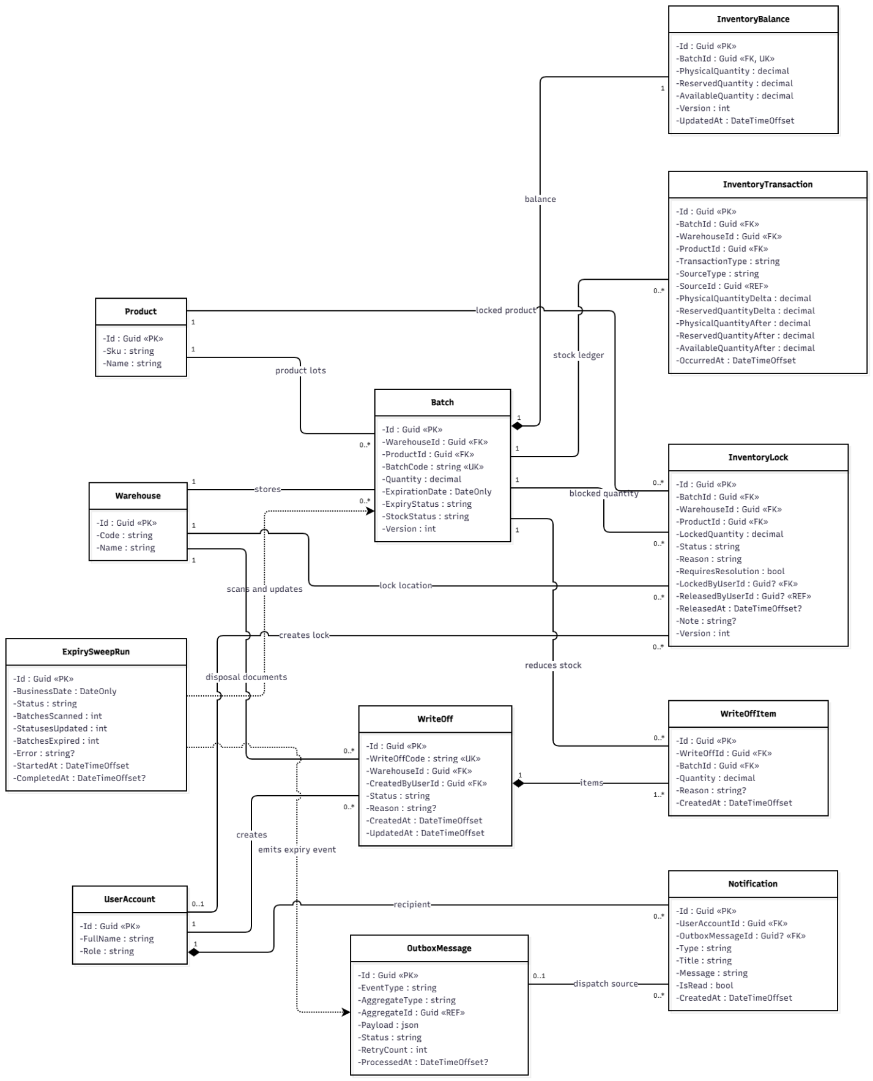
Figure 3.15.1 – Inventory Expiry Monitoring & Stock Blocking Class Diagram

3.15.2 Sequence Diagram: Monitor Batch Expiry and Update Eligibility
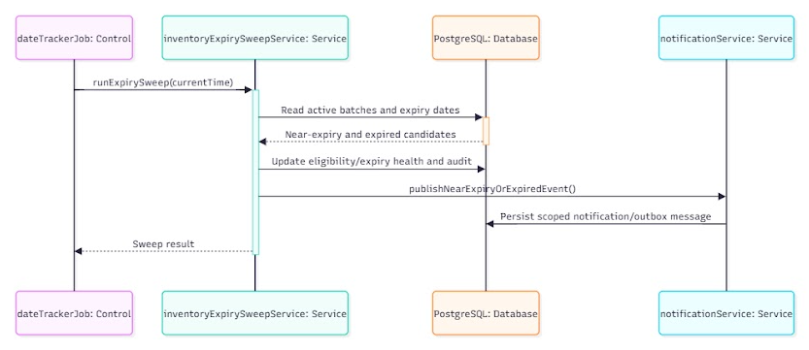
Figure 3.15.2 – Monitor Batch Expiry and Update Eligibility Sequence Diagram

3.15.3 Sequence Diagram: Block Damaged or Expired Stock and Resolve Reserved Stock
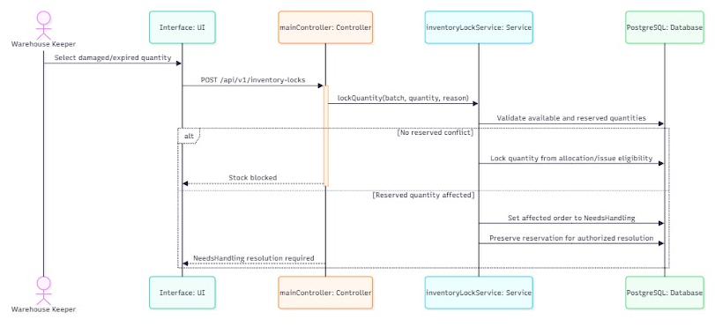
Figure 3.15.3 – Block Damaged or Expired Stock and Resolve Reserved Stock Sequence Diagram

3.15.4 Sequence Diagram: Approve and Process Inventory Write-Off
Figure 3.15.4 – Approve and Process Inventory Write-Off Sequence Diagram

3.15.5 Transaction, Idempotency, Concurrency and Exception Handling
Expiry detection, stock locks and write-offs must keep Available correct and never write off reserved stock (BR-43, BR-44, BR-71). Common conventions TX/ID/CC/EX are defined in Table 3.0; the tables below state the design of each function.
3.15.5.1 Monitor Batch Expiry and Update Eligibility (Figure 3.15.2)
Aspect | Design
Transaction boundary | Daily job at 23:30 ICT, before the 00:00 run of the next business date (JOB_RUN row). EXPIRY_SWEEP_RUN keeps the detailed counters for that date; batches are processed in chunks of a configurable size, each chunk one transaction that updates ExpiryState (Normal / Near-expiry / Expired) and writes outbox events for state changes.
Idempotency | Unique JOB_RUN (job, business date) and unique EXPIRY_SWEEP_RUN (BusinessDate); the update is conditional (WHERE ExpiryState <> new state), so re-running the sweep changes nothing and emits no duplicate events (NFR-R04).
Concurrency control | CC-4 advisory lock per date; batch updates take row locks briefly, so the 00:00 snapshot sees either the old or the new state of a batch, never a mixture. The run additionally filters EXP − ETA, so an expired batch is never allocated.
Exception handling | A failed chunk rolls back alone; the sweep is marked Failed with the error and resumes from the next unprocessed batch. Allocation independently filters EXP − ETA, so an expired batch is never allocated even if the sweep failed.
Table 3.15.5.1 – Transaction, idempotency, concurrency and exception design: Monitor Batch Expiry and Update Eligibility
3.15.5.2 Block Damaged or Expired Stock and Resolve Reserved Stock (Figure 3.15.3)
Aspect | Design
Transaction boundary | Lock: evidence uploaded first (INVENTORY_LOCK_ATTACHMENT). One transaction locks the affected SALES_ORDER rows (found through Reserved reservations on the batch), then the INVENTORY_BALANCE row (CC-3, CC-2); it checks quantity ≤ OnHand − (Locked − LockedReserved), inserts INVENTORY_LOCK, increases Locked, and increases LockedReserved by the part of the lock that exceeds the free quantity (OnHand − Reserved − Locked + LockedReserved). If LockedReserved grows, the affected orders become Needs handling and their shipments are blocked; reservations stay Reserved, so Available is not reduced twice. An INVENTORY_TRANSACTION (Lock) and outbox notifications are written. Unlock (Administrator only) reverses Locked and LockedReserved in one transaction.
Idempotency | ID-1; unlock is conditional WHERE Status = 'Active', so a lock is released once; releasing a reservation later (cancellation) moves the overlapping quantity from LockedReserved to free Locked in the same transaction.
Concurrency control | Locks follow CC-3 order: affected SALES_ORDER rows first, then INVENTORY_BALANCE. The balance row lock serializes stock locking with reservation commit, dispatch and write-off approval; the CC-2 check constraints are the final guard.
Exception handling | Quantity above OnHand − (Locked − LockedReserved) → 422 MSG020; unassigned warehouse → 403 MSG006; unlock by non-Administrator → 403 MSG006; missing reason/evidence → 400 MSG001.
Table 3.15.5.2 – Transaction, idempotency, concurrency and exception design: Block Damaged or Expired Stock and Resolve Reserved Stock
3.15.5.3 Approve and Process Inventory Write-Off (Figure 3.15.4)
Aspect | Design
Transaction boundary | Same transaction design as 3.7.7.3: lock write-off and balances, re-check quantity ≤ OnHand − Reserved, decrease OnHand, decrease Locked for the written-off locked quantity and close the lock, invalidate labels, append inventory transactions, audit. LockedReserved quantity must be resolved through the order exception flow first.
Idempotency | Conditional Pending → Approved plus unique inventory transaction per write-off item; double approval deducts once.
Concurrency control | CC-2 on balances; a quantity still reserved must first be released through the order exception flow (3.13.5).
Exception handling | Reserved quantity included → 409 MSG047; non-Administrator → 403 MSG006; reject without reason → 400 MSG001.
Table 3.15.5.3 – Transaction, idempotency, concurrency and exception design: Approve and Process Inventory Write-Off

3.16 Shipment Readiness, Dispatch & Exception Handling

3.16.1 Class Diagram
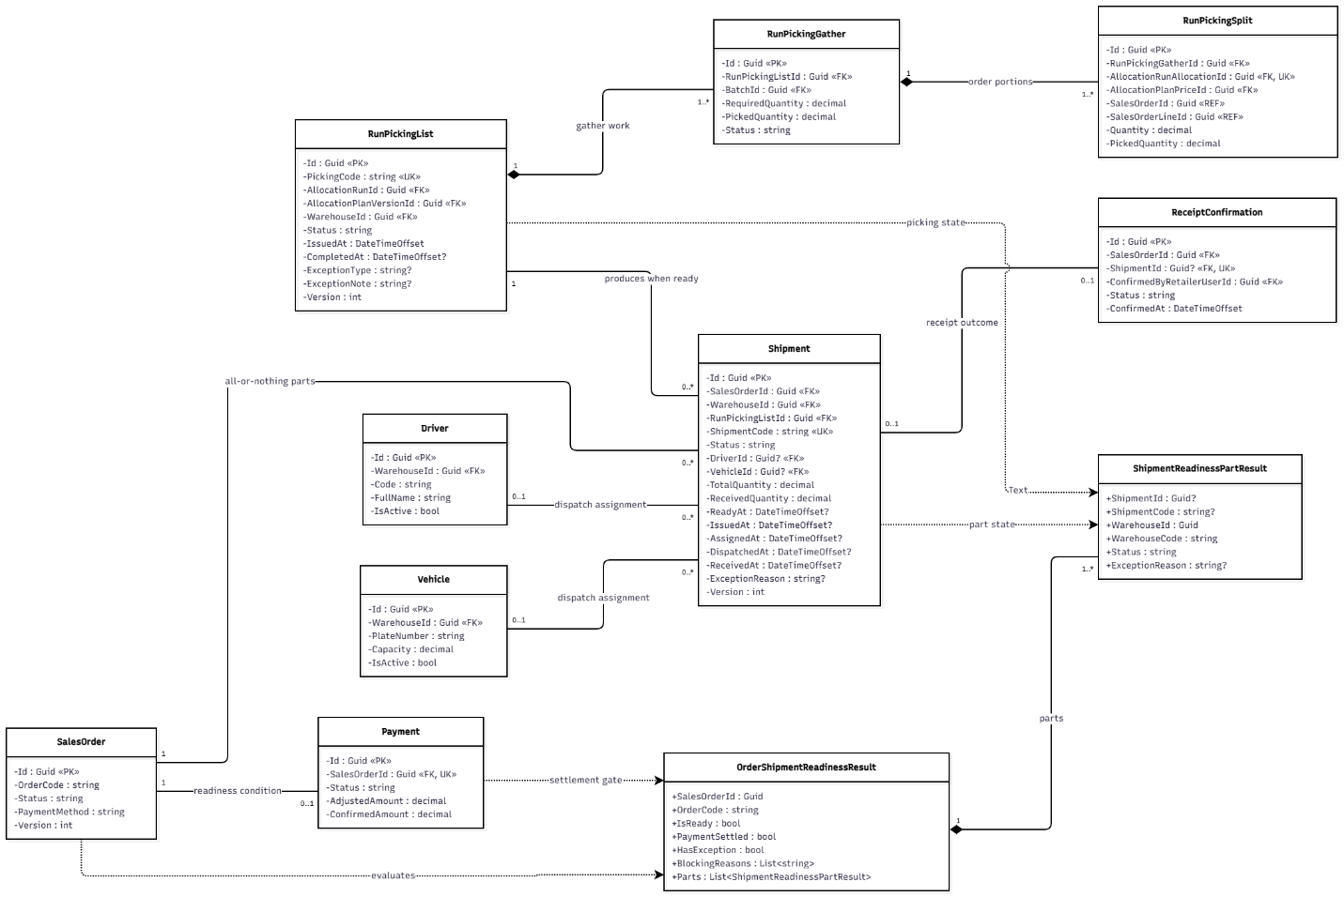
Figure 3.16.1 – Shipment Readiness, Dispatch & Exception Handling Class Diagram

3.16.2 Sequence Diagram: Accept Quotation, Issue PO and Generate Warehouse Shipments
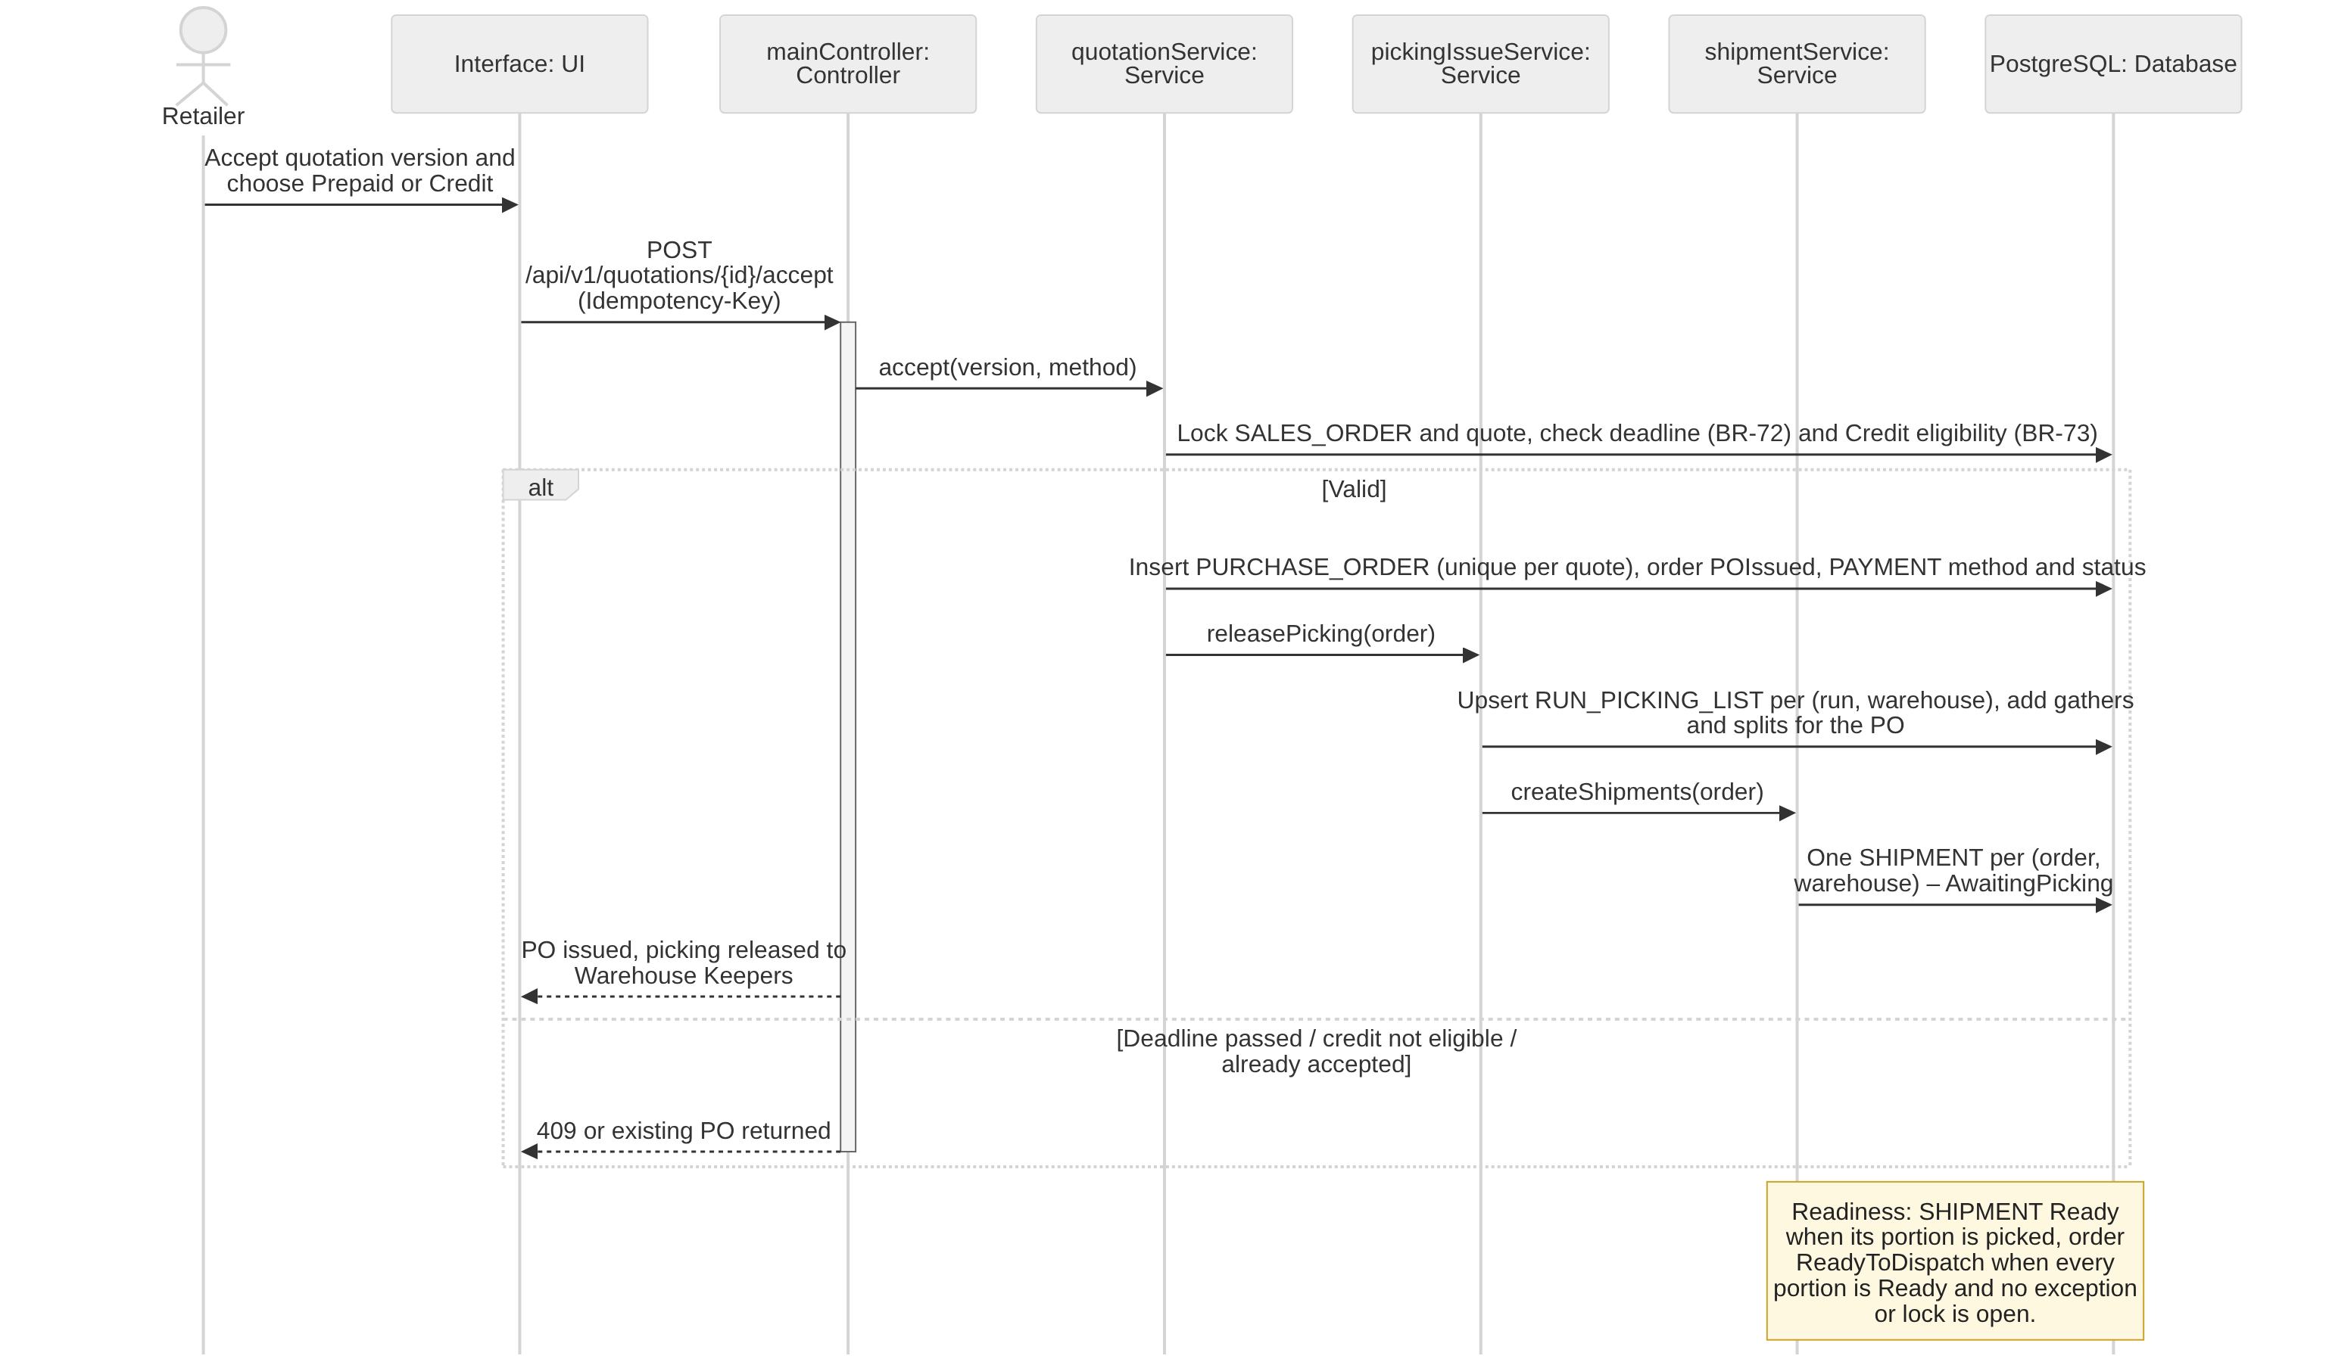
Figure 3.16.2 – Accept Quotation, Issue PO and Generate Warehouse Shipments Sequence Diagram

3.16.3 Sequence Diagram: Assign Delivery Personnel and Confirm Warehouse Dispatch
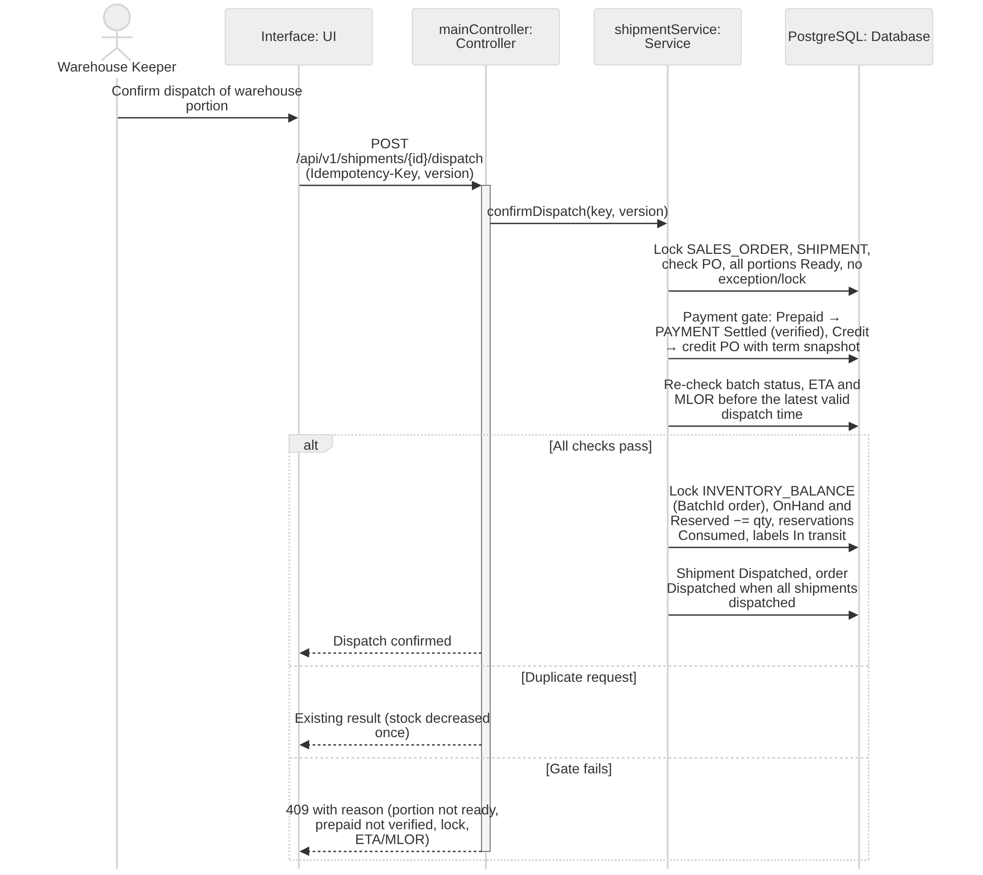
Figure 3.16.3 – Assign Delivery Personnel and Confirm Warehouse Dispatch Sequence Diagram

3.16.4 Sequence Diagram: Handle Picking or Shipment Exceptions and Record Actual Receipt
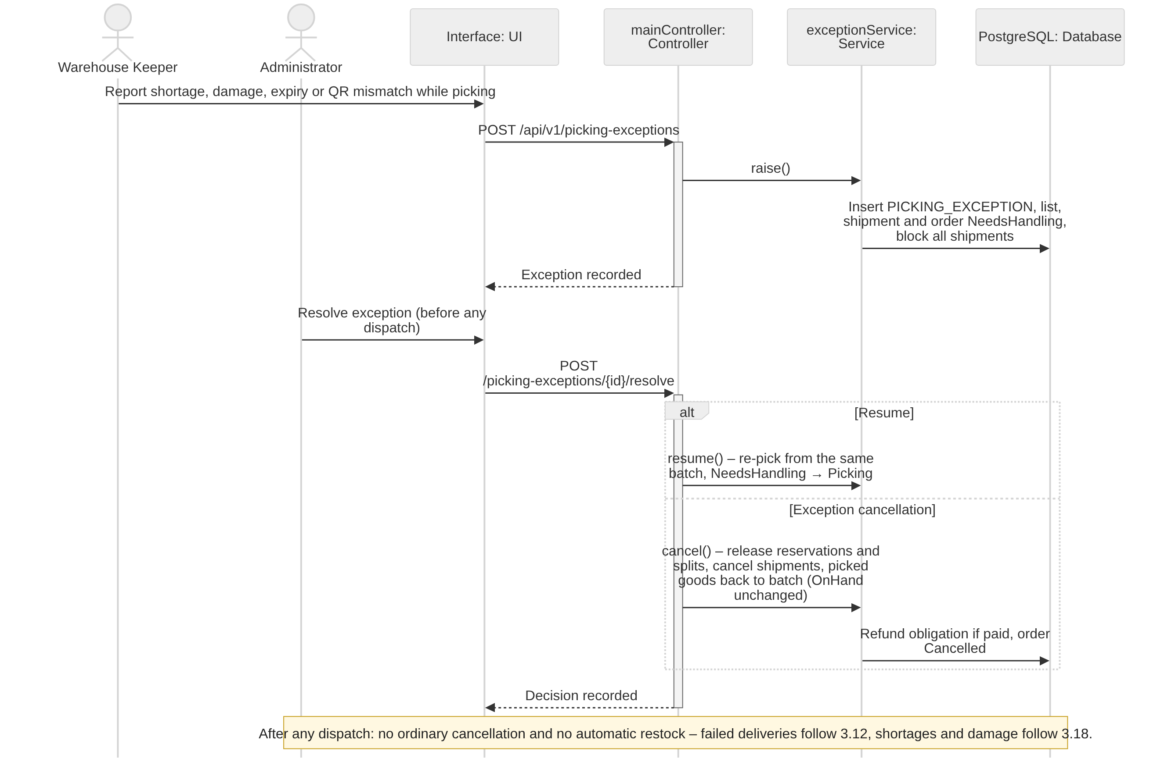
Figure 3.16.4 – Handle Picking or Shipment Exceptions and Record Actual Receipt Sequence Diagram

3.16.5 Transaction, Idempotency, Concurrency and Exception Handling
Whole-order readiness (BR-46) and exactly-once dispatch (BR-47) are enforced by locking the order before its shipments and stock rows. Common conventions TX/ID/CC/EX are defined in Table 3.0; the tables below state the design of each function.
3.16.5.1 Accept Quotation, Issue PO and Generate Warehouse Shipments (Figure 3.16.2)
Aspect | Design
Transaction boundary | Shipments and picking splits are generated in the same transaction that accepts the quotation and issues the PO (3.16.2): PURCHASE_ORDER, one SHIPMENT per (order, warehouse) in AwaitingPicking, gather and split rows on the warehouse RUN_PICKING_LIST and an outbox notification to the Warehouse Keeper. Credit eligibility is re-checked in this transaction (BR-73); a prepaid order is released for picking without waiting for the transfer because the payment gate is at dispatch. The readiness check is one transaction that locks the order and sets it ReadyToDispatch only when all shipments are Ready and no exception or lock is open.
Idempotency | Unique SHIPMENT (SalesOrderId, WarehouseId), unique RUN_PICKING_LIST (RunId, WarehouseId) and unique PURCHASE_ORDER per quotation: "exactly once" picking release even if Accept is submitted twice (AC-3.6.6-06).
Concurrency control | SALES_ORDER FOR UPDATE (CC-3) so a picking exception and the readiness check cannot interleave; picking list rows are created with INSERT … ON CONFLICT so two POs of the same run and warehouse share one list safely.
Exception handling | Quotation expired, superseded or already rejected → 409; Credit without a valid term → 422 and the Retailer may choose Prepaid within the remaining deadline (BR-73); open exception → 409 with Needs handling (BR-46).
Table 3.16.5.1 – Transaction, idempotency, concurrency and exception design: Accept Quotation, Issue PO and Generate Warehouse Shipments
3.16.5.2 Assign Delivery Personnel and Confirm Warehouse Dispatch (Figure 3.16.3)
Aspect | Design
Transaction boundary | Assignment as in 3.12.3. Dispatch (POST /api/v1/shipments/{id}/dispatch) is one transaction: lock SALES_ORDER, then the SHIPMENT; verify the PO, every portion Ready and no exception or lock on its batches; apply the payment gate – Prepaid requires PAYMENT Settled (transfer verified), Credit requires a credit PO with its term snapshot; re-check batch status, ETA and MLOR against the latest valid dispatch time; then lock INVENTORY_BALANCE rows in BatchId order, decrease OnHand and Reserved, set reservations Consumed, labels In transit and the shipment Dispatched, set the order Dispatched when all shipments are dispatched, append inventory transactions, audit and outbox.
Idempotency | confirmIssue(idempotencyKey, version) as in the sequence diagram: ID-1, conditional transition WHERE Status = 'Ready' and unique INVENTORY_TRANSACTION (ShipmentId, BatchId, Dispatch). A repeated confirmation returns the existing result and decreases stock once (AC-3.9.1-05).
Concurrency control | CC-3 lock order parent → shipment → balances; CC-1 on the shipment version sent by the client. Check constraints prevent negative OnHand or Reserved.
Exception handling | Not all portions Ready → 409 (AC-3.9.1-04); prepaid transfer not verified → 409 (payment gate, BR-66); batch expired, locked or no longer meeting ETA/MLOR → 409 MSG019 / MSG022 and the order goes to Needs handling; constraint violation → 409 MSG021; not the keeper of the warehouse → 403 MSG006.
Table 3.16.5.2 – Transaction, idempotency, concurrency and exception design: Assign Delivery Personnel and Confirm Warehouse Dispatch
3.16.5.3 Handle Picking or Shipment Exceptions and Record Actual Receipt (Figure 3.16.4)
Aspect | Design
Transaction boundary | Raising an exception is one transaction: insert PICKING_EXCEPTION (order, shipment, gather line, reason, evidence), set the picking list and shipment NeedsHandling and the order Needs handling, blocking all its shipments. Administrator resolution is one transaction per decision recorded on the PICKING_EXCEPTION: Resume (back to Picking / AwaitingPicking after re-pick from the same batch) or exception cancellation before dispatch through 3.13.7.4. Consequences before dispatch: OnHand never changes; cancellation releases the reservations, cancels splits and shipments and creates a refund obligation only if money was received; locked or damaged stock stays locked until an approved write-off. After any dispatch no PICKING_EXCEPTION or ordinary cancellation is allowed: a failed delivery follows 3.12.3 (new attempt or exception settlement) and missing or damaged quantities follow 3.18 (adjustment, refund obligation); dispatched stock is never restored automatically. Recording the actual received quantities of an exception shipment follows 3.8.8.2.
Idempotency | ID-1; conditional transitions on PICKING_EXCEPTION (Raised → Resolved/Cancelled); resolving a resolved exception is a no-op.
Concurrency control | SALES_ORDER FOR UPDATE serializes exception raising, resolution and dispatch; while an exception is open the dispatch check fails, so no warehouse ships its portion (BR-46).
Exception handling | Substitution of another batch → 422 (BR-45); cancellation after any dispatch → 409 MSG030; non-Administrator resolution → 403 MSG006.
Table 3.16.5.3 – Transaction, idempotency, concurrency and exception design: Handle Picking or Shipment Exceptions and Record Actual Receipt

3.17 Accounts Receivable & Debt Collection

3.17.1 Class Diagram
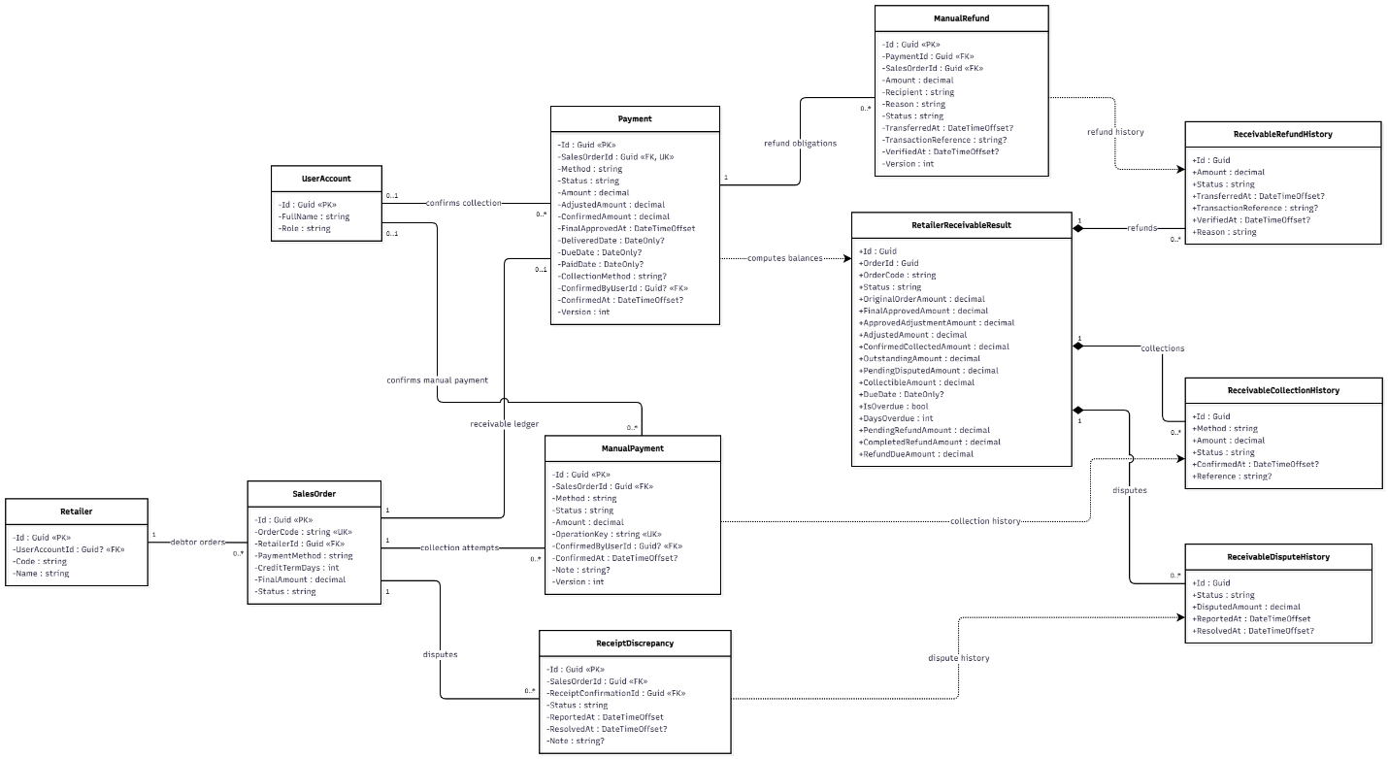
Figure 3.17.1 – Accounts Receivable & Debt Collection Class Diagram

3.17.2 Sequence Diagram: Create Receivable from Approved Final Order Amount
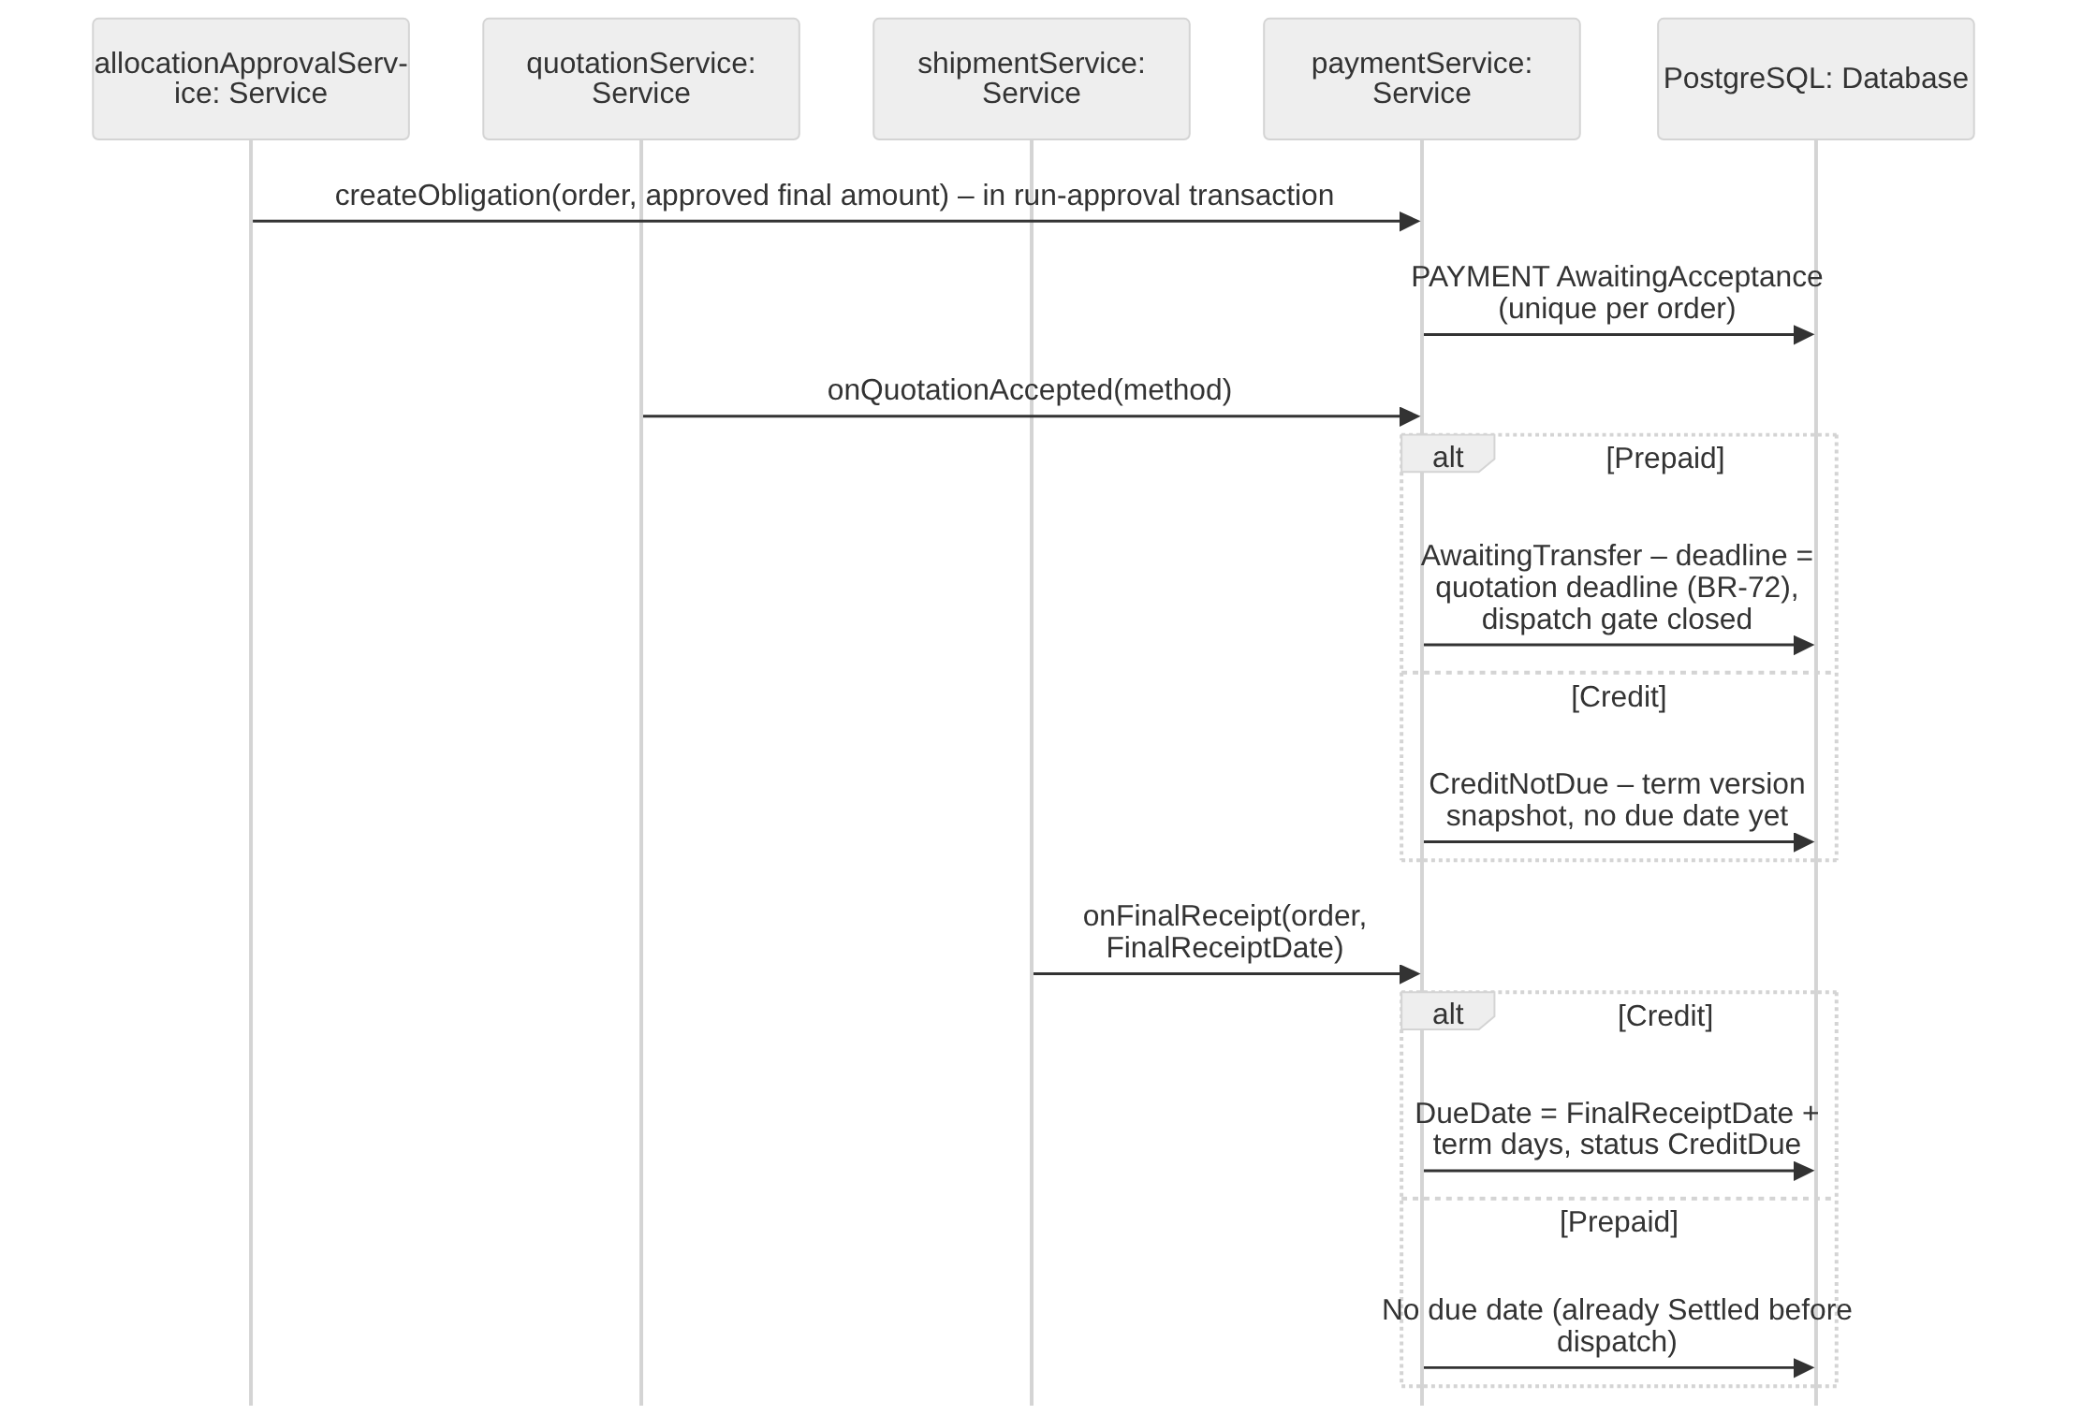
Figure 3.17.2 – Create Receivable from Approved Final Order Amount Sequence Diagram

3.17.3 Sequence Diagram: Record and Validate One-Time Full Payment
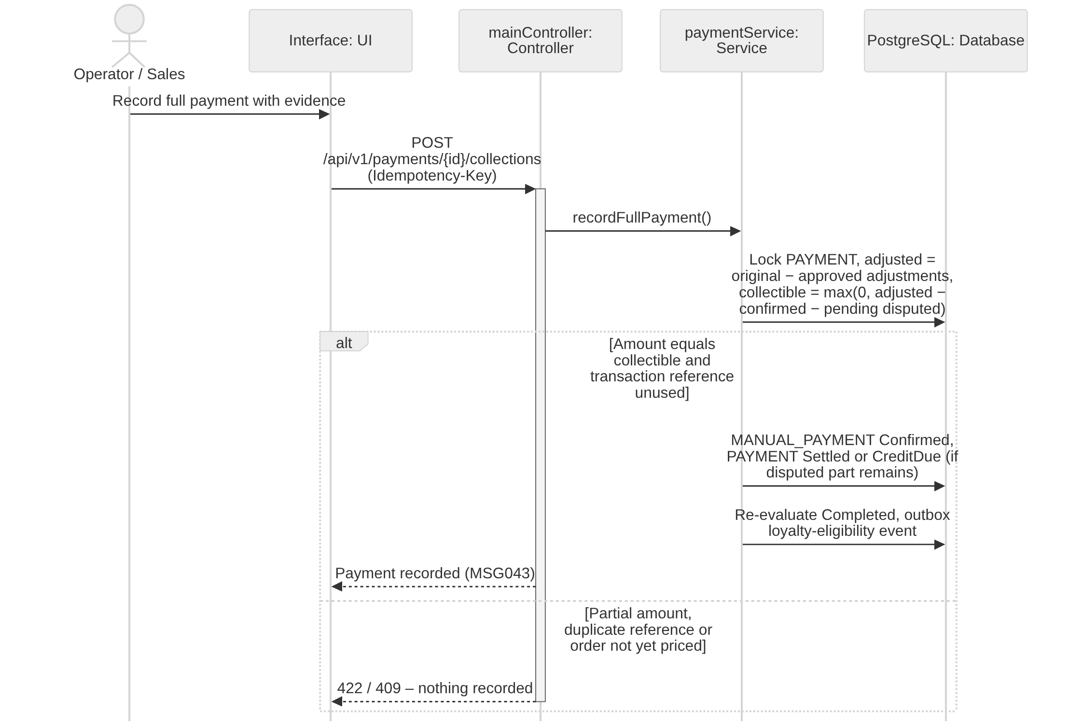
Figure 3.17.3 – Record and Validate One-Time Full Payment Sequence Diagram

3.17.4 Sequence Diagram: Detect Overdue Receivables and Send Reminders
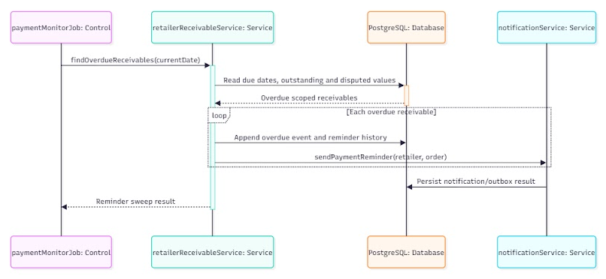
Figure 3.17.4 – Detect Overdue Receivables and Send Reminders Sequence Diagram

3.17.5 Sequence Diagram: View Scoped Sales and Retailer Payment Balances
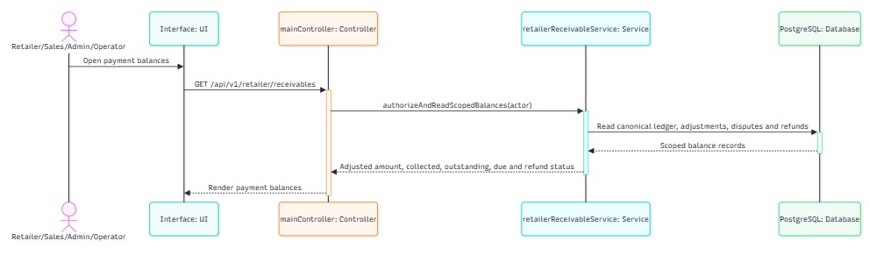
Figure 3.17.5 – View Scoped Sales and Retailer Payment Balances Sequence Diagram

3.17.6 Transaction, Idempotency, Concurrency and Exception Handling
Receivables follow BR-69 exactly: one obligation per order, full settlement only, disputed value separated, and jobs that can be re-run without duplicate effects. Common conventions TX/ID/CC/EX are defined in Table 3.0; the tables below state the design of each function.
3.17.6.1 Create Receivable from Approved Final Order Amount (Figure 3.17.2)
Aspect | Design
Transaction boundary | The PAYMENT obligation is created in the run-approval transaction (3.13.4) with the approved final amount (AwaitingAcceptance). Quotation acceptance (3.16.2) sets the method: Prepaid → AwaitingTransfer with the quotation deadline; Credit → CreditNotDue with the RETAILER_PAYMENT_TERM_VERSION snapshot. For Credit the DueDate is set only when FinalReceiptDate is known – in the receipt transaction when the last shipment is received with no missing quantity (3.8.8.2), or in the transaction that decides the last open Missing discrepancy (3.18.5.1 / 3.18.5.2): DueDate = FinalReceiptDate (ICT date) + term days, status CreditDue.
Idempotency | Unique PAYMENT (SalesOrderId); DueDate is set by a conditional update WHERE DueDate IS NULL, so a replayed receipt or decision can never move it.
Concurrency control | Created under the run and order locks of 3.13.4; later changes lock PAYMENT (CC-3); the receipt and discrepancy-decision transactions lock SALES_ORDER before PAYMENT.
Exception handling | Amount mismatch between quotation total and sum of batch lines → rejected (NFR-D01, 0 VND difference); a later change of the retailer term does not change an existing DueDate (BR-57).
Table 3.17.6.1 – Transaction, idempotency, concurrency and exception design: Create Receivable from Approved Final Order Amount
3.17.6.2 Record and Validate One-Time Full Payment (Figure 3.17.3)
Aspect | Design
Transaction boundary | As 3.9.7.1: one transaction locks PAYMENT, computes adjusted, outstanding and collectible amounts (BR-69), inserts MANUAL_PAYMENT, updates the confirmed amount and status, re-evaluates Completed (Delivered, Settled, no open complaint, no pending refund) and, when the order becomes Completed, emits the loyalty-earning event once.
Idempotency | ID-1; one confirmed full settlement per obligation; unique transaction reference.
Concurrency control | PAYMENT FOR UPDATE serializes with disputes, adjustments and refunds.
Exception handling | Partial amount → 422 (installments excluded, CR-19); duplicate → returns existing record; quotation expired → refund obligation instead of payment (BR-72).
Table 3.17.6.2 – Transaction, idempotency, concurrency and exception design: Record and Validate One-Time Full Payment
3.17.6.3 Detect Overdue Receivables and Send Reminders (Figure 3.17.4)
Aspect | Design
Transaction boundary | Job at 08:00 (TX-5): one set-based UPDATE per chunk marks unpaid obligations with due date < today and collectible now > 0 as Overdue and writes outbox reminder events to Sales and Operator in the same transaction.
Idempotency | Job key (Overdue, business date) is unique; the update is conditional on status, and notifications are unique per (payment, reminder date), so a re-run sends nothing twice (NFR-R04).
Concurrency control | CC-4 advisory lock; each chunk briefly locks PAYMENT rows, so a payment recorded at the same moment either commits first (not overdue) or after (clears Overdue on settlement).
Exception handling | Pending disputed portion excluded from the collectible amount (BR-52); orders not yet finally received have no DueDate and are never marked Overdue; job failure → alert and resume; notification failure handled by EX-3.
Table 3.17.6.3 – Transaction, idempotency, concurrency and exception design: Detect Overdue Receivables and Send Reminders
3.17.6.4 View Scoped Sales and Retailer Payment Balances (Figure 3.17.5)
Aspect | Design
Transaction boundary | Read-only in one READ ONLY REPEATABLE READ transaction so original, adjusted, paid, disputed and refund figures are consistent (TX-4).
Idempotency | Safe GET.
Concurrency control | No locks; MVCC.
Exception handling | Out of scope → 403 MSG006; invalid filter → 400 MSG002.
Table 3.17.6.4 – Transaction, idempotency, concurrency and exception design: View Scoped Sales and Retailer Payment Balances

3.18 Complaint, Financial Adjustment & Manual Refund

3.18.1 Class Diagram
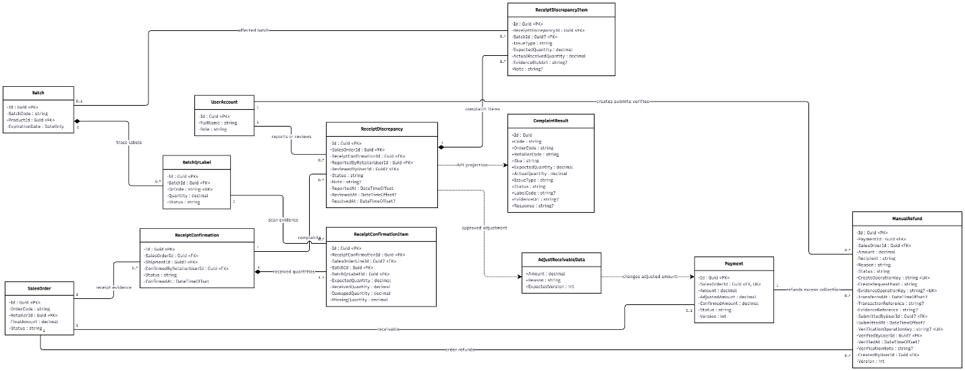
Figure 3.18.1 – Complaint, Financial Adjustment & Manual Refund Class Diagram

3.18.2 Sequence Diagram: Submit and Review Shipment-Linked Complaint
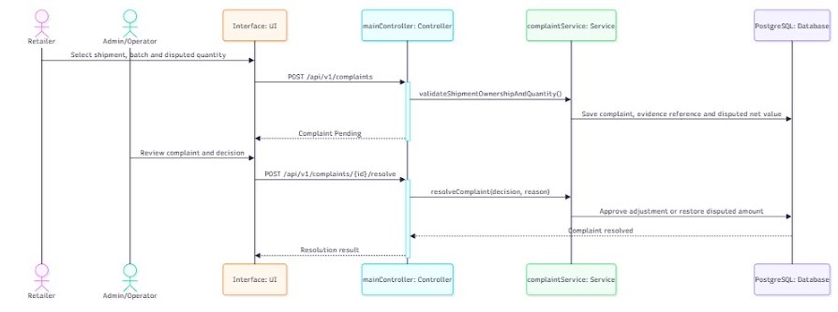
Figure 3.18.2 – Submit and Review Shipment-Linked Complaint Sequence Diagram

3.18.3 Sequence Diagram: Apply Approved Complaint Financial Adjustment
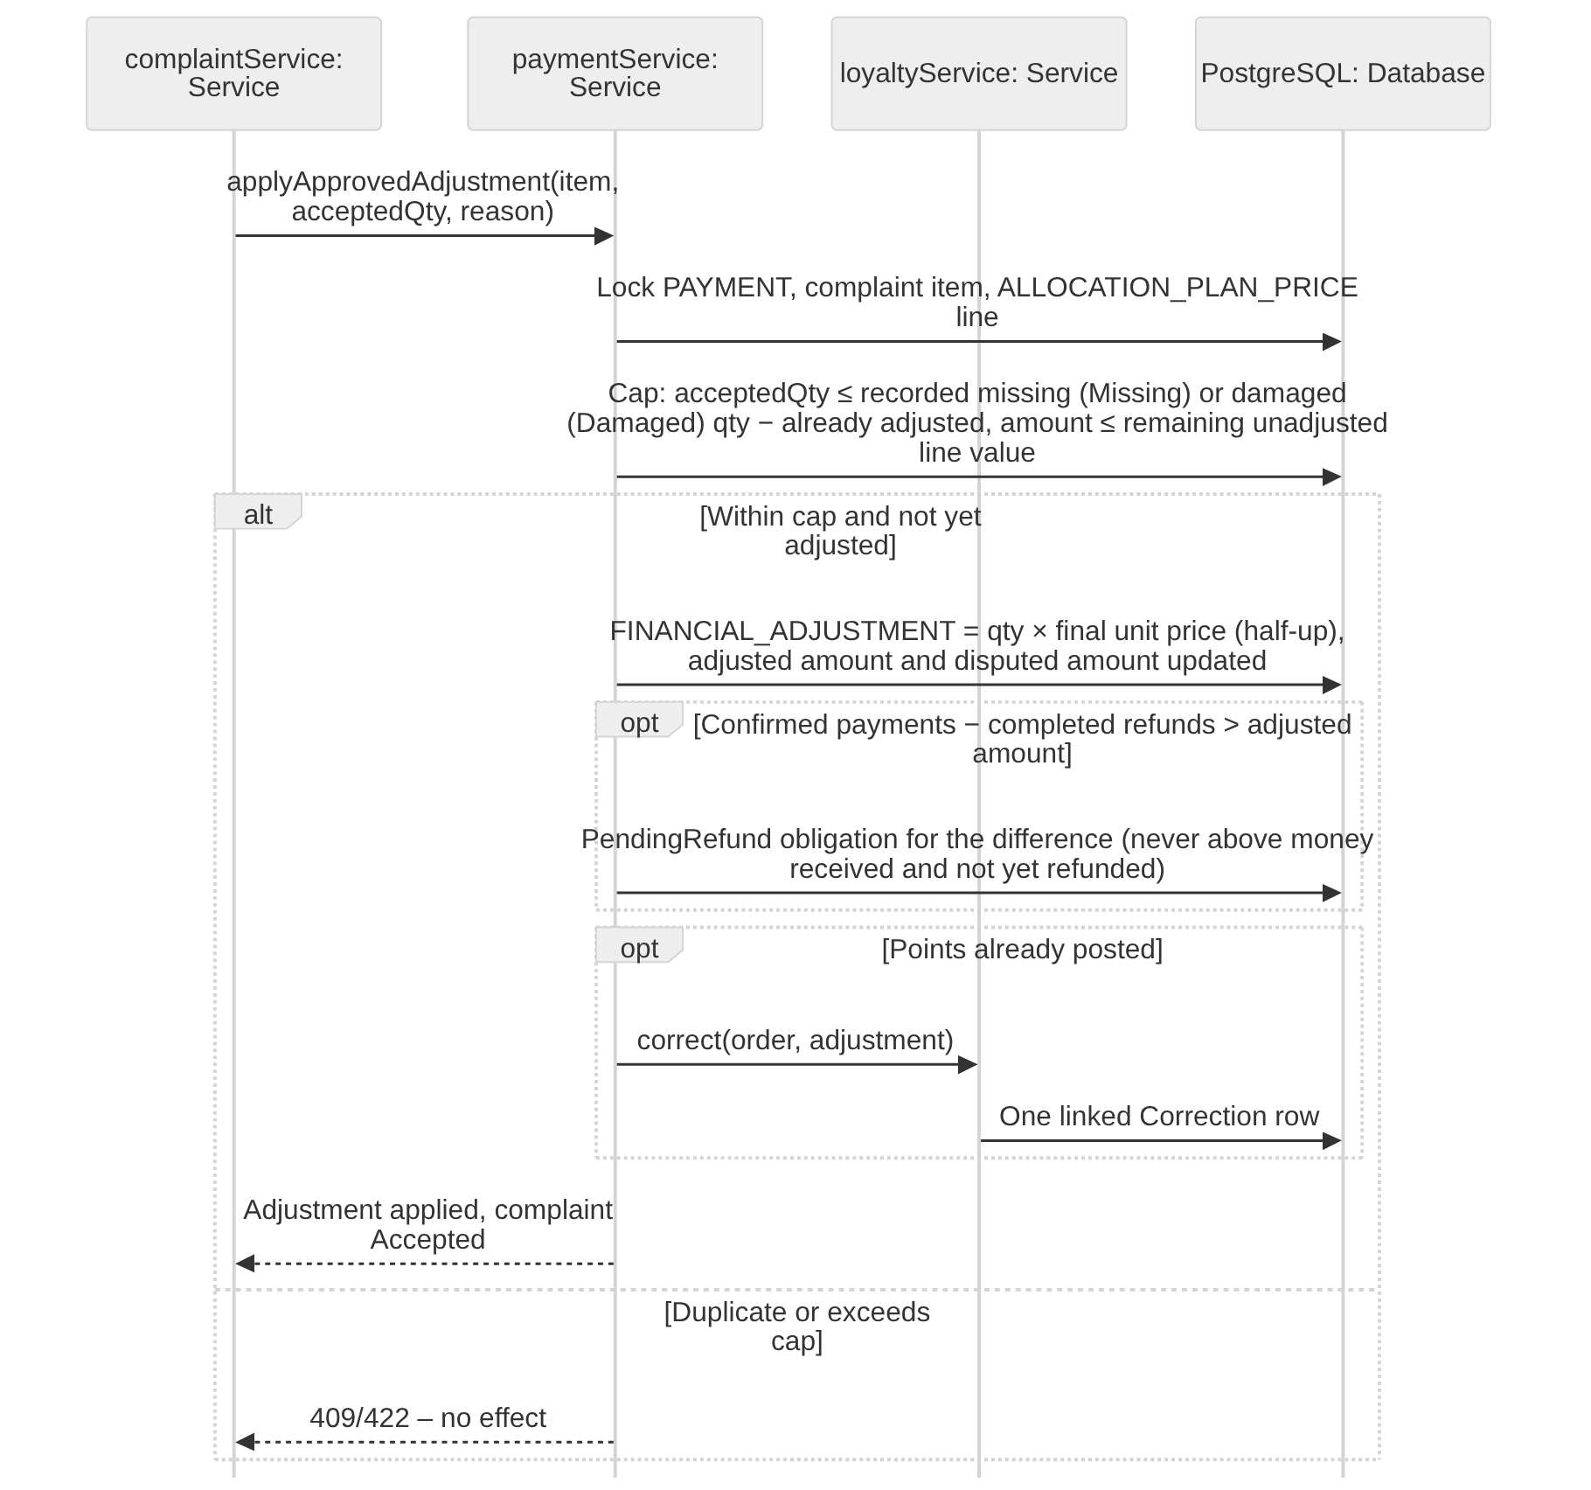
Figure 3.18.3 – Apply Approved Complaint Financial Adjustment Sequence Diagram

3.18.4 Sequence Diagram: Create, Verify and Complete Manual Refund
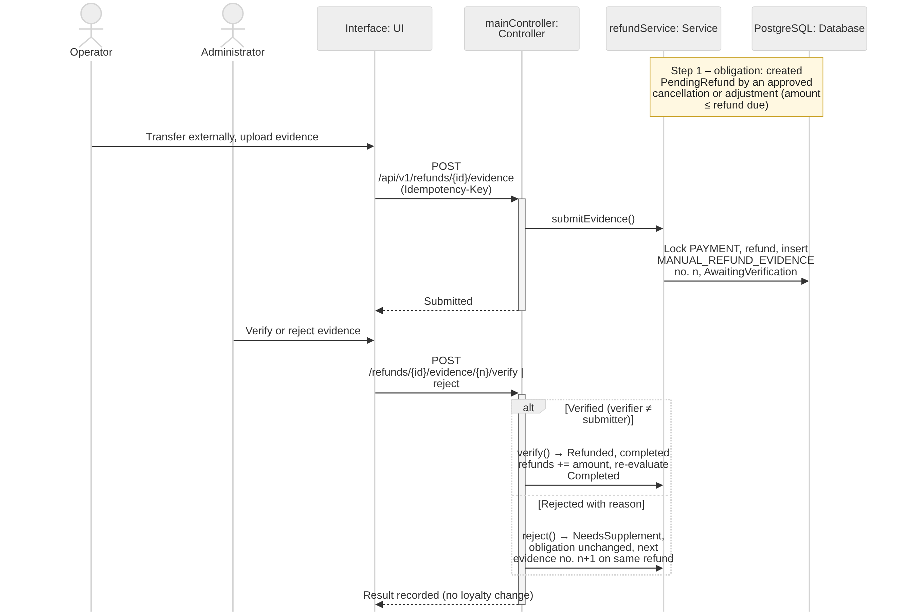
Figure 3.18.4 – Create, Verify and Complete Manual Refund Sequence Diagram

3.18.5 Transaction, Idempotency, Concurrency and Exception Handling
Complaint decisions change money and points through linked immutable records; they never change stock and can never be applied twice (BR-50, BR-67 – BR-70, BR-74). Common conventions TX/ID/CC/EX are defined in Table 3.0; the tables below state the design of each function.
3.18.5.1 Submit and Review Shipment-Linked Complaint (Figure 3.18.2)
Aspect | Design
Transaction boundary | Submission as in 3.8.4 (Missing items are also created automatically by the receipt transaction, 3.8.8.2). Operator recommendation is one transaction with CC-1 on the complaint. Administrator rejection is one transaction: lock SALES_ORDER, PAYMENT and the complaint, restore the disputed amount to the collectible balance and record the reason. When the decided item (accepted through 3.18.5.2 or rejected here) is the last open Missing item of the order, the same transaction sets the order Delivered, FinalReceiptDate = decision time and, for Credit, DueDate (3.17.6.1).
Idempotency | ID-1; conditional transitions Submitted → Under review → Accepted / Rejected.
Concurrency control | Lock order PAYMENT → RECEIPT_DISCREPANCY (CC-3); two reviewers deciding simultaneously: the second sees the decided status.
Exception handling | Decision without reason → 400 MSG001; already decided → 409; non-Administrator decision → 403 MSG006.
Table 3.18.5.1 – Transaction, idempotency, concurrency and exception design: Submit and Review Shipment-Linked Complaint
3.18.5.2 Apply Approved Complaint Financial Adjustment (Figure 3.18.3)
Aspect | Design
Transaction boundary | One transaction: lock SALES_ORDER, PAYMENT, the complaint item and the ALLOCATION_PLAN_PRICE line. Cap: accepted quantity ≤ the missing quantity (Missing item) or damaged quantity (Damaged item) recorded on RECEIPT_CONFIRMATION_ITEM for that shipment and batch line, minus quantity already adjusted; amount = quantity × final unit price (half-up), ≤ remaining unadjusted line value. Insert FINANCIAL_ADJUSTMENT, update adjusted and disputed amounts; if confirmed payments − completed refunds exceed the adjusted amount, create or increase a Pending MANUAL_REFUND by the difference (never above money received and not yet refunded); if points were already posted, insert one linked LOYALTY_TRANSACTION correction; set the complaint Accepted and apply the FinalReceiptDate rule of 3.18.5.1; audit and outbox.
Idempotency | ID-1; unique FINANCIAL_ADJUSTMENT per complaint item and unique loyalty correction per adjustment, so a repeated approval adjusts once (BR-68).
Concurrency control | PAYMENT and RETAILER_LOYALTY locked in that order; caps are re-checked after locking.
Exception handling | Cap exceeded → 422; duplicate approval returns the existing adjustment; no stock is returned (AC-3.10.4-06); refund obligation above refundable money → 422.
Table 3.18.5.2 – Transaction, idempotency, concurrency and exception design: Apply Approved Complaint Financial Adjustment
3.18.5.3 Create, Verify and Complete Manual Refund (Figure 3.18.4)
Aspect | Design
Transaction boundary | Three separate steps (BR-74), each one transaction. (1) Obligation: created PendingRefund only inside the transaction of an Administrator-approved decision (paid cancellation 3.13.7.4 or accepted adjustment 3.18.5.2); amount ≤ refund due. (2) Evidence: the Operator transfers externally, uploads evidence and a MANUAL_REFUND_EVIDENCE row (SubmissionNo n, transfer reference, amount) moves the refund to AwaitingVerification. (3) Verification: the Administrator (≠ submitter) sets Refunded and adds the amount to completed refunds on PAYMENT, or rejects with a reason → NeedsSupplement; the next submission adds row n+1 to the same refund. Completion re-evaluates order completion and never changes loyalty points.
Idempotency | ID-1; conditional transitions; unique external transaction reference; one open refund per (order, source decision); under the PAYMENT lock the sum of refund amounts never exceeds refund due = max(0, confirmed payments − adjusted amount − completed refunds) (AC-3.10.4-04).
Concurrency control | PAYMENT FOR UPDATE serializes refunds with payments and adjustments; CC-1 on MANUAL_REFUND.
Exception handling | Amount above refund due → 422; evidence submitted by the verifier → 403; rejected evidence without reason → 400 MSG001; non-Administrator verification → 403 MSG006; invalid file → 400 MSG049.
Table 3.18.5.3 – Transaction, idempotency, concurrency and exception design: Create, Verify and Complete Manual Refund

4. Activity Diagrams

4.1 Source Supply, Goods Receiving and Batch/Lot Inventory Control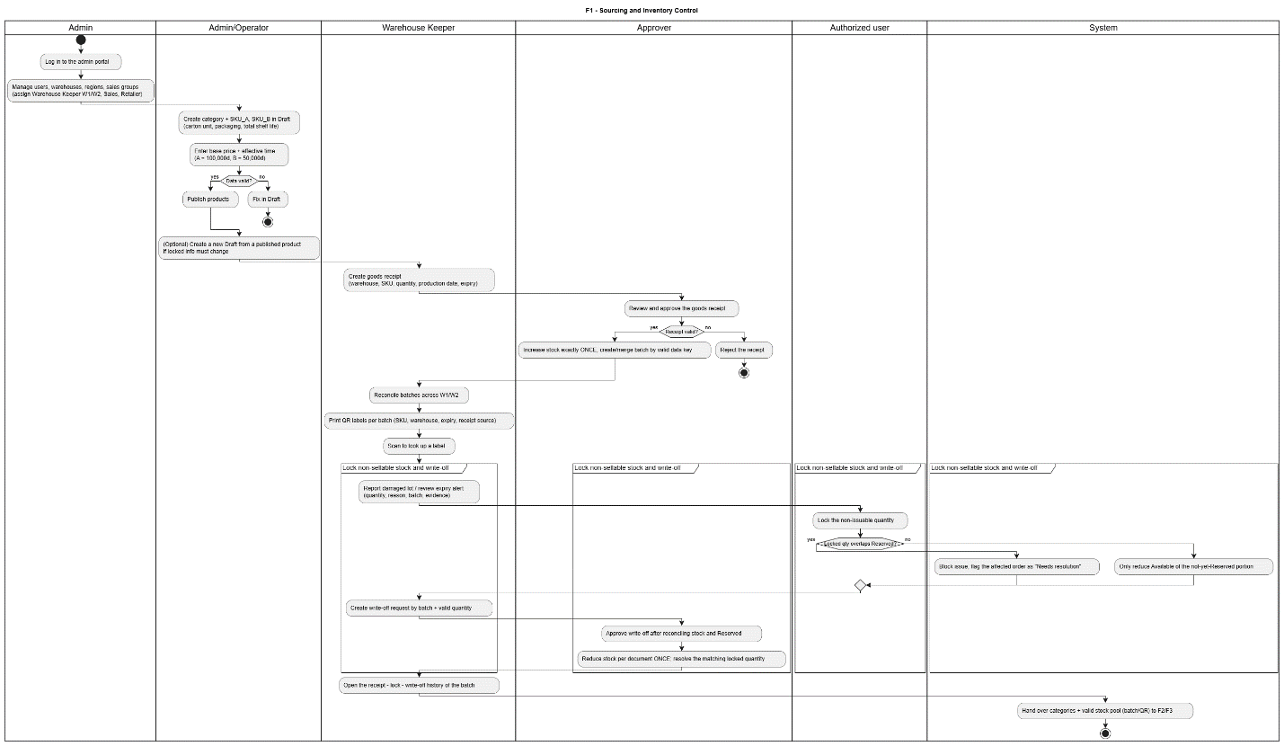
Figure 4.1 – F1 – Source Supply, Goods Receiving and Batch/Lot Inventory Control Activity Diagram

4.2 Retailer Registration, MLOR Configuration, Promotions, Sales Order Creation and Offline Synchronization
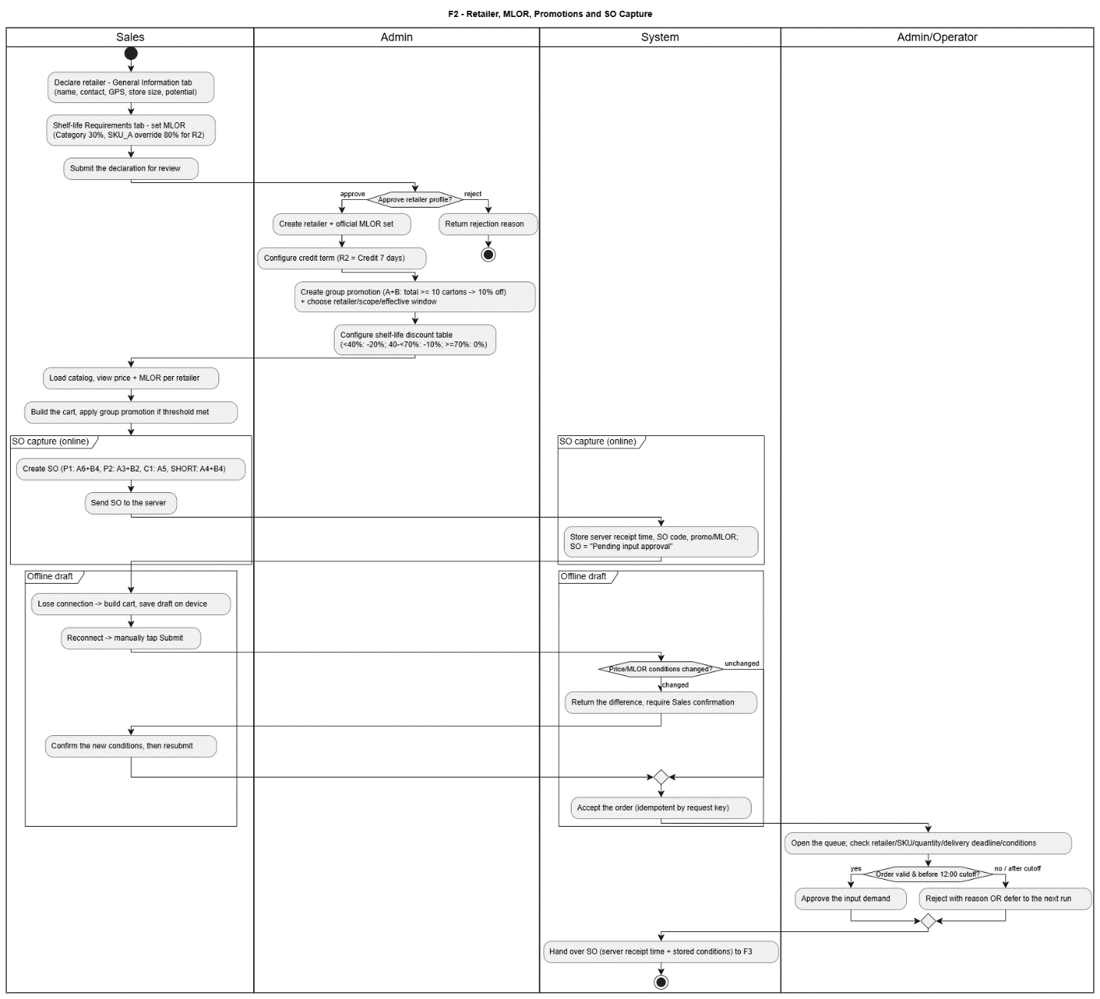
Figure 4.2 – F2 – Retailer Registration, MLOR Configuration, Promotions, Sales Order Creation and Offline Synchronization Activity Diagram

4.3 Daily FEFO–MLOR Allocation, Approval and Reservation
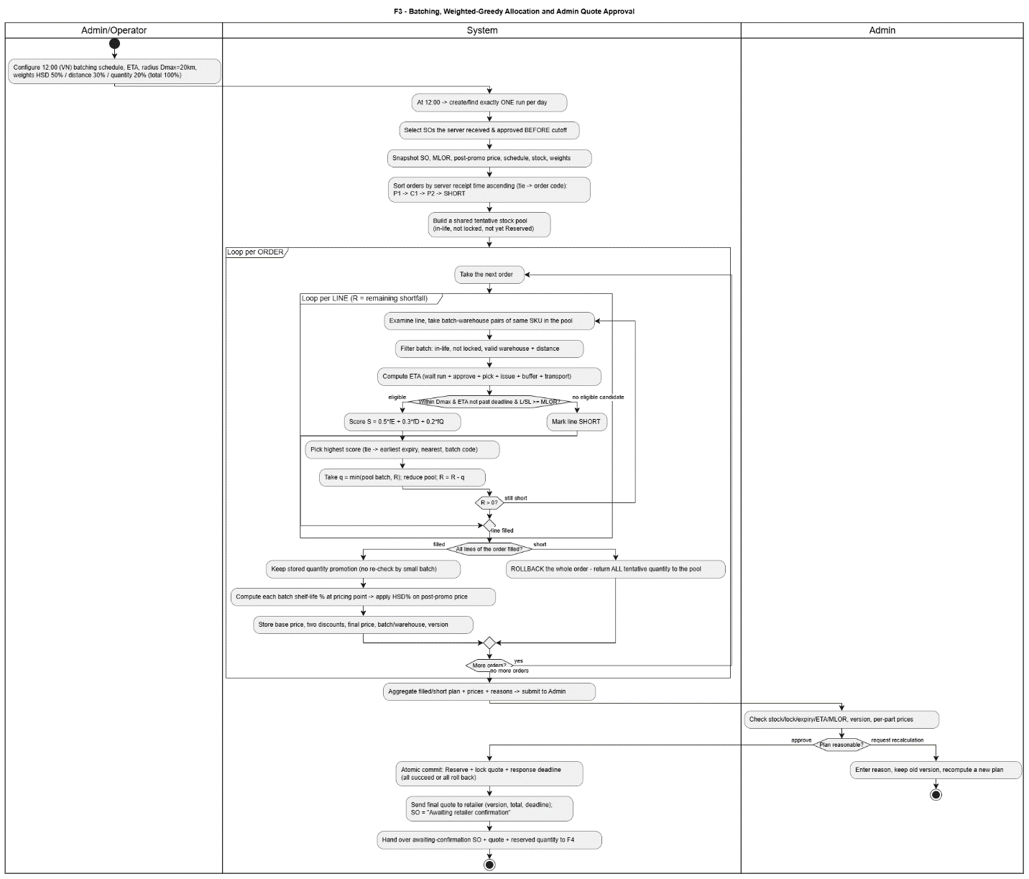
Figure 4.3 – F3 – Daily FEFO–MLOR Allocation, Approval and Reservation Activity Diagram

4.4 Order Processing, Picking, Goods Dispatch, Delivery and Retailer Receipt Confirmation
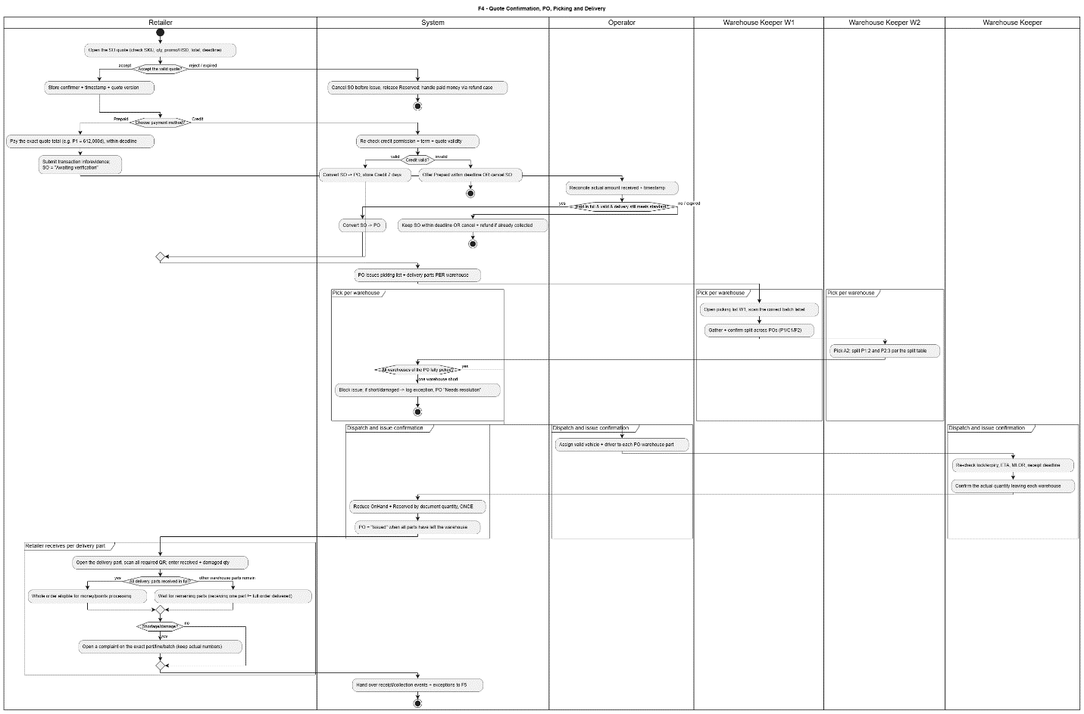
Figure 4.4 – F4 – Order Processing, Picking, Goods Dispatch, Delivery and Retailer Receipt Confirmation Activity Diagram

4.5 Payment Reconciliation, Order Completion, Loyalty, Reward Redemption, Complaints and Refunds
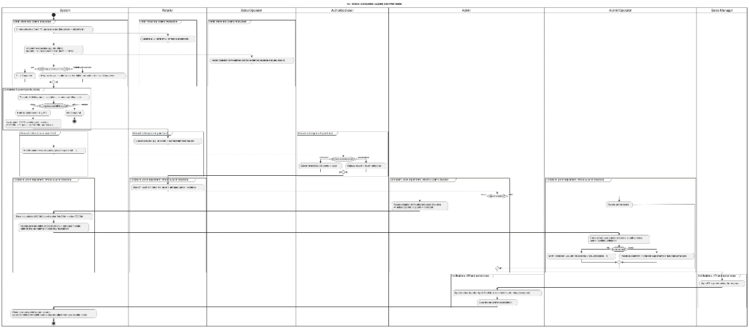
Figure 4.5 – F5 – Payment Reconciliation, Order Completion, Loyalty, Reward Redemption, Complaints and Refunds Activity Diagram

5. Technology Stack and External Services

5.1 Development Technologies and Versions
Layer | Technology / framework | Version / evidence
Frontend (Web Portal) | React, TypeScript, Vite, Chart.js | React 18; Chart.js for dashboards and KPI charts (Registration v1.8); exact TypeScript, Vite and Chart.js versions: verify package.json / lockfile before release.
Backend (API) | ASP.NET Core, .NET SDK, Entity Framework Core | .NET 10 / ASP.NET Core 10; EF Core package version not confirmed in README.
Mobile | Flutter (Dart), sqflite (SQLite offline cache) | Flutter/Dart SDK versions not confirmed in README; Android minSdkVersion 21 documented.
Primary database | Azure Database for PostgreSQL | Planned target: Azure Database for PostgreSQL. The engine version and migration version are recorded in the staging environment during test execution (Report 5 v1.2 §3.2); no specific version is claimed here.
API and client transport | REST (JSON over HTTPS), Axios (Portal), Dio (Mobile) | REST is the only committed API style (Registration v1.8); GraphQL is optional and not used (Table 1.2.4). Exact client library versions: verify repository lockfiles.
Scheduled jobs | ASP.NET Core hosted background worker (FSCM.Infrastructure.BackgroundJobs); Azure Functions Timer Trigger optional | Implemented: hosted worker for allocation trigger, expiry sweep, quotation expiry, overdue job, reminders and outbox dispatch. Proposed (Registration v1.8): Azure Functions may host required timer jobs; not required for the MVP.
Monitoring | Azure Monitor / Application Insights | Proposed operations service (Registration v1.8): availability tests, request latency, job outcomes and alerts used to measure the NFRs; configuration recorded at deployment.
Tooling and hosting | GitHub Actions, Azure Pipelines, Azure App Service, Vercel | Hosted service versions and runner images require verification against active configurations.

5.2 Third-Party Services, Purpose and Data Transmitted
External service | Purpose | Data sent / exchanged
Microsoft Entra ID | Portal authentication and identity-token exchange | Sign-in requests and account identifiers; the client forwards an Entra bearer token to FSCM API for validation and account linking. Tokens and configured tenant/client identifiers are involved; user credentials are handled by the identity provider.
Google Maps Platform | Address geocoding, road-distance lookup and map rendering | Warehouse/retailer address or geolocation coordinates and route origin/destination inputs; API key in server or restricted browser configuration.
payOS | Not used in the MVP baseline (optional adapter only, Table 1.2.4) | None in the MVP. Gateway checkout, webhooks and automatic settlement are excluded (Report 1 LI-08); prepaid transfers are verified manually by authorized staff against the quotation amount.
Azure Database for PostgreSQL | Primary persistent transactional data store | Application entities and operational records, including users, orders, batch stock, allocation, payment/loyalty records and related audit metadata, via secure database connections.
Azure Blob Storage | Evidence and artifact storage | Uploaded evidence images/files, such as dispatch/receipt and complaint attachments, with related object metadata and access identifiers.
Azure Notification Hubs | Push notification distribution (planned architecture) | Recipient/device push identifiers and event notification content or related-resource references; do not place payment credentials or sensitive payloads in push bodies.
Azure Key Vault | Secret and credential management (deployment design) | Secret names/identifiers and authenticated retrieval requests; application secrets are returned only to authorized workloads.
GitHub / GitHub Actions | Source repository and validation automation | Git commits, branch/PR metadata, source and build/test artifacts; deployment credentials only via protected secret settings.
Azure DevOps Repos / Pipelines | Backend repository mirroring and deployment pipeline | Mirrored Git branches, source revisions, build/test results, deployable packages and protected deployment configuration.
Vercel | Frontend web hosting | Built static frontend assets and deployment metadata; frontend environment configuration must contain no server secrets.
Azure Monitor | Application telemetry and operations monitoring (planned) | Operational logs, metrics, traces and exception metadata after appropriate secret/PII redaction.

6. Source Control, CI/CD and Release Management

6.1 Source Repositories and GitHub Actions Workflows
Workflow / system | Trigger and responsibilities | Documented status
backend-ci.yml (GitHub Actions) | Validate backend pushes and pull requests; run solution validation checks. | Explicit workflow link and PR/push behavior in Backend README.
Backend GitHub-to-Azure mirror workflow | Mirror every GitHub branch to FSCM-Backend Azure Repo. | Behavior documented.
Azure Pipelines (Backend) | Build, test, package and deploy main to configured Azure App Service. | Described in Backend README.
Frontend CI/CD | Build with npm run build; output dist/ is intended for Vercel. | README contains build command.
Mobile CI/CD | Run flutter test and create/release application package after verification. | README shows flutter test.

6.2 Build, Test, Package and Deploy Stages
1. Check out the target Git revision, restore/install dependencies and load only environment-specific non-secret settings from the repository.
2. Backend: dotnet restore FSCM.slnx; dotnet build FSCM.slnx --configuration Release --no-restore; dotnet test FSCM.slnx --configuration Release --no-build.
3. Frontend: npm install; npm run build (TypeScript project build followed by Vite bundle generation to dist/). Automated frontend test script is not stated in the supplied README.
4. Mobile: flutter create . when platform folders are absent; flutter pub get; flutter test; run flutter analyze when the Flutter SDK is available; package Android/iOS artifacts under approved signing settings.
5. Publish build/test artifacts and apply required manual release approval to the destination environment where applicable. Exact approval gates are not confirmed in the supplied sources.
6. Backend: the documented Azure Pipeline deploys main to its configured Azure App Service; deploy the frontend dist/ bundle to Vercel. Mobile app-store/internal distribution procedure is not documented.
7. Verify API health at /health, validate core user journeys and inspect deployment logs before declaring the release successful.

6.3 Deployment Environments
Environment | Application and hosting | Database / configuration | Current evidence
Development | Web Vite server http://localhost:5173; ASP.NET Core local API (README example localhost:5080); Flutter emulator uses 10.0.2.2:5080. | Local PostgreSQL for backend; .env VITE_USE_MOCK and VITE_API_BASE_URL; appsettings.Local.json / user secrets; Mobile USE_MOCK and API_BASE_URL. | Local commands and configuration examples explicitly documented in three READMEs.
Staging | A separately configured Azure App Service API and Vercel preview/staging web deployment are suitable target allocations, but no named endpoints or resources are specified in the sources. | Separate PostgreSQL, Blob and integration credentials must be configured; do not share production secrets. | Successful GitHub Actions workflow run, deployed Azure App Service staging API, Vercel staging deployment, and the corresponding mobile staging build.
Production | Backend main is described as deployed by Azure Pipelines to a configured Azure App Service; web dist/ deploys to Vercel; mobile release destination is not given. | Azure Database for PostgreSQL; integration secrets should use environment variables/secret storage. Resource names, regions, sizing and URLs are unconfirmed. | Hosting platforms documented

6.4 Deployment Procedure
1. Select the approved revision; verify that CI tests pass and record commit, artifact version and target environment.
2. Provision/verify the target Azure App Service, PostgreSQL connectivity, Vercel project and storage/integration services as applicable. Confirm service identities and least-privilege access.
3. Configure environment-specific application settings and secrets (Entra, Jwt, GoogleMaps, PayOS and database) in the deployment secret store; never commit secrets to Git.
4. Apply reviewed EF Core migrations using the backend command documented for local database updates, adapted for the target connection. Back up the target database before any non-backward-compatible schema change.
5. Deploy the backend build through the documented Azure Pipeline on main; deploy the frontend build output dist/ to Vercel. Build and distribute Mobile according to the target release channel once defined.
6. Run health checks, authorization checks and smoke tests covering login, batch stock, order creation/sync, allocation approvals and payment state; inspect deployment logs and freeze the release record.

6.5 Application Rollback Procedure
1. Halt promotion to further environments when health checks, core workflow tests or monitoring signal a release failure.
2. Identify the last known-good backend artifact and frontend deployment and restore those application versions using the hosting platform deployment history or redeploy the pinned Git revision.
3. Reapply previous environment configuration only when configuration changes caused the incident; re-check secret references and service bindings.
4. Treat PostgreSQL migrations separately: do not automatically run destructive down-migrations. Prefer backward-compatible changes; use a tested database backup/restore or a reviewed forward repair when needed.
5. Re-run /health, smoke tests, transactional and idempotency checks. Record release revision, incident, recovery actions and remaining data-reconciliation work.

7. AI Tools and Model Usage

7.1 AI-Assisted Development Tools
Tool / environment | Use in FSCM project | AI model / version
Google Antigravity | AI-assisted development environment used for coding, code exploration and implementation support. | Claude Opus 5.5  Gemini 3.8 Flash
ChatGPT | Requirements clarification, design/document drafting, development assistance and review support. | GPT 5.6 Sol  GPT-6 Astra  GPT 6.1 Sol  GPT-6 Astra
Claude | Analysis, development assistance and design/review support where used. | Claude Opus 5.5
OpenAI Codex | Code implementation and technical assistance via editor workflow. | GPT 5.6 Sol  GPT 6.1 Sol
Kiro | AI-assisted coding/specification environment. | Auto Model
Visual Studio Code / Android Studio | IDEs used for development, debugging and testing; not themselves AI models. | GPT 6.1 Sol  Gemini Pro 3.1

7.2 Application across Project Stages
Stage | Documented / intended AI-assisted use | Verification and responsibility
Requirements | Support elicitation, cross-checking SRS wording and business-rule consistency. | All AI-suggested changes require manual comparison with approved scope and SRS.
Design | Draft/review architecture descriptions, UML scaffolds, flows and interface decisions. | Review against reports, diagrams and current code; AI output does not constitute approved design.
Coding | Generate or refactor code, explain modules and troubleshoot compiler/runtime issues. | Changes need developer review, authorization/transactional validation and CI checks.
Testing | Assist with test-case ideas, edge cases and debugging. | Tests must be executed; generated assertions and results must not be represented as measured evidence without execution.
Review | Compare requirements, design and code and identify traceability gaps. | Review requires keeping original AI self-review output intact and documenting team responses to findings.

